**SUMMARY OF DISSERTATION STRUCTURE**

**Cover page**

The cover page includes everyone's highest degree.

**Quote**

Should indicate from whom it is quoted.

**Table of contents**

All numbered main/sub-chapters are included in the table of contents. All main chapters start on a new page.

**Graphical abstract**

It should incorporate all of your studies in one single graphical abstract.

**Main structure**

1.5 Line Spacing, justified text. The margins are 3 cm throughout the whole document. Maximum length between 30-60 pages without Cover Page, Table of Contents, List of Abbreviations, Student Profile, References, Bibliography, and Acknowledgements

**Font – included in styles**

Times New Roman font, size 12 throughout the paper.

**Tables and numbering**

Table title should be positioned above the table, while table legend should be below the table. The title should be self explanatory, keep the table structure simple, without merged cells if possible. Table numbering is continuous throughout the document. Please see example below.

**Figures and numbering**

Figure titles and descriptions should be positioned below the figure. The figure title should not only include simple statements like “Summary figure” or “Forest plot of xy outcome”, but it should also include a short description on the interpretation of the figure, e.g., “Forest plot representing the xy outcome compared between xy groups. The pooled results represent hazard ratios (HRs) with 95% confidence intervals (CIs). Subgroup analysis based on xy can be found…”. Figure numbering is continuous throughout the document. Please see example below.

**References**

APA 7th edition Vancouver.

**Page numbering**

Page numbering is centered at the bottom. Cover page should not be numbered.

**Page layout – orientation – portrait or landscape**

Use section breaks for changing the orientation of the pages. Don’t forget to check the page numbering in this case

**Publications – PDF attachment**

Publications related to the thesis should be sent in PDF format in a separate document at the time of submission of the thesis.

TITLE

**Ph.D. Thesis**

**NAME with degree (e.g. M.D.)**

Translational Medicine Program

XYZ Division

SEMMELWEIS UNIVERSITY

Supervisor: NAME with DEGREE (e.g. M.D., Ph.D.)

NAME with DEGREE (e.g. M.D., Ph.D.)

Official reviewers: NAME with DEGREE (e.g. M.D., Ph.D.)

NAME with DEGREE (e.g. M.D., Ph.D.)

Head of the Complex

Examination Committee: NAME with DEGREE (e.g. M.D., Ph.D.)

Members of the Complex

Examination Committee: NAME with DEGREE (e.g. M.D., Ph.D.)

NAME with DEGREE (e.g. M.D., Ph.D.)

Budapest

2025

***“PLEASE WRITE HERE QUOTE”***

AUTHOR

TABLE OF CONTENT

1 LIST OF ABBREVATIONS 5

2 STUDENT PROFILE 6

2.1 Vision and mission statement, specific goals 6

2.2 Scientometrics 6

2.3 Future plans 6

3 SUMMARY OF THE THESIS 7

4 GRAPHICAL ABSTRACT 8

5 INTRODUCTION 9

5.1 Overview of the topic 9

5.1.1 What is the topic? 9

5.1.2 What is the problem to solve? 9

5.1.3 What is the importance of the topic? 9

5.1.4 What would be the impact of our research results? 9

5.2 Further introductory chapters, if necessary 10

6 OBJECTIVES 11

6.1 Study I. – Investigating the Impact of Maternal Age on the Development of Non-Chromosomal Congenital Anomalies in the Hungarian Population between 1980 and 2009 11

6.2 Study II. – Investigating the Impact of Maternal Age on the Development of Non-Chromosomal Congenital Anomalies Worldwide 11

7 METHODS 12

7.1 Study I. 12

7.1.1 Study design 12

7.1.2 Setting 12

7.1.3 Ethics and patient consent 12

7.1.4 Participants 12

7.1.5 Variables and data sources 12

7.1.6 Bias and evidence synthesis 12

7.1.7 Statistical methods 12

7.2 Study II. 12

7.2.1 Literature search and eligibility criteria 12

7.2.2 Study selection and data extraction 12

7.2.3 Quality assessment 12

7.2.4 Data synthesis and analysis 12

8 RESULTS 13

8.1 Study I: Population-based registry analysis 13

8.2 Study II: Meta-analysis 14

9 DISCUSSION 17

9.1 Summary of findings, international comparisons (including all studies) 17

9.2 Strengths (including all studies) 17

9.3 Limitations (including all studies) 17

10 CONCLUSIONS 18

11 IMPLEMENTATIONS FOR PRACTICE 19

12 IMPLEMENTATION FOR RESEARCH 20

13 IMPLEMENTATION FOR POLICYMAKERS 21

14 FUTURE PERSPECTIVES 22

15 REFERENCES 23

16 BIBLIOGRAPHY 24

16.1 Publications related to the thesis 24

16.2 Publications not related to the thesis 24

17 ACKNOWLEDGEMENTS 25

1. LIST OF ABBREVATIONS

**BLANK** Blandit Lorem Ante Nec Kata

**LAPSE** Lectus Auctor Pharetra Sed Elit

**NOISE** Nullam Ornare Ipsum Sed Elit

**PURE** Purus Ultricies Risus Efficitur

**VAGUE** Vivamus Auctor Gravida Ultricies Et

1. STUDENT PROFILE
   1. Vision and mission statement, specific goals

Vivamus auctor, lectus vel consectetur gravida, purus sapien feugiat urna, et ultricies felis sapien ac metus. Phasellus dictum, nisl vel tempor hendrerit, augue ligula volutpat mi, at vehicula justo lorem nec orci. Pellentesque non libero lacus. Integer volutpat congue sem, in tempor lectus congue sit amet. Cras dictum nulla ut ante varius, sed fermentum erat consequat.

* 1. Scientometrics

**Number of all publications:** x

Cumulative IF: x.xxx

Av IF/publication: x.xxx

Ranking (SCImago): D1:, Q1:, Q2:, Q3:, Q4:

**Number of publications related to the subject of the thesis:** x

Cumulative IF: x.xxx

Av IF/publication: x.xxx

Ranking (Sci Mago): D1:, Q1:, Q2:, Q3:, Q4:

**Number of citations on Google Scholar:** x

**Number of citations on MTMT (independent):** x

**H-index:** x

The detailed bibliography of the student can be found on pages x-y.

* 1. Future plans

Vivamus auctor, lectus vel consectetur gravida, purus sapien feugiat urna, et ultricies felis sapien ac metus. Phasellus dictum, nisl vel tempor hendrerit, augue ligula volutpat mi, at vehicula justo lorem nec orci. Pellentesque non libero lacus. Integer volutpat congue sem, in tempor lectus congue sit amet. Cras dictum nulla ut ante varius, sed fermentum erat consequat.

Vivamus auctor, lectus vel consectetur gravida, purus sapien feugiat urna, et ultricies felis sapien ac metus. Phasellus dictum, nisl vel tempor hendrerit, augue ligula volutpat mi, at vehicula justo lorem nec orci. Pellentesque non libero lacus.

1. SUMMARY OF THE THESIS

Vivamus auctor, lectus vel consectetur gravida, purus sapien feugiat urna, et ultricies felis sapien ac metus. Phasellus dictum, nisl vel tempor hendrerit, augue ligula volutpat mi, at vehicula justo lorem nec orci. Pellentesque non libero lacus. Integer volutpat congue sem, in tempor lectus congue sit amet. Cras dictum nulla ut ante varius, sed fermentum erat consequat.

Nullam placerat nisi vitae velit luctus, a interdum nisi finibus. Aenean blandit ligula eget libero vehicula, ac iaculis risus tincidunt. Suspendisse potenti. Sed in facilisis tortor. Fusce at elit eget justo volutpat sodales non sit amet urna. Nam et nisl a neque ultricies tincidunt. Proin ornare lorem id magna pharetra, eget viverra nunc facilisis.

1. GRAPHICAL ABSTRACT

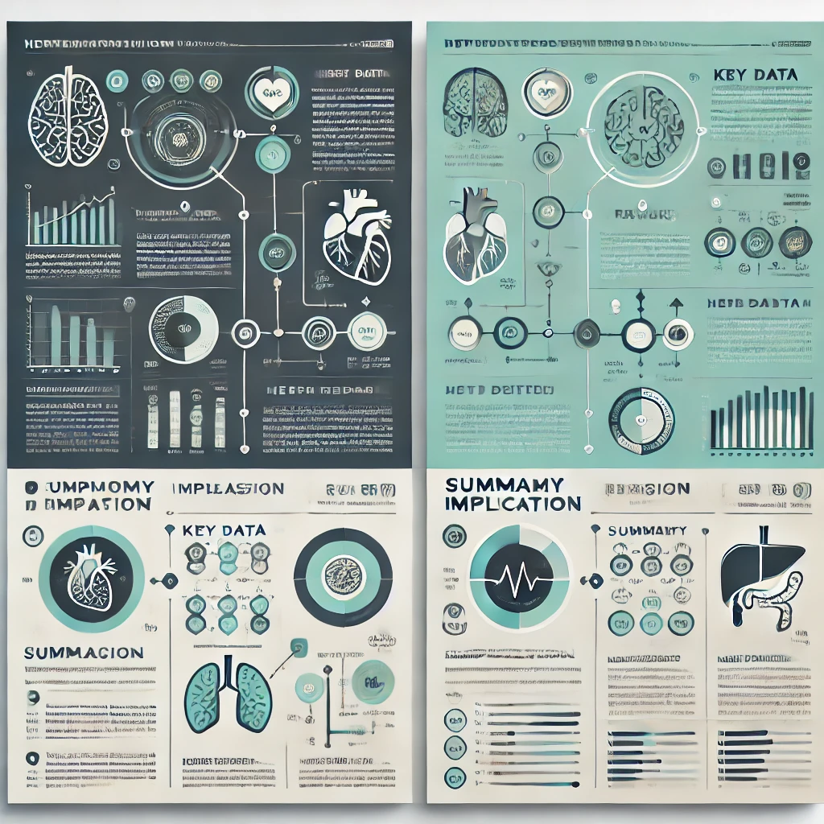

1. INTRODUCTION
   1. Overview of the topic
      1. What is the topic?

Lorem ipsum dolor sit amet, consectetur adipiscing elit. Nullam sed felis at lorem volutpat dignissim. Vivamus vehicula, nunc sit amet laoreet tincidunt, turpis nulla tincidunt metus, nec pellentesque urna libero id mauris. Fusce non urna eu eros gravida dictum. Mauris fermentum est in libero malesuada, sed gravida purus ultricies. Nam ac interdum nisi. Sed at convallis magna.

* + 1. What is the problem to solve?

Lorem ipsum dolor sit amet, consectetur adipiscing elit. Nullam sed felis at lorem volutpat dignissim. Vivamus vehicula, nunc sit amet laoreet tincidunt, turpis nulla tincidunt metus, nec pellentesque urna libero id mauris. Fusce non urna eu eros gravida dictum. Mauris fermentum est in libero malesuada, sed gravida purus ultricies. Nam ac interdum nisi. Sed at convallis magna.

* + 1. What is the importance of the topic?

Lorem ipsum dolor sit amet, consectetur adipiscing elit. Nullam sed felis at lorem volutpat dignissim. Vivamus vehicula, nunc sit amet laoreet tincidunt, turpis nulla tincidunt metus, nec pellentesque urna libero id mauris. Fusce non urna eu eros gravida dictum. Mauris fermentum est in libero malesuada, sed gravida purus ultricies. Nam ac interdum nisi. Sed at convallis magna.

* + 1. What would be the impact of our research results?

Lorem ipsum dolor sit amet, consectetur adipiscing elit. Nullam sed felis at lorem volutpat dignissim. Vivamus vehicula, nunc sit amet laoreet tincidunt, turpis nulla tincidunt metus, nec pellentesque urna libero id mauris. Fusce non urna eu eros gravida dictum. Mauris fermentum est in libero malesuada, sed gravida purus ultricies. Nam ac interdum nisi. Sed at convallis magna.

* 1. Heading 1

Lorem ipsum dolor sit amet, consectetur adipiscing elit. Nullam sed felis at lorem volutpat dignissim. Vivamus vehicula, nunc sit amet laoreet tincidunt, turpis nulla tincidunt metus, nec pellentesque urna libero id mauris. Fusce non urna eu eros gravida dictum. Mauris fermentum est in libero malesuada, sed gravida purus ultricies. Nam ac interdum nisi. Sed at convallis magna. Curabitur pretium ligula vitae nunc facilisis, vel aliquet magna blandit. Aenean vulputate nisi ac felis tempor, a varius elit suscipit.

* 1. Heading 2 and etc.

Etiam eget eros nec elit dapibus sollicitudin vel eget orci. Integer non dolor id lacus suscipit feugiat. Ut accumsan vel orci a condimentum. Cras pellentesque ligula vel ligula interdum, non gravida justo iaculis. Donec vel turpis non justo volutpat viverra. Suspendisse potenti. Nam bibendum vestibulum leo, non ultricies magna consequat id.

1. OBJECTIVES
   1. Study I. – Study title

Lorem ipsum dolor sit amet, consectetur adipiscing elit. Nullam sed felis at lorem volutpat dignissim. Vivamus vehicula, nunc sit amet laoreet tincidunt, turpis nulla tincidunt metus, nec pellentesque urna libero id mauris. Fusce non urna eu eros gravida dictum. Mauris fermentum est in libero malesuada, sed gravida purus ultricies.

* 1. Study II. – Study title

Lorem ipsum dolor sit amet, consectetur adipiscing elit. Nullam sed felis at lorem volutpat dignissim. Vivamus vehicula, nunc sit amet laoreet tincidunt, turpis nulla tincidunt metus, nec pellentesque urna libero id mauris. Fusce non urna eu eros gravida dictum. Mauris fermentum est in libero malesuada, sed gravida purus ultricies.

* 1. Study III – or further studies – Study title

Lorem ipsum dolor sit amet, consectetur adipiscing elit. Nullam sed felis at lorem volutpat dignissim. Vivamus vehicula, nunc sit amet laoreet tincidunt, turpis nulla tincidunt metus, nec pellentesque urna libero id mauris. Fusce non urna eu eros gravida dictum. Mauris fermentum est in libero malesuada, sed gravida purus ultricies.

1. METHODS
   1. Study I.
      1. Study design
      2. Setting
      3. Ethics and patient consent
      4. Participants
      5. Variables and data sources
      6. Bias and evidence synthesis
      7. Statistical methods
   2. Study II.
      1. Literature search and eligibility criteria

.

* + 1. Study selection and data extraction
    2. Quality assessment
    3. Data synthesis and analysis

1. RESULTS
   1. Study I: Population-based registry analysis

PLEASE USE RELEVANT SUBHEADINGS

8.2 Study II: Meta-analysis

PLEASE USE RELEVANT SUBHEADINGS

***Figure XY.*** *PRISMA 2020 flowchart representing the study selection process (reference)*

**Table XY.** Basic characteristics of …

|  |  |  |  |  |  |  |  |  |  |  |  |
| --- | --- | --- | --- | --- | --- | --- | --- | --- | --- | --- | --- |
| **Congenital anomaly** | **ICD-10 Category** | **Age < 20** | **N** | **Age 30-35** | **N** | **Age 35-40** | **N** | **Age > 35** | **N** | **Age > 40** | **N** |
| All NCAs  (with or without CAs) | Q00-Q89 | 1.08 (0.89; 1.32) | 14 | 1.23 (0.85; 1.78) | 13 | 1.47 (0.87; 2.49) | 9 | 1.31 (1.06; 1.61) | 13 | 1.44 (1.25; 1.66) | 11 |
| All NCAs  (without CAs) | Q00-Q89 | 1.21 (0.59; 2.49) | 5 | 1.54 (0.55; 4.32) | 6 | 1.73 (0.45; 6.70) | 5 | 1.37 (0.76; 2.45) | 6 | 1.25 (1.08; 1.46) | 6 |
| All NCAs  (with CAs) | Q00-Q89 | 1.15 (0.87; 1.52) | 10 | 1.02 (0.99; 1.06) | 7 | 1.20 (0.99; 1.44) | 4 | 1.26 (1.12; 1.42) | 7 | 1.63 (1.26; 2.09) | 6 |
| **Nervous system** | Q00-Q07 | 1.16 (0.74; 1.81) | 10 | 1.64 (0.70; 3.81) | 8 | 2.56 (0.64; 10.32) | 5 | 1.53 (0.80; 2.94) | 8 | 1.56 (0.67; 3.62) | 7 |
| Encephalocele | Q01 | 1.76 (0.44; 7.12) | 3 | 1.51 (0.33; 6.83) | 3 | no data |  | 1.43 (0.57; 3.60) | 3 | no data |  |
| Congenital hydrocephalus | Q03 | 1.19 (1.02; 1.38) | 2 | no data |  | no data |  | no data |  | no data |  |
| Spina bifida | Q05 | 1.30 (0.93; 1.82) | 9 | 1.15 (0.65; 2.06) | 8 | 1.79 (0.61; 5.31) | 5 | 1.39 (0.75; 2.59) | 8 | 1.96 (0.72; 5.31) | 5 |
| Anencephaly | Q00.0 | 1.40 (0.98; 1.99) | 9 | 1.15 (0.72; 1.84) | 8 | 1.20 (0.53; 2.72) | 6 | 1.02 (0.60; 1.72) | 8 | 1.30 (0.71; 2.38) | 6 |
| **Circulatory System** | Q20-Q28 | 0.87 (0.68; 1.11) | 3 | 1.09 (1.00; 1.20) | 3 | 1.18 (0.94; 1.49) | 3 | 1.33 (0.97; 1.82) | 3 | 1.94 (1.28; 2.93) | 4 |
| Congenital Heart Defects | Q20-Q26 | 0.87 (0.78; 0.97) | 10 | 1.45 (0.83; 2.52) | 10 | 1.91 (0.65; 5.62) | 6 | 1.50 (1.11; 2.04) | 10 | 1.75 (1.32; 2.32) | 6 |
| **Cleft lip and palate** | Q35-Q37 | 0.93 (0.76; 1.14) | 6 | 1.58 (0.77; 3.22) | 6 | 1.85 (0.59; 5.75) | 4 | 1.47 (0.95; 2.28) | 6 | 1.57 (1.11; 2.20) | 4 |
| Cleft palate | Q35 | 0.99 (0.56; 1.73) | 6 | 1.42 (0.66; 3.06) | 8 | 2.08 (0.54; 7.99) | 5 | 1.78 (1.16; 2.73) | 8 | 1.77 (1.48; 2.11) | 5 |
| **Digestive System** | Q38-Q45 | 0.98 (0.71; 1.37) | 2 | no data |  | no data |  | no data |  | 2.16 (1.34; 3.49) | 2 |
| **Urinary System** | Q60-Q64 | no data |  | 0.97 (0.75; 1.26) | 3 | no data |  | 0.86 (0.57; 1.29) | 3 | no data |  |
| Hypospadiasis | Q54 | 0.99 (0.91; 1.07) | 5 | 1.06 (0.96; 1.17) | 4 | no data |  | 1.11 (0.88; 1.39) | 4 | no data |  |
| **Musculoskeletal System** | Q65-Q79 | 0.88 (0.72; 1.08) | 2 | no data |  | 0.93 (0.71; 1.22) | 2 | 0.94 (0.65; 1.37) | 2 | 0.90 (0.55; 1.46) | 3 |
| Congenital Diaphragmatic Hernia | Q79.0 | 0.96 (0.88; 1.06) | 5 | 1.74 (0.52; 5.80) | 4 | no data |  | 1.52 (0.79; 2.91) | 5 | no data |  |
| Omphalocele | Q79.2 | 1.44 (1.08; 1.92) | 14 | 1.13 (0.85; 1.50) | 14 | 1.35 (0.98; 1.87) | 13 | 1.47 (1.20; 1.79) | 14 | 2.57 (1.77; 3.73) | 13 |
| Gastroschisis | Q79.3 | 3.08 (2.74; 3.47) | 22 | 0.32 (0.23; 0.44) | 17 | 0.27 (0.16; 0.47) | 12 | 0.22 (0.15; 0.32) | 17 | 0.41 (0.23; 0.74) | 11 |

Please state all abbreviations used in the table.

Lorem ipsum dolor sit amet, consectetur adipiscing elit. Nullam sed felis at lorem volutpat dignissim. Vivamus vehicula, nunc sit amet laoreet tincidunt, turpis nulla tincidunt metus, nec pellentesque urna libero id mauris.

**Figure 6.** *Forest plot representing the RR with 95% CI of all non-chromosomal anomalies (ICD-10: Q00-Q89) in different age groups compared to the 20-30 age grou**ps*

1. DISCUSSION
   1. Summary of findings, international comparisons (including all studies)
   2. Strengths (including all studies)
   3. Limitations (including all studies)
2. CONCLUSIONS
3. IMPLEMENTATIONS FOR PRACTICE

1. IMPLEMENTATION FOR RESEARCH

Methodology issues

Study design

New aspects

1. IMPLEMENTATION FOR POLICYMAKERS

1. FUTURE PERSPECTIVES
2. REFERENCES

1. BIBLIOGRAPHY
   1. Publications related to the thesis
   2. Publications not related to the thesis
2. ACKNOWLEDGEMENTS