1. Patient data / Patient personal details
Country:
City:
Hospital:
Doctor:
Blood sample code:
Date of blood sampling:

Insurance number:…………………………..
Name:…………………………………………
Date of questioning: ………………………………(year/month/day)

2. Changes in anamnesis

2.1 Lifestyle
Smoking: yes / no
if yes: amount (cigarettes/day):…………………
For how many years? …………………………
if not:
Did you smoke earlier? yes / no
if yes: amount (pcs/occasion):…………………………………
For how many years?………………………………………
How long ago did you stop smoking? ……………………………….

Alcohol consumption: yes / no
if yes: frequency: occasionally/monthly/weekly/daily
amount (g/day):…………………………………
since when? (years):………………………….
Alcohol consumption in the last 2 weeks: …………………..
if not:
Did you drink alcohol earlier? yes / no
if yes: frequency: occasionally/monthly/weekly/daily
amount (g/occasion):…………………………………
For how many years?………………………………………
How long ago did you stop drinking alcohol?..........................
Guide for estimation of the amount:
1 dl beer (4.5 vol. %) = ~3.5 g alcohol
1 dl wine (12.5 vol. %) = ~10 g alcohol
1 dl hard drink (50 vol. %) = ~40 g alcohol[T1]
Diet: yes / no
if yes: diabetic / gluten-free / vegetarian / paleolit / lactose-free / other:………………

Physical activity: none / occasionally / regularly / intensely
None: no exercise or exercise for < 3 hours/week for < 2 years
Occasionally: < 3 hours/week for >= 2 years
Regularly: > 3 hours/week for >= 2 years
Intensely: > 7 hours/week for>= 2 years

Drug abuse: yes / no Prescribed medication should not be included here.
if yes: type of drug:……………………………………. amount:………………………………………….
for how many years:……………………………
Job: blue collar worker / white collar worker
mining / sewing / other works with long-term vibration exposure

2.2 Comorbidities diagnosed since last visit
Diabetes mellitus: yes/no
if yes: type I. / type II / type III. / MODY
Allergies: yes / no
if yes: specify: inhalative / other nutrition / drug / eczema / other
Hypertension: yes / no
if yes: since (year):
Malignancy in history: yes / no
if yes: date: ……………….(year/month/day)
please specify: …………………..
Thromboembolic events in history: yes / no
if yes: deep vein thrombosis: yes / no
if yes: date:…………….(year/month/day)
(többször hozzáadható)
pulmonary embolism: yes / no
if yes: date:…………….(year/month/day)
(többször hozzáadható)
repeated miscarriages or stillbirths: yes / no
if yes: date:…………….(year/month/day)
(többször hozzáadható)
stroke: yes / no
if yes: date:…………….(year/month/day)
(többször hozzáadható)
myocardial infarction: yes / no
if yes: date:…………….(year/month/day)
(többször hozzáadható)

Autoimmunity diagnosed since last visit: yes /no
if yes: systemic / organ specific
if systemic: Rheumatoid arthritis / Systemic lupus erythematosus / Scleroderma / Sjögren's Syndrome / Antiphospholipid syndrome / Idiopathic inflammatory myopathies / Vasculitis / Other
if Rheumatoid arthritis: date of diagnosis: ……..(year/month/day)
if Systemic lupus erythematosus:date of diagnosis:…..(year/month/day)
if Scleroderma: date of diagnosis: ……..(year/month/day)
if Sjögren's Syndrome: date of diagnosis: ……..(year/month/day)
if Antiphospholipid syndrome: date of diagnosis:....(year/month/day)
if Idiopathic inflammatory myopathies: date of diagnosis:......(year/month/day)
if Vasculitis: date of diagnosis: ……..(year/month/day)
if Other:please specify: …… date of diagnosis: ……..(year/month/day)
if organ specific: Type I diabetes / Hashimoto's thyroiditis / Graves' disease / Addison’s disease / Autoimmune hepatitis / Primary biliary cholangitis / Primary sclerosing cholangitis / Multi-glandular diseases / Autoimmune pancreatitis / Coeliac disease / Autoimmune hemolytic anemia / Autoimmune thrombocytopenic purpura / Myasthenia gravis / Multiple sclerosis / Inflammatory neuropathies / Other
if Type I diabetes: date of diagnosis: ……..(year/month/day)
if Hashimoto's thyroiditis: date of diagnosis: ……..(year/month/day)
if Graves' disease: date of diagnosis: ……..(year/month/day)
if Addison’s disease: date of diagnosis: ……..(year/month/day)
if Autoimmune hepatitis: date of diagnosis: ……..(year/month/day)
if Primary biliary cholangitis: date of diagnosis: ……..(year/month/day)
if Primary sclerosing cholangitis:date of diagnosis: ….(year/month/day)
if Multi-glandular diseases: date of diagnosis: ……..(year/month/day)
if Autoimmune pancreatitis: date of diagnosis: ……..(year/month/day)
if Coeliac disease: date of diagnosis: ……..(year/month/day)
if Autoimmune hemolytic anemia: date of diagnosis:...(year/month/day)
if Autoimmune thrombocytopenic purpura:date of diagnosis:....(year/month/day)
if Myasthenia gravis: date of diagnosis: ……..(year/month/day)
if Multiple sclerosis: date of diagnosis: ……..(year/month/day)
if Inflammatory neuropathies: date of diagnosis: ….(year/month/day)
if Other: please specify: ……………
date of diagnosis:.......(year/month/day)
Raynaud phenomenon: yes / no
if yes: start date: …….. (year)
Scleroderma subgroup: limited cutaneous SSc / diffuse cutaneous SSc/ SSc sine scleroderma (based on medical documentations)
Intestinal lung disease: yes / no *
if yes: date of diagnosis: ……………….(year/month/day)
* Definition: Fibrosis proven by HRCT and ( <80% FVC or <80 DLCO) on pulmonary function tests.
Ischemic heart disease*: yes / no
if yes: date of diagnosis: ……………….(year/month/day)
* Definition: previews myocardial infarct or PTCA or CABG or pozitiv CT-angiography or pozitiv coronary angiography
Congestive heart disease*: yes / no
* Definition: using of loop diuretics
Scleroderma renal crisis: yes / no
Renal replacement therapy (dialysis) due to SRC: yes / no
Malabsorption: yes / no
Malabsorption definition: decreased serum protein / nutritional supplement / long-term weight loss.
Bacterial overgrowth: yes / no
Bacterial overgrowth definition: proven by H2 exhalation / cyclic antibiotic treatment.
Hiperalimentation required: yes / no
Asthma: yes / no
if yes: date of start of treatment: …………….(year/month/day)
COPD: yes / no
if yes: date of start of treatment: …………….(year/month/day)
Gout diagnosed since last visit: yes / no
if yes: date of first attack: ………….(year/month/day)
Spondyloarthritis diagnosed since last visit: yes / no
if yes: date of diagnosis: ………….(year/month/day)
axial spondyloarthritis / peripheral spondyloarthritis / reactive arthritis / psoriatic arthritis / enteropathic arthritis / endogenous uveitis

Other internal organ disease: yes / no
if yes: heart / lung / gastrointestinal / liver / renal / hematologic / thyroid
please specify: …………….
Osteoporosis (DEXA): yes / no
if yes: date of diagnosis: ………….(year/month/day)
any osteoporotic fracture: yes / no
if yes date of the first fracture:………….(year/month/day)
Number of the osteoporotic fractures:…………..
Digital painful ischemia developed since inclusion visit: yes / no
Digital ulcer developed since inclusion visit: yes / no
Digital gangrene developed since inclusion visit: yes / no
Lung biopsy: yes / no
if yes: please copy the histology findings: ………………
Renal biopsy: yes / no
if yes: date: ………….(year/month/day)
please specify: ……………….

2.3 Family history (Please check only the ones diagnosed after inclusion visit)
Thromboembolic events in family history
if yes: relationship to patient:*...........................
deep vein thrombosis / pulmonary embolism / stroke / myocardial infarction

Autoimmunity in family: yes /no
if yes: relationship to patient*:…………………………………….
systemic / organ specific
if systemic: Rheumatoid arthritis / Systemic lupus erythematosus / Scleroderma / Sjögren's Syndrome / The antiphospholipid syndrome / Idiopathic inflammatory myopathies / Vasculitis / Other
if Other: please specify: ……………
if organ specific: Type I diabetes / Hashimoto's thyroiditis / Graves' disease / Addison’s disease / Autoimmune hepatitis / Primary biliary cholangitis / Primary sclerosing cholangitis / Multi-glandular diseases / Autoimmune pancreatitis / Coeliac disease / Autoimmune hemolytic anemia / Autoimmune thrombocytopenic purpura / Myasthenia gravis / Multiple sclerosis / inflammatory neuropathies / Other
if Other: please specify: ……………
Spondyloarthritis in family history: yes / no
if yes: relationship to patient*: …………………………………….
Asthma in family history: yes / no
if yes: relationship to patient*: …………………………………….
COPD in family history: yes / no
if yes: relationship to patient*:…………………………………….
* relationship: father / mother / sibling / child / paternal grandfather / paternal grandmother / maternal grandmother / maternal grandfather / paternal cousin / maternal cousin / father sibling (uncle, aunt) / mother sibling (uncle, aunt) / siblings child (nephew, niece) / grandchild / paternal grandfathers sibling / paternal grandmothers sibling / maternal grandfathers sibling / maternal grandmothers sibling / other blood relation / spouse (husband, wife, other not blood relation)

3. Complaints / Risk factors
Current painful digital ischemia: yes / no
Morning stiffness: yes / no
if yes: Morning stiffness duration (min): …….
Sicca symptoms (dry eyes and/or dry mouth): yes / no
Esophageal symptoms (dysphagia or reflux): yes / no
if yes: dysphagia: yes/ no
reflux: yes / no
Stomach symptoms (early satiety, heartburn, vomiting): yes / no
if yes: early satiety: yes / no
heartburn: yes / no
vomiting: yes / no
Intestinal symptoms (diarrhea, bloating, constipation): yes /no
if yes: diarrhea: yes / no
bloating: yes / no
constipation: yes / no

(Pseudo-)obstruction (vomiting or constipation, with dilatation of bowels on imaging): yes/no
Worsening of cardiopulmonary symptoms within last month: yes / no
Worsening of Raynaud symptoms within last month: yes / no
Worsening of skin thickness within last month: yes / no
Palpitations: yes / no
Dyspnoe: yes / no
Exertional dyspnoe: yes / no
Exposure to solvents: yes / no

4. Questionnaires
HAQ score: ………
SSc-HAQ - Raynaud complaint (0-100): ……….
SSc-HAQ - Digital ulcer complaints (0-100): ……….
SSc-HAQ - Gastrointestinal complaints (0-100): ………
SSc-HAQ - Lung complaints (0-100): ……..
SSc-HAQ – Overall (0-100): …..
Pain in the last week (0-100): …….
Joint pain in the last week (0-100): ………..
Fatigue in the last week (0-100): ………
Arthritis activity in the last week (0-100): ………
Skin thickness questionnaire:………………….
SF-36 PCS (%): ………
SF-36 MCS (%): ……….
UCLA: ………..

5. Status
Body weight (kg): …..………………………
Body height (cm): ………………
BMI (automatikusan számolt)
Blood pressure (Hgmm): ……..… / ………
Heart rate: ……………………… /minute
6MWT: yes / no
if yes: O2 saturation at rest: ………%
Blood pressure at rest ……………Hgmm
Heart rate at rest ………………../min
O2 saturation at exercise: ……….%
Blood pressure at exercise……………Hgmm
Heart rate at exercise………………../min
Distance on 6MWT (m): …………
Interruption 6MWT: yes / no
if yes: Reason for interruption: cardiological / musculoskeletal / other
Borg scale (0-10): …… *
NYHA: 1 / 2 / 3 / 4 **
*Instruction for Borg Dyspnea Scale
Use this scale to rate the difficulty of breathing. It starts at number 0 where breathing is causing no difficulty at all and progresses through to number 10 where breathing difficulty is maximal.
0 – Nothing at all
1 – Very slight
2 – Slight
3 – Moderate
4 – Somewhat severe
5 – Severe
6
7 – Very severe
8
9 – Very, very severe (almost maximal)
10 – Maximal
**NYHA Classification
1 – No symptoms and no limitation in ordinary physical activity.
2 – Mild symptoms (mild shortness of breath and/or angina) and slight limitation during ordinary activity.
3 – Marked limitation in activity due to symptoms, even during less-than-ordinary activity (walking short distances 20-100 m). Comfortable only at rest.
4 – Severe limitation. Experiences symptoms even while at rest. Mostly bedbound patients.

6. Physical examination
Scleroedema: yes/no
Sclerodactyly: yes / no
Puffy fingers (current or previous): yes / no
Proximal scleroderma: yes / no
Scleroderma subgroup (based on current physical examination): limited cutaneous SSc / diffuse cutaneous SSc / SSc sine scleroderma
Pitting scars on fingertips: previously / current / never
Gangrene: previously / current / never
Digital ulcer: previously / current / never
Telangiectasia: yes / no
Pigmentation disturbances: yes / no
Muscle weakness*: yes / no
Muscle atrophy: yes / no
Subcutaneous calcinosis: previously / current / never
Calcinosis complicated by infection or requiring surgery: yes / no
Disease activity by physician (0-100): ………….
Joint activity by physician (0-100): ………….
Musculoskeletal activity by physician (0-100): ………….
Overall disease severity by physician (0-100):…………
Presence of anasarca: yes / no
*Proximal muscle weakness on clinical examination defined as shoulder abduction and/or hip or knee flexion less than 5/5 power (not due to contracture or pain)

Tenderness joints: yes / no
if yes:
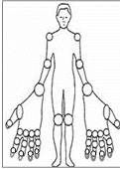
right IP: yes / no
right PIP II: yes / no
right PIP III: yes / no
right PIP IV: yes / no
right PIP V: yes / no
right MCP I: yes / no
right MCP II: yes / no
right MCP III: yes / no
right MCP IV: yes / no
right MCP V: yes / no
right Wrist: yes / no
right Elbow: yes / no
right Shoulder: yes / no
right Knee: yes / no
left IP: yes / no
left PIP II: yes / no
left PIP III: yes / no
left PIP IV: yes / no
left PIP V: yes / no
left MCP I: yes / no
left MCP II: yes / no
left MCP III: yes / no
left MCP IV: yes / no
left MCP V: yes / no
left Wrist: yes / no
left Elbow: yes / no
left Shoulder: yes / no
left Knee: yes / no

Number of tenderness joints: ……
Swollen joints: yes / no
if yes:
right IP: yes / no
right PIP II: yes / no
right PIP III: yes / no
right PIP IV: yes / no
right PIP V: yes / no
right MCP I: yes / no
right MCP II: yes / no
right MCP III: yes / no
right MCP IV: yes / no
right MCP V: yes / no
right Wrist: yes / no
right Elbow: yes / no
right Shoulder: yes / no
right Knee: yes / no
left IP: yes / no
left PIP II: yes / no
left PIP III: yes / no
left PIP IV: yes / no
left PIP V: yes / no
left MCP I: yes / no
left MCP II: yes / no
left MCP III: yes / no
left MCP IV: yes / no
left MCP V: yes / no
left Wrist: yes / no
left Elbow: yes / no
left Shoulder: yes / no
left Knee: yes / no

Number of swollen joints: ……
DAS28 (ESR): ………….
DAS28 (CRP): ………….
SDAI: …………
CDAI: ………….
Contracture: yes / no
if yes, small joint contracture: yes / no
if yes: number of small joints with contracture: ……
large joint contracture*: yes / no
if yes: number of large joints with contracture: ……

Tendon friction rubs: yes / no
*Joint contracture defined as any degree of contracture with the inability to reduce the joint to the anatomically neutral position in the large joints, specifically elbows and knees.

Modified Rodnan skin score: yes / no
if patient has MRSS: face: 0 / 1 / 2 / 3
chest: 0 / 1 / 2 / 3
stomach: 0 / 1 / 2 / 3
right digits: 0 / 1 / 2 / 3
right hand: 0 / 1 / 2 / 3
right lower arm: 0 / 1 / 2 / 3
right upper arm: 0 / 1 / 2 / 3
right thigh: 0 / 1 / 2 / 3
right foot: 0 / 1 / 2 / 3
left digits: 0 / 1 / 2 / 3
left hand: 0 / 1 / 2 / 3
left lower arm: 0 / 1 / 2 / 3
left upper arm: 0 / 1 / 2 / 3
left thigh: 0 / 1 / 2 / 3
left foot: 0 / 1 / 2 / 3
Modified Rodnan skin score: ………..

7. Examinations

7.1 Laboratory / immunserology*
Date of laboratory examination: ………….. (year/month/day)

Erythrocyte sedimentation rate (mm/h)
CRP (mg/l)
Hemoglobin (g/l)
Hematokrit (%)
RDW (%CV)
MCV (fl)
Iron (g/dl)
Leukocyte /ul
Lymphocyte /ul
Platelets /ul
MPV (fl)
Urea (mmol/l)
Creatinine (umol/l)
GFR (ml/min/1.73m2)
Uric acid (umol/l)
LDH (U/l)
Total protein (g/l)
Albumin (g/l)
C3 (g/l)
C4 (g/l)
Creatine-kinase (U/l)
Amilase U/ml
Lipase U/ml
TSH mU/l
HgbA1c (%)
Total cholesterol mmol/l
HDL cholesterol mmol/l
Serum triglycerides mmol/l

Hypocomplementaemia: yes / no
Proteinuria (>300mg/dl): yes / no
Haematuria: yes / no
if yes: renal hematuria / extarenal hematuria
Blood type: A / B / AB / 0
Rh positive / Rh negative
Direct Coombs test: yes / no *
if yes: Date: ………….. (year/month/day)
positive / negative
Cryoglobulinemia: yes / no *
if yes: Date: ………….. (year/month/day)
positive / negative
Serum electrophoresis: yes / no *
if yes: Date: ………….. (year/month/day)
Percent of gamma zone (%): …………
Paraproteins: yes / no
if yes: Percent of paratproteins (%): ………..
Please specify the type of paraproteins: ……………….
Immunoglobulins: yes /no *
if yes: Date: ………….. (year/month/day)
IgG (g/l):………….
IgM (g/l): ………..
IgA (g/l):……….
Total IgE (U/ml):………….
Immunserology: yes / no
if yes: ANA: positive / negative / unknown
if positive or negative:Date: ………….. (year/month/day)
ACA: positive / negative / unknown
if positive or negative:Date: ………….. (year/month/day)
Scl-70: positive / negative / unknown
if positive or negative:Date: ………….. (year/month/day)
RNS pol III: positive / negative / unknown
if positive or negative:Date: ………….. (year/month/day)
anti-Pm-Scl: positive / negative / unknown
if positive or negative:Date: ………….. (year/month/day)
anti-Ku: positive / negative / unknown
if positive or negative:Date: ………….. (year/month/day)
anti-Th/To: positive / negative / unknown
if positive or negative:Date: ………….. (year/month/day)
Fibrillarin: positive / negative / unknown
if positive or negative:Date: ………….. (year/month/day)
Ro-52: positive / negative / unknown
if positive or negative:Date: ………….. (year/month/day)
NOR90: positive / negative / unknown
if positive or negative:Date: ………….. (year/month/day)
Jo-1: positive / negative / unknown
if positive or negative:Date: ………….. (year/month/day)
PL-7: positive / negative / unknown
if positive or negative:Date: ………….. (year/month/day)
PL-12: positive / negative / unknown
if positive or negative:Date: ………….. (year/month/day)
Mi-2: positive / negative / unknown
if positive or negative:Date: ………….. (year/month/day)
SRP: positive / negative / unknown
if positive or negative:Date: ………….. (year/month/day)
RIB: positive / negative / unknown
if positive or negative:Date: ………….. (year/month/day)
AMA-M2 (PDH): positive / negative / unknown
if positive or negative:Date: ………….. (year/month/day)
TIF1y: positive / negative / unknown
if positive or negative:Date: ………….. (year/month/day)
MDA5: positive / negative / unknown
if positive or negative:Date: ………….. (year/month/day)
NXP2: positive / negative / unknown
if positive or negative:Date: ………….. (year/month/day)
SAE1: positive / negative / unknown
if positive or negative:Date: ………….. (year/month/day)
EJ: positive / negative / unknown
if positive or negative:Date: ………….. (year/month/day)
OJ: positive / negative / unknown
if positive or negative:Date: ………….. (year/month/day)
Anti-SSA: positive / negative / unknown
if positive or negative:Date: ………….. (year/month/day)
Anti-SSB: positive / negative / unknown
if positive or negative:Date: ………….. (year/month/day)
Anti-CCP: positive / negative / unknown
if positive or negative:Date: ………….. (year/month/day)
RF: positive / negative / unknown
if positive or negative:Date: ………….. (year/month/day)
TPO positive / negative / unknown
if positive or negative:Date: ………….. (year/month/day)
TG positive / negative / unknown
if positive or negative:Date: ………….. (year/month/day)
ANCA positive / negative / unknown
if positive or negative:Date: ………….. (year/month/day)
dsDNS positive / negative / unknown
if positive or negative:Date: ………….. (year/month/day)
M2 positive / negative / unknown
if positive or negative:Date: ………….. (year/month/day)
LKM1 positive / negative / unknown
if positive or negative:Date: ………….. (year/month/day)
SLA positive / negative / unknown
if positive or negative:Date: ………….. (year/month/day)
SMA positive / negative / unknown
if positive or negative:Date: ………….. (year/month/day)
Sp100 positive / negative / unknown
if positive or negative:Date: ………….. (year/month/day)
Transglutaminase positive / negative / unknown
if positive or negative:Date: ………….. (year/month/day)
Endomysium positive / negative / unknown
if positive or negative:Date: ………….. (year/month/day)
Gliadin positive / negative / unknown
if positive or negative:Date: ………….. (year/month/day)
Any other positive autoantibody: yes / no
if yes: Specify: ………..
Date: ………………(year/month/day)
(többször hozzáadható)
*Results within 3 months of the time of examination may be accepted.

7.2. Imaging techniques
Esophagus X-ray*: yes / no
if yes, Date: ………….. (year/month/day)
Esophageal dysmotility: yes / no
Esophageal stricture: yes / no
Esophageal dilatation: yes / no
*Results within 3 months of the time of examination may be accepted.
Lung X-ray*: yes / no*
if yes, Date: ………….. (year/month/day)
Any fibrosis: yes / no
if yes: Basal fibrosis: yes / no
Diffuse fibrosis: yes / no
*Results within 3 months of the time of examination may be accepted.
Lung HRCT*: yes / no *
if yes, Date: ………….. (year/month/day)
Basal fibrosis: yes / no
Diffuse fibrosis: yes / no
Fibrosis % involvement: <20% / intermediate / >20% / unknown
Any ground glass opacity: yes / no
Any hone combing: yes / no
Any reticular changes: yes / no
Any tractions: yes / no
Any bullae: yes / no
Any lymp node enlargement: yes / no
Any granuloma yes / no
Any air trapping yes / no
Any consolidation yes / no
Any emphysema yes / no
Any pleural effusion yes / no
Specify the pattern of fibrosis: usual interstitial pneumonia (UIP) / non-specific interstitial pneumonia (NSIP) / organising pneumonia (OP) / diffuse alveolar damage (DAD) / respiratory bronchiolitis / desquamative interstitial pneumonia / lymphoid interstitial pneumonia / unknown
Any other suspected symptom on HRCT then fibrosis: yes / no
if yes: infection: yes / no
if yes: bronchoscopy performed: yes / no
if yes: please insert finding: ……
microbiology performed on ……date…
if yes: please insert finding: ……

if yes: malignancy: yes / no
if yes: bronchoscopy performed: yes / no
if yes: please insert finding: ……
microbiology performed: yes / no
if yes: please insert finding: ……
biopsy / histology performed: yes / no
if yes: please insert finding: ……
Insert the complete HRCT finding, please: ………………………………..
*Results within 6 months of the time of examination may be accepted.
Esophagogastroscopy*: yes / no *
if yes, Date: ………….. (year/month/day)
Gastroesophageal reflux: yes / no
Barrett’s oesophagus: yes / no
Oesophagus stricture: yes / no
Other oesophagus abnormality: yes /no
if yes: please define: ………………
Gastric ulcer: yes /no
Vascular ectasia: yes /no
Bleeding / haemorrhage: yes /no
Watermelon stomach: yes / no
Other gastric abnormality: yes / no
if yes: please define: ………………
Duodenal ulcer: yes /no
Celiac disease (scalloped duodenal folds, grooves and fissurations): yes /no
if yes: confirmed by histology: yes / no
*Results within 3 months of the time of examination may be accepted.
Colonoscopy*: yes /no *
if yes, Date: ………….. (year/month/day)
Polyp: yes / no
if yes: Tubular /Villous6 Sessile /Serrated
Diverticulosis: yes /no
Vascular ectasia: yes /no
Hemorrhoides: yes / no
if yes: external /internal
Bleeding / haemorrhage: yes /no
Other colon abnormality: yes /no
if yes: please define: ………….
*Results within 3 months of the time of examination may be accepted.

7.3. Electrocardiography / echocardiography / right heart catheterization / spiroergometry
Electrocardiography*: yes / no *
if yes: Date: ………….. (year/month/day)
Rhythm: Sinus rhythm/ Atrial fibrillation/ Atrial flutter/ Atrial paced/ AV paced / Other
Atrioventricular block: 1st degree/ 2nd degree/ 3rd degree/ no
Bundle branch block: No/ Incomplete RBBB/ RBBB/ Incomplete LBBB/ LBBB/
other
Syncope secondary to conduction blocks: yes / no
Arrythmias requiring therapy: yes / no
Atrial arrhythmias requiring electric cardioversion: yes / no
Syncope secondary to conduction blocks: yes / no
Right axis deviation: yes / no
Ventricular arrhythmias: yes / no
Atrial arrhythmias: yes / no
* Current hospitalization or outpatient visit
Holter-ECG*: yes / no *
if yes, Date: ………….. (year/month/day)
maximum / minimum / average heart rate
Asystolia longer than 2 sec: yes / no
Ischemic period: yes / no
Arrhythmias: yes / no
if yes: ventricular / supraventricular
Total number of premature atrial complexes: ………..
Total premature ventricular complexes: ………..
*Results within 3 months of the time of examination may be accepted.
Pacemaker: yes /no
Pacemaker implanted: yes / no
If Yes: Type: Temporary / permanent
Date:.................................
Reason for pacemaker: Bradyarrhythmia / Treatment of left ventricular outflow tract obstruction / Cardiac resynchronisation therapy / Sudden cardiac death / AV block / Other
Type of pacemaker: AAI / VVI / DDD / ICD / CRT-P / CRT-D / CCM
Echocardiography*: yes / no
if yes: Date: ………….. (year/month/day)
Pericardial effusion: yes / no
if yes, small / moderate / large **
Calculated PAPsys (mmHg): …………
Pulmonary hypertension****: yes / no
Left ventricular ejection fraction (%): …………
Tricuspid Annular Plane Systolic Excursion (TAPSE) (mm): ……
Severe right ventricular dysfunction (TAPSE≤14): yes / no
Diastolic disorder***: yes / no
E (cm/sec): ………….
A (cm/sec): ………….
e’ (average of septal and lateral) (cm/sec):
E/e’<8 / 8<E/e’<14 / E/e’>14
Prosthetic valve: yes / no
if yes: mitral / aortic / tricuspid / pulmonary
Left ventricular hypertrophy*****: yes / no
Septal thickness (cm):…………..
Posterior wall thickness (cm):……………
Left ventricular enddiastolic diameter (cm):……………..
Calculated heart weight (g):………………………
Heart weight/body surface area:…………… (g/m2)
Any enlarged chamber: yes / no
if yes:
left ventricle: yes / no
left atrium: yes / no
right ventricle: yes / no
left atrium: yes / no
Significant heart valve disease: yes / no
Any sign of left heart dysfunction/failure: ………..yes / no
Insert the complete echocardiography finding, please:…………..
*Results within 3 months of the time of examination may be accepted.
**small: localized or < 10 mm
moderate: 10-20 mm
large: > 20 mm
***: impaired relaxation or pseudonormal mitral inflow or restrictive mitral inflow
****: Calculated PAPsys (mmHhmm) ≥ 40

Right heart catheterization: yes / no *
if yes:
date of catheterization:………………… (year/month/day)
Pulmonary hypertension: yes / no
Pulmonary arterial systolic pressure (mmHg): …………
PAP distolic (mmHg): …………
PAP mean (mmHg): …………
Pulmonary capillary wedge pressure (PCWP) (mmHg): …………
Pulmonary arterial hypertension if PAP mean ≥ 25 and PCWP ≤ 15 Hgmm
Pulmonary resistance (dyn/s/cm⁻⁵)*: ………..
Cardiac index (l/min/m²): ………….
Cardiac output (l/min): ……….
Vasodilatator responder: yes / no

Coronarography: yes / no *
if yes:
Date: ………….. (year/month/day)
Significant stenosis: yes / no
if yes: LM / LAD / LCX / RCA
Stent implantation: yes / no
if yes: number of stents: 1 / 2 / 3
Indication for surgery intervention: yes / no

Exercise electrocardiogram: yes / no *
if yes: Date: ………….. (year/month/day)
Ischemic event: yes / no
Carotid ultrasonography: yes / no *
if yes: Date: ………….. (year/month/day)
Atherosclerotic plaque: yes / no
Significant stenosis: yes /no

7.4 Pulmonary function test
Pulmonary function test*: yes / no
if yes, Date: ………….. (year/month/day)
FVC (%): …………
FEV1 (%): …………
VC (%): ………..
TLC (%): ……….
FRC (%): ………..
TLCO (%): …………
KCO (%): ………..
RV (%):………….
R (kPa/L/s):……………
FEV1/FVC: …………
*Results within 3 months of the time of examination may be accepted.

7.5 Capillary microscopy
Capillary microscopy*: yes / no
if yes: Date: ………….. (year/month/day)
SSc pattern: yes / no
if yes: Pattern: early / active / late
Decreased capillary density**: yes / no
*Results within 3 months of the time of examination may be accepted.
**Decreased capillary density: less than 7 loops/mm.

7.6 Bronchoalveolar lavage*: yes / no *
if yes: Date: ………….. (year/month/day)
Total volume (ml): …………
Cell count /ml: …………….
Macrophages (%): ………..
Lymphocytes (%): …………
Neutrophils (%): ………
Eosinophils (%): ………..
Basophils (%): ………..
Plasma cells (%): ……….
Immunohistochemistry or flow cytometry: yes / no
if yes: Add the complete findings:……………………
Microbiology: yes / no
if yes: Add the complete findings:……………………
*Results within 3 months of the time of examination may be accepted.

8. Scores
Damage score: (calculated from previously given data):……………………..
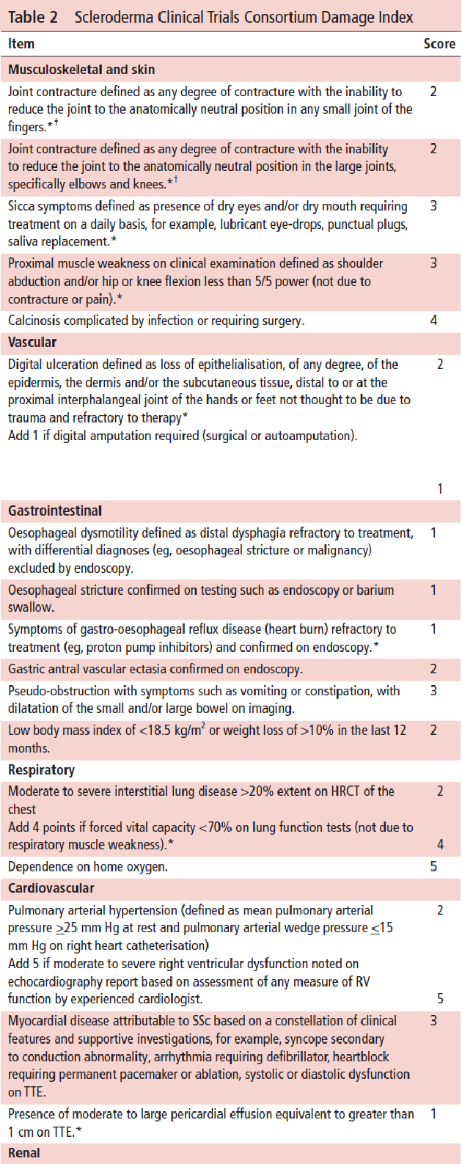
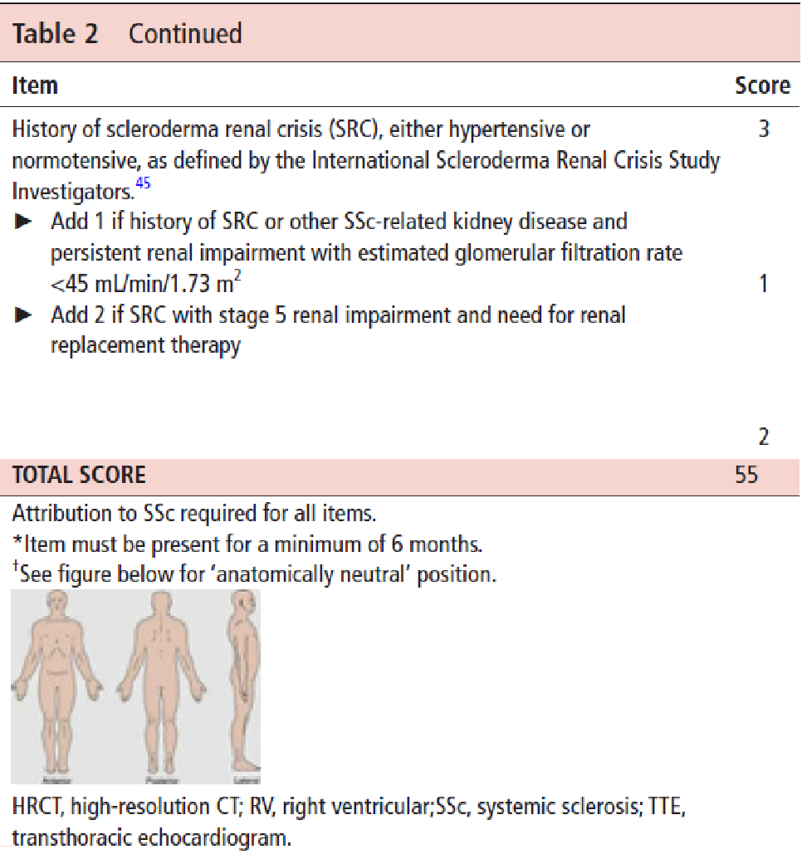
Modified activity Score (calculated from previous data)
EScSG activity score (calculated from previous data)
New Activity score (calculated from previous data)
12 point activity score (calculated from previous data)

CRISS: (calculated from previously given data)

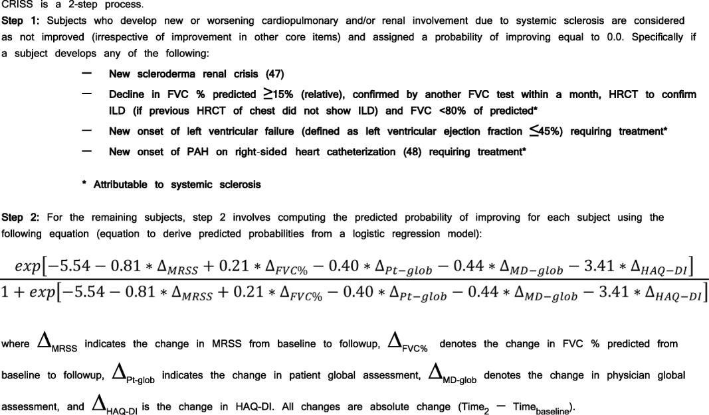

9. Therapy
Prednisolone /methylprednisolone: yes / no
if yes: dose (mg/day): ………….
start date: ………….. (year/month/day)
stop date: ………….. (year/month/day)
NSAID: yes / no
if yes: occasionally / regularly
daily: yes / no
weekly : yes / no
Cyclophosphamide: yes / no
if yes: dose (mg/administration): ………….
start date: ………….. (year/month/day)
stop date: ………….. (year/month/day)
route of administration: oral / intravenous
Methotrexate: yes / no
if yes: dose (mg/week): ………….
start date: ………….. (year/month/day)
stop date: ………….. (year/month/day)
route of administration: oral / subcutaneous
Azathioprine: yes / no
if yes: dose (mg/day): ………….
start date: ………….. (year/month/day)
stop date: ………….. (year/month/day)
Mycophenolate mofetil: yes / no
if yes: dose (g/day): ………….
start date: ………….. (year/month/day)
stop date: ………….. (year/month/day)
Rituximab: yes / no
Tnf alpha antagonist: yes / no
Autologus stem cell transplantation: yes / no
Immunglobulins: yes / no
Tocilizumab: yes / no
Abatacept: yes / no
JAK inhibitors: yes / no
Bosentan: yes / no
Ambrisentan: yes / no
Macitentan: yes / no
Sildenafil: yes / no
Vardenafil: yes / no
Tadalafil: yes / no
Riociguat: yes / no
Prostanoids: yes / no
Ca channel blockers: yes / no
Pentoxyphyllin: yes / no
ACE inhibitors: yes / no
Angiotensin II receptor blockers (ARBs): yes / no
Proton pump inhibitors: yes / no
H2 receptor blockers: yes / no
Prokinetics: yes / no
Diuretics: yes / no
Anti-platelet agent: yes / no
Pirfenidon: yes / no
Nintedanib: yes / no
Oxygen supply: yes / no
Vitamin-D: yes / no
Calcium: yes / no
Thyroid hormone substitution: yes /no
Bronchodilator treatment: yes / no
if yes: Adrenergic inhalative agents: yes / no
if yes: alpha and beta adrenergic receptor agonists / non selective beta adrenergic receptor agonists / selective beta-2 adrenergic receptor agonists / combination of adrenergic agents / combination of adrenergic with corticosteroids or others except anticholinergic agents / combination of adrenergic anticholinergic agents
Other inhalative agents: yes / no
if yes: glucocorticoids / anticholinergic agents / anti-allergic agents other than corticosteroids (chromoglic acid or nedocromil)
Systemic adrenergic agents: yes / no
if yes: alpha and beta adrenergic receptor agonists / non selective beta adrenergic receptor agonists / selective beta-2 adrenergic receptor agonists
Other systemic agents: yes / no
if yes: xantins / xantins with adrenergic agents / leucotriene-receptor antagonists / other agents
Other, specify please:…………………………..

9. Epicrisis
Multidisciplinary (ILD) team discussion: yes / no
Who was present: Surgeon / Internist / Oncologist /Pathologist / Radiologist/Cardiologist/Pulmonologist
Type of discharge
To home/To another inpatient ward/ The patient died/ other
Planned next intervention: date (dd/mm/yyyy): ………./………./……….
Comments:.................

