Endoscopic Ultrasonography

Date of EUS (dd/mm/yyyy): ………./………./……….

Procedure starting time (hh:mm): ………. : ……….

Procedure ending time (hh:mm): ………. : ……….

Visualization of the pancreas
- Good, complete (head, uncinate proc., body, tail, duct)
- Partially, incomplete (head, uncinate proc., body, tail, duct)
- Poor, non-diagnostic (head, uncinate proc., body, tail, duct)

Homogenity
- Homogeneous
- Inhomogeneous, includes area(s) of low echogenicity
- Inhomogeneous, includes calcifications

Acute pancreatitis: Yes or No or Uncertain
Chronic pancreatitis: Yes or No or Uncertain
Dilated pancreatic duct (PD): Yes or No or Uncertain
Diameter (head-body-tail): ……….-……….-………. mm
If dilated: Diffuse Segmental (head body tail)
Pancreatic duct stone: Yes or No or Uncertain
Size: ……..mm Number: ………..
Pancreatic cystic neoplasms: Yes or No or Uncertain
Cyst Number: ……….
Unifocal or Multifocal
Size (biggest): ………. mm
Location of dominant cyst: HoP or BoP or ToP
Multilobularity: Yes or No or Uncertain
Number of lobules: .........
Type of multilobularity
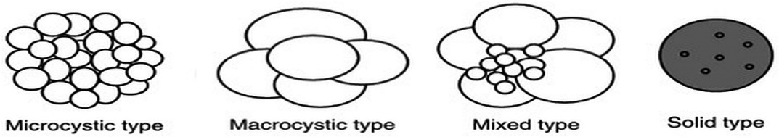
Microcystic Macrocystic Mixed Solid

Septums: Yes or No or Uncertain
Thickened or Thin septation
Solid component/nodule: Yes or No or Uncertain
Anechoic Hypoechoic Hyperechoic
Nodule size: ………. mm
Thickened cyst wall: Yes or No or Uncertain
If Yes: ………. mm
Central fibrous scar: Yes or No or Uncertain
Central stellate pattern: Yes or No or Uncertain
Calcifications: Yes or No or Uncertain
If Yes: Peripheral Central
PCN fluid content:
Anechoic Hypoechoic Hyperechoic
Homogeneous Inhomogeneous
PCN – PD communication: Yes or No or Uncertain
Vascular involvement: Yes or No or Uncertain
Level of involvement: Access Invasion
SMA SMV SA SV CT PV
Contrast enhanced EUS performed: Yes or No
Contrast enhancement: Yes or No or Uncertain
If Yes: Peripheral Central
Elastography
Strain ratio: ……….
FNA: Yes or No
Needle type (manufacturer): ……………………………….
Needle size: ……….
Passage number: ……….
Aspiration technique:
- Slow pull
- Suction
Vacuum volume: ……….ml
Obtained volume: ……….ml
String sign: Yes or No
CEA(ng/ml): ……….
Amylase (U/l): ……….
Cytopathology diagnosis: …………………………………………..
Antibiotic prophylaxis: Before or After
Intravenosus or Oral
Type of antibiotic:……………………….
Adverse Events: Bleeding Perforation Infection
Lymphadenopathy: Yes or No or Uncertain
Visible lymphnode  Location | Peripancreatic | Mesenteric | Periaortic
 | Yes or No | Yes or No | Yes or No
Number
Size (biggest) | mm | mm | mm
Previous cholecystectomy: Yes or No
Gallbladder inflammation: Yes or No or Uncertain
Gallbladder stone: Yes or No or Uncertain
If Yes, number and size (biggest): ………. ……….mm
Gallbladder polyp: Yes or No or Uncertain
Biggest diameter: ………. mm
Dilated common bile duct: Yes or No or Uncertain
Diameter: ………. mm
Thickened CBD wall: Yes or No or Uncertain
Intrahepatic bile ducts dilated: Yes or No or Uncertain

Pictures of PCN (with the greatest diameter/with the most worrisome features and without flow and any measure tools):
Video of PCN

