MRI/MRCP

Date (dd/mm/yyyy): ………./………./……….

Gallbladder inflammation: Yes or No or Uncertain

Gallbladder stone: Yes or No or Uncertain
If Yes, number and size (biggest): ………. ……….mm

Gallbladder polyp: Yes or No or Uncertain
Biggest diameter: ……….mm

Dilated common bile duct: Yes or No or Uncertain
Diameter: ……….mm

Dilated intrahepatic bile ducts: Yes or No or Uncertain

Peripancreatic fluid:. Yes or No or Uncertain

Edematous pancreas: Yes or No or Uncertain

Enlarged pancreas: Yes or No or Uncertain
If yes: Diffuse Segmental (head body tail)

Atrophic pancreas: Yes or No or Uncertain

Irregular pancreas contours: Yes or No or Uncertain

Blurred pancreas contours: Yes or No or Uncertain

Acute pancreatitis: Yes or No or Uncertain

Chronic pancreatitis: Yes or No or Uncertain

Dilated pancreatic duct (PD): Yes or No or Uncertain
Diameter (head-body-tail): ……….-……….-………. mm
If dilated: Diffuse Segmental (head body tail)

Pancreatic duct stone: Yes or No or Uncertain
Size: ……..mm Number: ………..

Pancreatic cystic neoplasms: Yes or No or Uncertain
Cyst Number: ……….
Unifocal or Multifocal
Size (biggest): ………. mm
Location of dominant cyst: HoP or BoP or ToP
Multilobularity: Yes or No or Uncertain
Number of lobules: ……….
Type of multilobularity
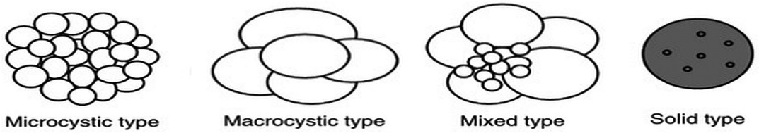
Microcystic Macrocystic Mixed Solid

Septums: Yes or No or Uncertain
Thickened or Thin septation
Hypointense: T1 T2
Hyperintense: T1 T2
Solid component/nodule: Yes or No or Uncertain
Nodule size: ………. mm
Hypointense: T1 T2
Hyperintense: T1 T2
Thickened cyst wall: Yes or No or Uncertain
If Yes: ………. mm
Hypointense: T1 T2
Hyperintense: T1 T2
Central fibrous scar: Yes or No or Uncertain
Hypointense: T1 T2
Hyperintense: T1 T2
Central stellate pattern: Yes or No or Uncertain
Calcifications: Yes or No or Uncertain
If Yes: Peripheral Central
PCN fluid content
Hypointense: T1 T2
Hyperintense: T1 T2
PCN – PD communication: Yes or No or Uncertain
If Yes: side-branch main branch
Vascular involvement: Yes or No or Uncertain
Levels of involvement: Access Invasion
SMA SMV SA SV CT PV
Lymphadenopathy: Yes or No or Uncertain
Visible lymphnode  Location | Peripancreatic | Mesenteric | Periaortic
 | Yes or No | Yes or No | Yes or No
Number
Size (biggest) | mm | mm | mm

Synchron tumor: Yes or No
If Yes: …………………………………………………………………

Anything else worth to share:
………………………………………………………………………………………………………………………………………………………………………………………………………………………………………………………………………………………………………………………………

