REGISTRY OF PANCREATIC CANCER
USER’S GUIDE

Contents
Prologue 2
Online interface: 3
1. Personal details: 5
2. Details of the medical history: 5
Alcohol consumption: 5
Smoking: 6
Drug abuse: 6
Exposure to chemicals: 6
Infectious disease: 7
Any disease of the pancreas: 7
Pancreas disorders in family history: 8
Congenital pancreas malformations: 9
Other chronic diseases: 9
Medications taken regularly: 9
Diet: 9
BMI: 9
Other information: 9
3. Symtoms: 10
4. Patient related data: 11
5. Tumor related data: (TMN) 11
Pathological stage: 13
Immunohistochemistry: 14
Endoscopic intervention: 14
Radiological intervention: 15
6. Oncological therapy: 15
7. Supportive treatment: 15
8. Final report: 16

Prologue
The Registry of Pancreas two main aims:
- detailed summary of patients, specific diseases, prospective clinical research data, performance of statistic analysis
- storage of patient’s biological (blood or tissue) sample, genetic studies and another examination from patient’s samples

Uploading ways:
- online form for direct data upload
- printed form from: http://opr2.pancreas.hu/en

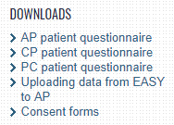

Data security
During upload, increased attention should be given to the security of personal data, with special regards to the covering and deletion of personal data (name, date of birth, social security number, etc.) found in the headers, footers, and other parts of attached documents, diagnostic reports, final reports, radiograms, and other images and documents. The filtering of incidental mistakes stemming from the abovementioned issue is also essential during monitoring (2nd, 3rd, and 4th check-marks).

Online interface:
Log in to http://opr2.pancreas.hu/en and find Registry of Chronic Pancreatitis on the left.
If you click the „PC” icon you can upload new cases to the registry. The icon next to it directs you to previously uploaded patients.
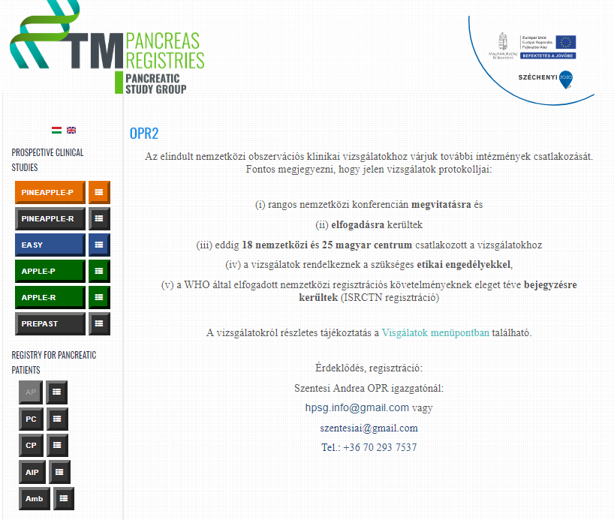

In this section, you should fill the personal details, date of interview, reason of admission (acut or planned), institute, doctor code, patient’s blood sample code, date of blood sampling.
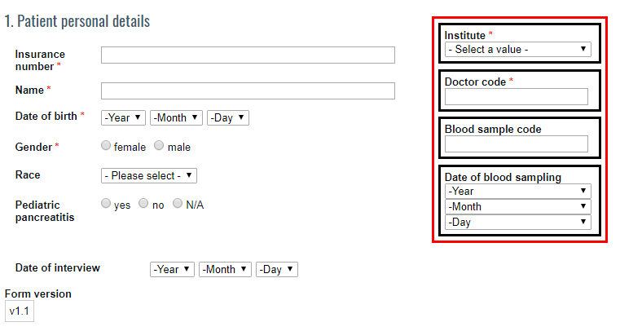

1. Personal details:
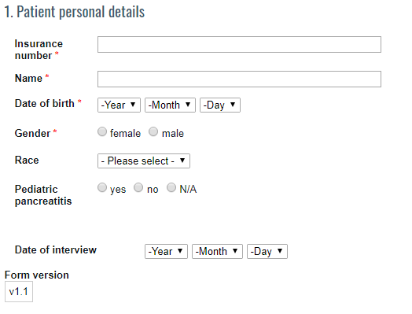

You have to add the patient’s insurance number, name, date of birth and gender.

2. Details of the medical history:
The upload is based on the comleted printed PC questionnaire. If you have missing information, you may use the e-Medsolution System. Please mark ’no data’ if you don’t have the required information.

Alcohol consumption:
- If the patient is a regular drinker: please add frequency, amount, number of years and the amount of alcohol consumed in the last two weeks. Please highlight the amounts in grams.
- If the patient is not a regular drinker: please mark previous alcohol consumption habits.
- No data (N/A): if you don’t have the required information
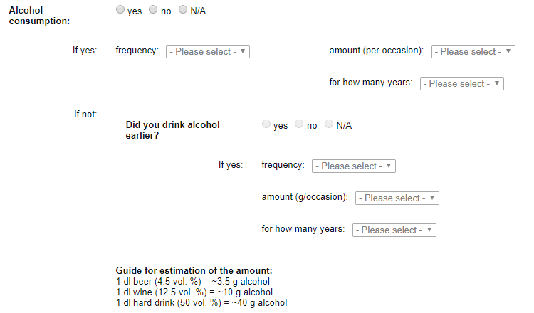

Smoking:
- If the patient is a regular smoker: please add the amount of cigarettes/day, number of years
- If the patient is not a regular smoker: please mark previous smoking habits
- No data (N/A): if you don’t have the required information

Drug abuse:
- If yes: Please mark the type of drug, amount and number of years
- No
- No data (N/A): if you don’t have the required information

Exposure to chemicals:
You should mark every harmful chemical, which the patient has encountered.
- If yes: Please mark the type of harmful chemicals and number of years
- No
- No data (N/A): if you don’t have the required information

Infectious disease:
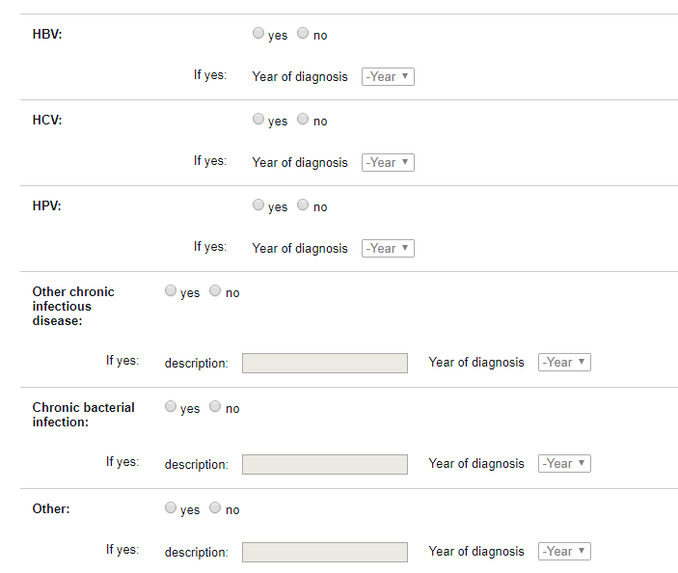
If the patient has one of these diseases, please mark it.
The patient’s anamnesis can help you.

Any disease of the pancreas:
Please mark the earlier pancreas diseases.
The patient’s anamnesis can help you.
- If the patient had Acute pancreatitis/chronic/autoimmune pancreatitis/pancreatic cancer in the history, please mark in the proper field.
- No data (N/A): if you don’t have the required information
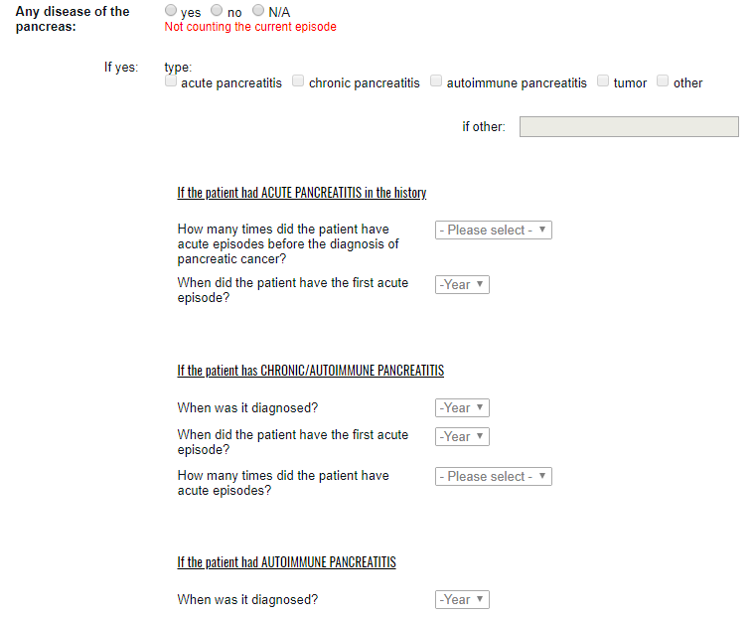

Pancreas disorders in family history:
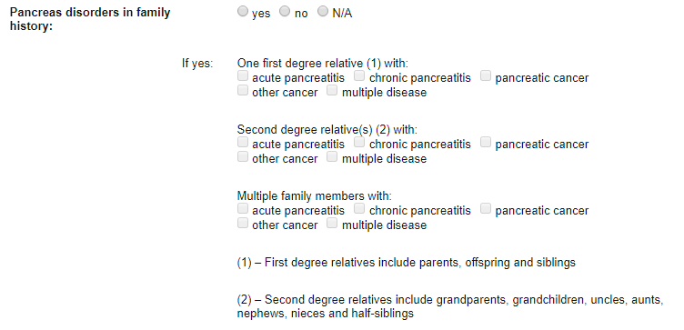
- If there was pancreas disease in the patient’s family, please mark what degree relative of the patient had which type of pancreas disease.
- No data (N/A): if you don’t have the required information

Congenital pancreas malformations:
- If the patient has any congenital pancreas malformation, please highlight it in the corresponding field.
- No data (N/A): if you don’t have the required information

Other chronic diseases:
- Please list every chronic disease that the patients had been diagnosed before this observation..
- No data (N/A): if you don’t have the required information
The patient’s anamnesis can help you.

Medications taken regularly:
Please list every medication taken regularly.
The patient’s anamnesis can help you.
Please note that medications applied during the current observation and prescribed for further therapy should not be highlighted here.
No data (N/A): if you don’t have the required information

Diet:
- If the patient was on a diet earlier please highlight it
- No data (N/A): if you don’t have the required information

BMI:
The system automatically calculates BMI after recording weight and height. The weight should be the value before pancreas tumor. It’s a good idea to ask the patient about his/her earlier weight. There will be a question about recent weight loss later. Based on this values you can calculate the weight before pancreas tumor without asking embarrassing questions.

Other information:
Please list every other information that is important.

3. Symtoms:
Start date of symptoms.
If the patient had abdominal pain at the date of diagnosis, please describe it as per below:
    - start
    - type of pain
    - intensity of the pain
    - location of the pain: please specify with the help of the numbers

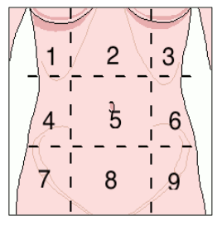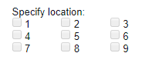
Abdominal pain generally
Nausea
Vomiting: please highlight how many times per day and contents of cast: unknown, watery, containing food residue, bloody, containing bile.
Recurrent fever
Appetite
Weight loss
Stool: Please mark based on the period before the symptons.
Jaundice

4. Patient related data:
There might be examinations (e.g. MR) in this section that the patient didn’t have. In this case, please leave those fields empty.
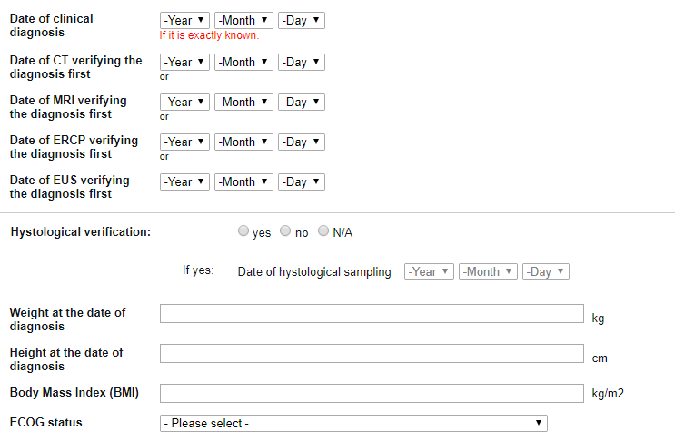
ECOG status by oncoteam.

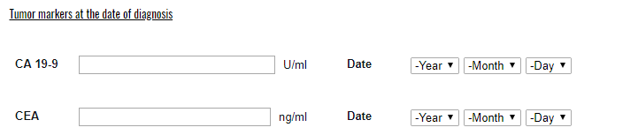

5. Tumor related data: (TMN)
T = Primary tumor:
TX: primary tumor cannot be assessed
T0: no evidence of primary tumor
Tis: carcinoma in situ
T1: tumor limited to the pancreas, 2 cm or less in greatest dimension
T2: tumor limited to the pancreas, more than 2 cm in greatest dimension
T3: tumor extends beyond the pancreas but without involvement of the celiac
axis or the superior mesenteric artery
T4: tumor involves the celiac axis or the superior mesenteric artery, unresectable
primary tumor
N = Reginonal lymph nodes:
NX: reginal lymph nodes cannot be assessed
N0: n regional lymph node metastasis
N1: regional lymph node metastasis
M = distant metastasis:
M0: no destant metastasis
M1: distant metastasis
Tumor location: head, body or tail

If the pateint had hystological vertification please mark the below.
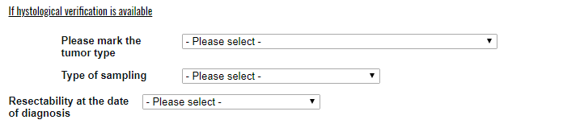

If the patient had surgical intervention please mark the date and type of it.
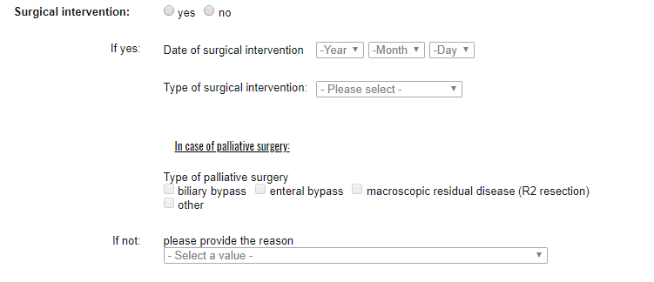
In case of palliative surgery please mark the type of it.
If the patient didn’t have surgery please mark the reason (e.g.: non resectable, comorbidities, poor performance status or other reason).

Pathological stage:
If the patient didn’t have hystological vertification please mark N/A in this section. In other cases, please mark it at the proper parameters.
pT: primary tumor (pTx, pT0, PTis, pT1, pT2, pT3, pT4 or N/A)
pN: reginonal lymph nodes (pNx, pN0, pN1 or N/A)
Number of positive lymph nodes:
e.g.
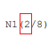
Number of lymph nodes removed:
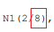
Histological grade: (Grade 1, Grade 2, Grade 3, Grade 4 or N/A)
Margin status: (R0, R1, not evaluable or N/A)
Perineural invasion and vascular invasion: by the hystological vertification.
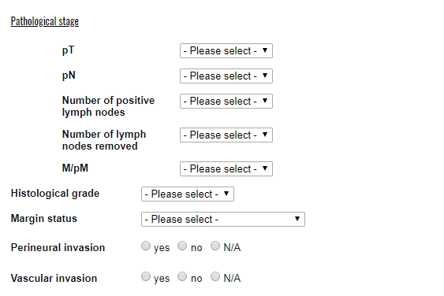

Immunohistochemistry:
- N/A: if you don’t have the required information.
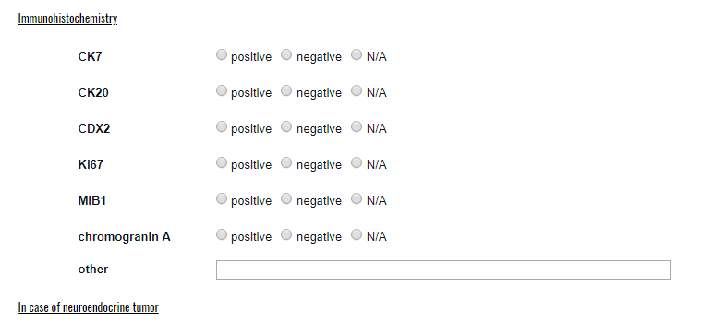

Endoscopic intervention:
If the patient has endoscopic intervention and biliary stent placement, please add the material (metal or plastic).

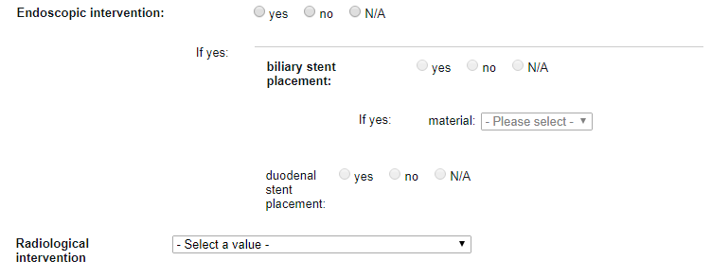
Radiological intervention: e.g.: percutaneous transhepatic biliary drenage (PTBD)
Please mark if the patient didn’t have radiological intervention.

6. Oncological therapy:
If the patient has adenocarcinoma, please choose section „a” and please mark:
- Radiotherapy
- Chemotherapy
- Molecular targeted agent

If the patient has neuroendocrin tumor, please choose section „b” and mark the below:
- Somatostatin analogue treatment
- Interferon
- Chemotherapy
- Molecular targeted agent
- Peptide receptor radionuclid therapy

7. Supportive treatment:
Pain management:
minor analgesic
major analgesic
Pancreas enzym substitution
Nutrition supplements

Participation in clinical studies:
Please mark if the patient participated in other clinical studies.
Please add the name of the study and other parameters.

8. Final report:
Please upload the patient’s final report without the personal details.
Please add the file to the page and click here:

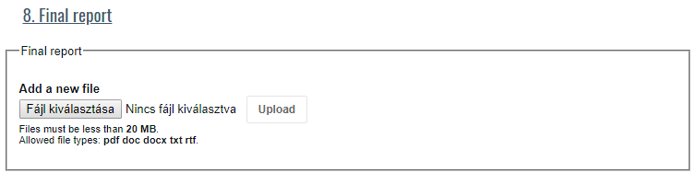
Into the „Notes” section please upload every oncological therapy, imaging and hystological outcome anonymously.

Finally, you can save your work as draft or finalize it.

