SEMMELWEIS EGYETEM
DOKTORI ISKOLA

Ph.D. értekezések

3313.

SZIGETVÁRY CSENGE ERZSÉBET

Transzlációs és klinikai farmakológia
című program

Programvezető: Dr. Ferdinandy Péter, egyetemi tanár
Témavezetők: Dr. Molnár Zsolt, egyetemi tanár és
Dr. Ruszkai Zoltán, egyetemi adjunktus
Advanced strategies in improving outcomes during mechanical ventilation
Ph.D. Thesis

Csenge Erzsébet Szigetváry, M.D.
Translational Medicine Program
Pharmaceutical Sciences and Health Technologies Division
SEMMELWEIS UNIVERSITY


Supervisor: Prof. Zsolt Molnár, M.D., Ph.D., EDAIC
Zoltán Ruszkai, M.D., Ph.D.
Official reviewers: Péter Kanizsai, M.D., Ph.D.
Octavian Andronic, M.D., Ph.D.

Head of the Complex
Examination Committee: Prof. Endre Zima, M.D., Ph.D.
Members of the Complex
Examination Committee: Prof. Mitja Lainscak M.D., Ph.D.
Kinga Farkas, M.D., Ph.D.
Péter Fehérvári D.Sc., Ph.D.

Budapest
2025

“Ha percnyi léted súlyától legörnyedsz,
Emel majd a végetlen érzete.
S ha ennek elragadna büszkesége,
Fog korlátozni az arasznyi lét.”
MADÁCH IMRE

TABLE OF CONTENT
1. LIST OF ABBREVIATIONS 5
2. STUDENT PROFILE 7
2.1. Vision and mission statement, specific goals 7
2.2. Scientometrics 7
2.3. Future plans 7
3. SUMMARY OF THE THESIS 8
4. GRAPHICAL ABSTRACTS 9
5. INTRODUCTION 10
5.1. Overview of Study I. – Individualized vs. fixed intraoperative PEEP settings 10
5.2. Overview of Study II. – Hemoadsorption as Adjuvant Therapy in ARDS 11
6. OBJECTIVES 12
6.1. Study I. – Individualized vs. fixed intraoperative PEEP settings 12
6.2. Study II. – Hemoadsorption as Adjuvant Therapy in ARDS 12
7. METHODS 13
7.1. Study I. – Individualized vs. fixed intraoperative PEEP settings 13
7.1.1. Systematic search, eligibility 13
7.1.2. Selection, data synthesis and statistical analysis 13
7.1.3. Quality of evidence and risk of bias assessment 14
7.2. Study II. – Hemoadsorption as Adjuvant Therapy in ARDS 14
7.2.1. Systematic search, eligibility 14
7.2.2. Selection, data syntesis and statistical analysis 14
7.2.3. Quality of evidence and risk of bias assessment 15
8. RESULTS 16
8.1. Study I. – Individualized vs. fixed intraoperative PEEP settings 16
8.1.1. Systematic search and selection 16
8.1.2. Baseline characteristics 17
8.1.3. Primary outcome 18
8.1.4. Secondary outcomes 19
8.1.5. Risk of bias and quality of evidence assessment 31
8.2. Study II. – Hemoadsorption as Adjuvant Therapy in ARDS 37
8.2.1. Systematic search and selection 37
8.2.2. Baseline characteristics -táblázat, hivatkozás 37
8.2.3. Primary outcome 40
8.2.4. Secondary outcomes 41
8.2.5. Risk of bias and quality of evidence assessment 44
9. DISCUSSION 47
9.1. Study I. – Individualized vs. fixed intraoperative PEEP settings 47
9.1.1. Positive End-Expiratory Pressure settings 47
9.1.2. Postoperative Pulmonary Complications and Oxygenation 47
9.1.3. Hemodynamics 48
9.1.4. Respiratory Mechanics 49
9.1.5. Other Secondary Outcomes 50
9.2. Study II. – Hemoadsorption as Adjuvant Therapy in ARDS 51
9.2.1. Hemoadsorption as an Adjunctive Therapy 51
9.2.2. Inflammatory Response Modulation 51
9.2.3. Effects on Oxygenation 52
9.2.4. Hemoadsorption in COVID-19 Patients 53
9.2.5. Procedure Safety and Mortality 53
9.3. Strengths (including all studies) 53
9.4. Limitations 53
10. CONCLUSIONS 55
10.1. Study I. – Individualized vs. fixed intraoperative PEEP settings 55
10.2. Study II. – Hemoadsorption as Adjuvant Therapy in ARDS 55
11. IMPLEMENTATION FOR PRACTICE 56
12. IMPLEMENTATION FOR RESEARCH 57
13. Implementation for Policymakers 58
14. FUTURE PERSPECTIVES 59
15. REFERENCES 60
16. BIBLIOGRAPHY 73
16.1. Publications related to the thesis 73
16.2. Publications not related to the thesis 73
17. ACKNOWLEDGEMENTS 75

1. LIST OF ABBREVIATIONS
ARDS acute respiratory distress syndrome
ARMs alveolar recruitment maneuvers
Cdyn dynamic compliance
CG control group
CI confidence interval
CRP C-reactive protein
Cstat static compliance
CT computed tomography
dP driving pressure
ECMO extracorporeal membrane oxygenation
EIT electrical impedance tomography
HA hemoadsorption
IBW ideal body weight
ICU intensive care unit
IL-6 interleukin 6
IL-8 interleukin 8
LOS length of stay
MD mean difference
NE norepinephrine
OR odds ratio
PCT procalcitonin
PEEP positive end-expiratory pressure
Peso esophageal pressure
PPC postoperative pulmonary complication
Pplat plateau pressure
Ptp transpulmonary pressure
RCT randomized controlled trial
RR risk ratio
SD standard deviation
Se Lac serum lactate level
SG study group
TNF-α tumor necrosis factor alfa
US ultrasound
VT tidal volume
ZEEP zero end-expiratory pressure

2. STUDENT PROFILE

2.1. Vision and mission statement, specific goals
The objective of my PhD work was to deepen my knowledge in scientific methodology and expand understanding in advanced strategies during mechanical ventilation, a key aspect of my field of residency, anesthesiology and intensive therapy. To achieve my goals, I have conducted two systematic reviews and meta-analyses to summarize and evaluate the current evidence in the literature on two important topics.

2.2. Scientometrics
Number of all publications | 5
Cumulative IF | 19.9
AvIF/publication: | 3.98
Ranking (SciMago) | D1: -, Q1: 5, Q2: -
Number of publications related to the subject of the thesis | 2
Cumulative IF | 6.8
AvIF/publication | 3.4
Ranking (SciMago) | D1: -, Q1: 2, Q2: -
Number of citations on Google Scholar | 60
Number of citations on MTMT (independent) | 36
H-index | 2

2.3. Future plans
My future plans include deepening my professional and practical knowledge in anesthesiology and intensive care. I am grateful to my mentors for equipping me with a valuable tool that supports staying up-to-date and embracing opportunities for growth. They have taught me the importance of reading scientific literature and developing a more critical mindset. I am also looking forward to participate in and lead future research projects both in perioperative and intensive care medicine.

3. SUMMARY OF THE THESIS
The aim of this thesis is to present advanced strategies designed to improve patient health outcomes in both anesthesia and intensive care via two relatively novel approaches to treatment.
Applying positive end-expiratory pressure (PEEP) is already known to be a cornerstone of lung protective ventilation, however average settings may not fit everyone [1–6].This systematic review and meta-analysis focused on the effects of individualized PEEP (positive end-expiratory pressure) settings compared to fixed PEEP values during abdominal surgery. Our findings demonstrated that individualized PEEP led to better perioperative outcomes, including fewer postoperative pulmonary complications (PPCs), improved oxygenation (PaO₂/FiO₂), higher PEEP levels, and enhanced respiratory mechanics. However, there was a tendency toward a higher vasopressor requirement with individualized PEEP. These findings highlight the potential benefits of individualized PEEP in improving respiratory outcomes while suggesting the need for further research to evaluate its hemodynamic effects comprehensively.
The second study addressed the emerging role of hemoadsorption (HA) therapy as an adjunctive treatment for acute respiratory distress syndrome (ARDS), a condition often associated with hyperinflammation[7]. This systematic review intended to analyze the effects of HA in ARDS. While the available studies were limited in number and quality, our results revealed promising outcomes, including improved oxygenation, attenuation of the inflammatory response, and reduced vasopressor requirements after HA. Importantly, no serious device-related adverse events were reported. These findings provide a foundation for future high-quality clinical trials to better define the role of HA in ARDS management.
In summary, both studies contribute to advancing our understanding of individualized strategies and adjunctive therapies in mechanically ventilated patients. These findings not only synthesize the current evidence but also provide valuable insights for designing future studies to optimize patient outcomes in anesthesiology and intensive therapy.

4. GRAPHICAL ABSTRACTS
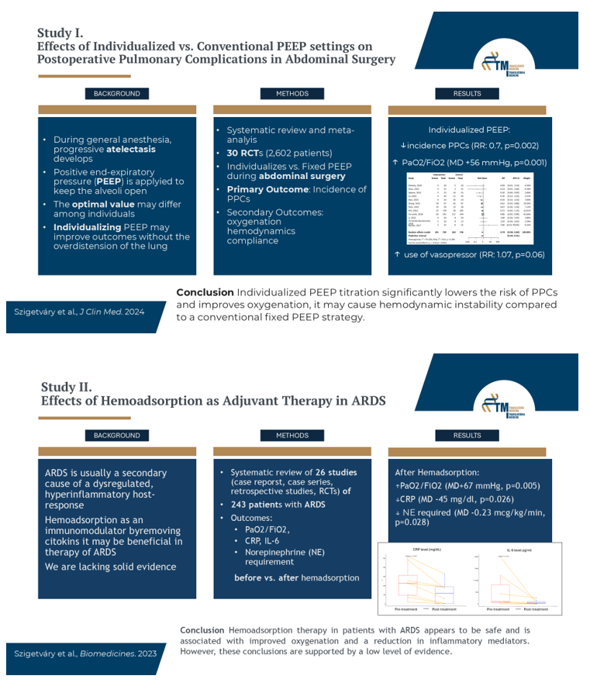
Figure 1- Graphical abstracts of the studies included in the thesis

5. INTRODUCTION

5.1. Overview of Study I. – Individualized vs. fixed intraoperative PEEP settings
During general anesthesia, functional residual capacity reduces, progressive atelectasis develops in dependent areas of the lungs[8]. At the same time, due to atelectasis, inspiratory pressures may cause excessive overdistention in the aerated parts of the lungs [9]. Other perioperative factors, e.g. pain in general can impair respiration, as it limits respiratory muscle function for secretion elimination and adequate ventilation. All these can lead to increased morbidity and mortality, especially in older patients with comorbidities, but harm otherwise healthy individuals too [10]. Postoperative pulmonary complications (PPCs) are among the most frequent perioperative complications, with prevalence estimates ranging from 9% to 40%, depending on the definition used, on patient and surgical factors [11]. To enhance outcome measurement in clinical trials, a consensus definition of PPCs was established. It encompasses respiratory conditions with common pathophysiological mechanisms—pulmonary collapse and airway contamination—such as atelectasis, pneumonia, ARDS, and aspiration [11].
There are existing evidence that following a perioperative lung-protective ventilation approach may reduce the incidence of PPCs [10,12]. In addition to low tidal volumes (VT = 6–8 mL/kg of ideal body weight), applying PEEP is an important component of lung-protective ventilation strategies during general anesthesia and in the management of ARDS [1–6]. Given that an optimal PEEP has yet to be clearly defined, individualized ventilation strategies have recently gained attention, focusing on setting PEEP based on patient-specific needs and optimizing parameters like driving pressure, respiratory compliance, or transpulmonary pressure to reduce both atelectrauma and barotrauma [1,13–15]. However, whether individualized PEEP titration reduces the incidence of PPCs compared with conventional settings remains uncertain, and more robust evidence is needed [14,16,17]. Therefore, conducting a systematic review and meta-analysis of the currently available randomized controlled trials in this field may provide firmer conclusions.

5.2. Overview of Study II. – Hemoadsorption as Adjuvant Therapy in ARDS
Acute respiratory distress syndrome (ARDS), first described in 1967, is a clinical syndrome of acute hypoxemic respiratory failure[18]. Regarding its pathogenesis, it is usually a secondary result of a wide range of pulmonary and extrapulmonary triggers, including severe infections, shock, trauma, and extensive burns. Despite decades of research, ARDS remains associated with high mortality and substantial management difficulties [18,19].
Lung-protective ventilation has been extensively studied in patients with ARDS and remains a cornerstone of supportive care, typically involving the use of lower tidal volumes and various levels of PEEP to improve oxygenation, prevent further ventilator-induced lung injury (VILI) and reduce mortality [20,21]. Clinical trials have shown that adjunctive approaches, such as prone positioning, recruitment maneuvers, conservative fluid management, and extracorporeal support (ECMO, hemoadsorption) may improve oxygenation in ARDS, though survival benefits remain unproven [22].
The pathophysiology of ARDS involves hyperactivated or dysregulated host-response of immune pathways, with a central role of circulating cytokins [23]. These local and systemic effects of inflammation may exacerbate lung injury, worsening ventilation–perfusion mismatch and increasing diffusion distance, ultimately leading to more severe hypoxemia. Studies in conditions other than ARDS have suggested that extracorporeal adsorption of vasoactive substances may reduce circulating cytokine concentrations and exert a positive effect on survival [24–27]. This provides a rationale for investigating the effects and potencial role of immunomodulatory therapies, such as hemoadsorption in improving oxygenation in ARDS. Although publications on the pathophysiological rationale and clinical use of hemoadsorption in severe acute respiratory failure have increased over the past eight years, solid evidence to define its overall role remains lacking.

6. OBJECTIVES

6.1. Study I. – Individualized vs. fixed intraoperative PEEP settings
Conducting a systematic review and meta-analysis we aimed to assess the perioperative effects of two mechanical ventilation strategies in patients undergoing abdominal surgery: using individualized PEEP titration methods versus conventional fixed PEEP settings maintained throughout the surgical procedure. We hypothesized that individualized approach is superior and may reduce the incidence of PPCs.

6.2. Study II. – Hemoadsorption as Adjuvant Therapy in ARDS
Given the current lack of solid evidence in the literature, our aim was to to summarize the existing data and currently available evidence regarding hemoadsorption in patients treated for severe ARDS in this systematic review and meta-analysis.

7. METHODS
We conducted two systematic reviews and meta-analyses following the PRISMA 2020 guideline and adhered to the recommendations outlined in the Cochrane Handbook. Additionally, the pre-study protocols were registered in advance in PROSPERO [28,29].

7.1. Study I. – Individualized vs. fixed intraoperative PEEP settings

7.1.1. Systematic search, eligibility
The study was registered on PROSPERO (CRD42021282228) on October 13, 2021. A systematic search was conducted on October 14, 2021, and updated on April 26, 2024, across four medical databases: MEDLINE (via PubMed), Cochrane Library (CENTRAL), Embase, and Web of Science, using a predefined search strategy. The research included only randomized controlled trials (RCTs) comparing individually titrated PEEP with fixed PEEP levels or zero PEEP (ZEEP) in adult patients undergoing abdominal surgery under general anesthesia. Both elective and non-elective surgeries, including laparoscopic and open abdominal procedures (major gastrointestinal, gynecological, and urological), were considered. Trials involving pediatric patients (<18 years) or patients ventilated for reasons unrelated to abdominal surgery were excluded.

7.1.2. Selection, data synthesis and statistical analysis
Two authors independently performed the study selection process, first by screening titles and abstracts, and then by reviewing the full texts of studies that met the inclusion criteria. Any disagreements were resolved through consultation with a third author. Data extraction from the selected articles was also carried out independently to ensure accuracy and precision.
Given at least three studies reporting a specific outcome, performing a meta-analysis was feasible. For continuous variables, mean differences were calculated based on the reported mean ± SD. If medians, quartiles, minimums, and maximums were presented in the article, we employed the Luo and Shi methods to estimate the mean ± SD. For dichotomous outcomes, risk ratios (RRs) with 95% confidence intervals (CIs) were calculated to compare the different PEEP strategies. For pooled results, the exact Mantel–Haenszel method (without continuity correction) was used to address zero cell counts [30,31]. The Hartung–Knapp adjustment was applied when more than five studies were available for a given outcome [32,33].
Statistical analyses were performed with R (R Core Team 2021, v4.1.2) using the meta (Schwarzer 2022, v6.2-1) and dmetar (Cuijpers, Furukawa, and Ebert 2020, v0.0.9000) packages [34–36].

7.1.3. Quality of evidence and risk of bias assessment
Following the Cochrane Collaboration's recommendations, investigators independently evaluated the quality of the studies using the "Revised Tool for Assessing the Risk of Bias in Randomised Trials." Any disagreements were resolved by involving a fourth author. The quality assessment of the included studies was conducted using the Grading of Recommendations, Assessment, Development, and Evaluation (GRADE) approach, following Cochrane guidelines, and implemented through the GRADEPro Guideline Development Tool [37].

7.2. Study II. – Hemoadsorption as Adjuvant Therapy in ARDS

7.2.1. Systematic search, eligibility
After registering our study protocol on PROSPERO (CRD42022292176), we conducted a systematic search in the same five databases—MEDLINE via PubMed, Embase, Cochrane Central Register of Controlled Trials (CENTRAL), Scopus, and Web of Science—on December 17, 2021, using a predefined search query. The search was repeated on February 25, 2023. The target population for this research comprised patients with ARDS, and we aimed to compare those who received hemoadsorption therapy with patients who received only standard medical treatment. Prospective and retrospective studies, as well as case reports and case series, were eligible for inclusion in our systematic review.

7.2.2. Selection, data syntesis and statistical analysis
As in the previous study, the selection and data extraction were conducted independently by two authors following the selection criteria. Any disagreements were resolved by involving a third author.
For case reports or case series with very few eligible patients, data were pooled and visualized using boxplots. A Wilcoxon test was performed to determine whether there was a significant difference in the before- and after-treatment values.
The meta-analysis followed the recommendations of Harrer et al. [38]. For each continuous outcome, we analyzed the before- and after-treatment means as well as mean differences. In one outcome, at least one study also provided the difference between before- and after-treatment means for a control group (CG). In such cases, we also analyzed the difference in these mean differences. The Hartung-Knapp adjustment was applied, and we used the classical inverse variance method with the restricted maximum likelihood estimator [32].
Heterogeneity was assessed using the I² statistic with confidence intervals and the Cochrane Q test. I² values of 25%, 50%, and 75% were interpreted as low, moderate, and high heterogeneity, respectively.
In some instances, only the median and interquartile range of a continuous outcome were available. In these cases, we used methods outlined by Luo et al., and Wan et al., similar to the first study [39,40]. While standard deviations for before- and after-treatment outcomes were available or estimable, the standard deviation of the change was missing. Following the Cochrane Handbook guidelines, we tested correlations ranging from −0.5 to 0.9 [29]. All tested correlations yielded similar results, and the published results were based on a correlation of 0.8.

7.2.3. Quality of evidence and risk of bias assessment
We followed the Cochrane Collaboration's recommendations for evaluating the quality of studies and used the GRADE approach for assessment [29,37]. The methodological quality of the case series was recommended to be assessed using the Joanna Briggs Institute Critical Appraisal Tool [41]. The evaluations were conducted independently by two authors, with a third author consulted to resolve any disagreements. For the risk of bias assessment, we employed study-type-appropriate tools: the Joanna Briggs Institute Critical Appraisal Tool [42] for case reports and case series; the ROBINS-I tool for cohort studies; and the RoB-2 tool for randomized controlled trials [43,44].

8. RESULTS

8.1. Study I. – Individualized vs. fixed intraoperative PEEP settings

8.1.1. Systematic search and selection
Our systematic search identified 1,541 articles, which underwent the selection process. Eventually, 30 studies were deemed eligible for inclusion in our data synthesis. The selection process is presented on the PRISMA flowchart (Figure 2).
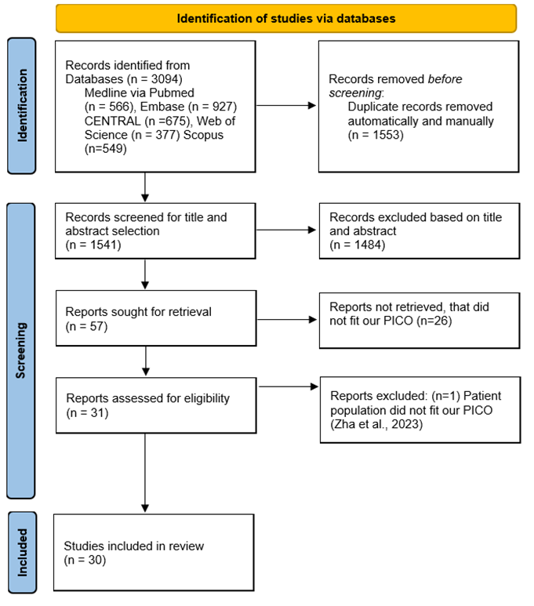
Figure 2 - PRISMA 2020 flow chart. Steps of the search and selection process of the included articles of Study I.

8.1.2. Baseline characteristics
We analyzed data from 30 studies encompassing a total of 2,602 patients [1,3,6,13–15,17,45–67]. Baseline characteristics of the included studies, such as patient population, PEEP titration strategies, and types of surgery, are summarized in Table 1. Seven trials focused on PEEP titration in obese patients, while the remaining studies involved non-obese patients undergoing either laparoscopic or open surgeries. Some studies included mixed populations or surgery types; these were categorized into the miscellaneous group for analysis.
Table 1 - Baseline characteristics of the included studies in Study I.
Study | Patients – intervention/control (n) | Type of surgery | Study group titration method | Control group PEEP used (cmH₂O)
Deeparaj et al., 2023[47] | 41/41 | laparoscopic gynaecological surgery | Cstat -guided | 5
Eichler et al., 2018[48] | 20/17 | laparoscopic bariatric surgery | Ptp-guided | 10
Elshazly et al., 2021[49] | 20/20 | laparoscopic bariatric surgery | US-guided | 4
Fernandez-Bustamante et al., 2020[46] | 24/13 | laparoscopic and open-abdominal surgeries | Cstat,or Ptp-guided | </=2
Ferrado et al., 2017[50] | 18/18 | open abdominal surgery | Cdyn-guided | 5
Ferrado et al., 2018[13] | 241/244 | laparoscopic and open-abdominal surgeries | Cdyn-guided | 5
Gao et al., 2023[51] | 23/23 | robotic-assisted laparoscopic prostatectomy | FiO₂-guided | 5
Girrbach et al., 2020[51] | 20/20 | robot-assisted laparoscopic radical prostatectomy | EIT-guided | 5
Kim et al., 2023[52] | 178/185 | laparoscopic/robotic abdominal surgery | dP-guided | 5
Li et al., 2021[53] | 60/60 | laparoscopic surgery | Cdyn-guided | 5
Li et al., 2023[54] | 20/20 | laparoscopic bariatric surgery | Cdyn-guided | 8
Liu et al., 2019[3] | 58/57 | laparoscopic radical gastrectomy | Cstat-guided | ZEEP
Liu et al., 2020[55] | 44/43 | laparoscopic total hysterectomy | Cstat-guided | ZEEP
Luo et al., 2023[56] | 36/36 | laparoscopic gastrointestinal surgery | US-guided+dP-guided | 5
Mini et al., 2021[57] | 41/41 | open abdominal surgery | dP-guided | 5
Nestler et al., 2017[14] | 25/25 | laparoscopic bariatric surgery | EIT-guided | 5
Pan et al., 2023[58] | 26/26 | robot-assisted prostate surgery | EIT-guided | 5
Pereira et al., 2018[1] | 20/20 | laparoscopic and open-abdominal surgeries | EIT-guided | 4
Piriyapatsom et al., 2020[59] | 22/22 | laparoscopic gynaecological surgery | Ptp guided | 5
Ruszkai et al., 2021[6] | 15/15 | open radical cystectomy | Cstat-guided | 6
Salama et al., 2023[60] | 33/33 | open abdominal surgery | Cstat-guided | 5
Van Hecke et al., 2019[61] | 50/50 | laparoscopic bariatric surgery | Cdyn-guided | 10
Xavier et al., 2024[62] | 10/10 | laparoscopic bariatric surgery | Cstat-guided | 5
Xiao et al., 2023[67] | 24/24 | CRS + HIPEC | EIT-guided | 5
Xu et al., 2022[45] | 17/16 | laparoscopic surgery | dP-guided | 6
Yang et al., 2023[63] | 23/22 | laparoscopic sleeve gastrectomy | dP-guided | 5
Yoon et al., 2021[15] | 30/30 | robot-assisted radical prostatectomy | Cdyn-guided | 7
Zhang et al., 2021[64] | 67/67 | open upper abdominal surgery | dP-guided | 6
Zhang et al, 2022[65] | 67/67 | laparoscopic gynaecological surgery | dP-guided | 5
Zhou et al., 2021[66] | 32/32 | laparoscopic robot-assisted prostatectomy | Cdyn-guided | ZEEP
Cstat: static compliance; Ptp: transpulmonary pressure; US: ultrasound; Cdyn: dynamic compliance; FiO₂: fraction of inspired oxygen; EIT: electronic impedance tomograph; dP: driving pressure.
Among the included randomized controlled trials (RCTs), various titration methods were applied, including electrical impedance tomography (EIT)-guided [1,14,17,58,67], ultrasound (US)-guided [49,56], driving pressure-guided [45,52,57,63–65], transpulmonary pressure-guided [46,48,59], and compliance-optimizing techniques [6,13,15,46,50,53–55,60–62,66,68].

8.1.3. Primary outcome
The primary outcome was the incidence of postoperative pulmonary complications (PPCs). Data on atelectasis, pneumonia, ARDS, and pulmonary aspiration—either individually or in combination—were pooled from 12 studies involving 1,466 patients [13–15,46,49,52,54,55,60,64,66,67]. Among these, 444 patients experienced PPCs. Our analysis indicated that patients receiving personalized PEEP settings were 30% less likely to develop PPCs than those receiving fixed PEEP settings (24.8% vs. 35.7%; RR = 0.70, CI: 0.58–0.84, I² = 7%, p = 0.002), as shown in Figure 3.
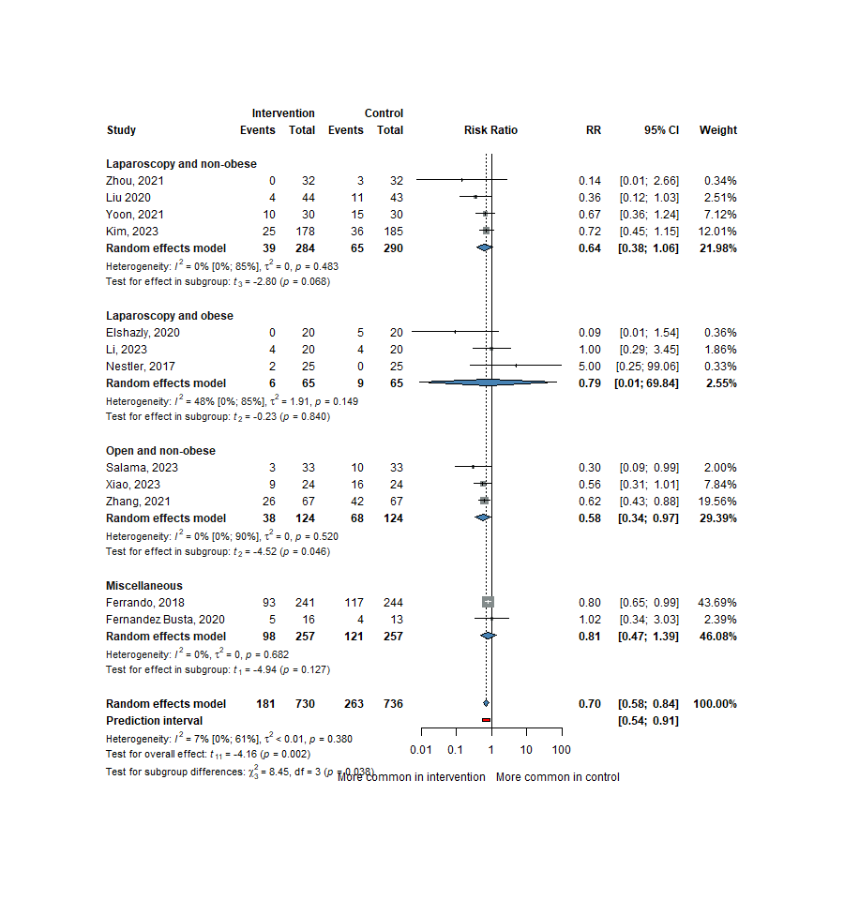
Figure 3 - Forest plot of studies representing the incidence of postoperative pulmonary complications, with subgroups.

8.1.4. Secondary outcomes

8.1.4.1. PaO₂/FiO₂ at the End of Surgery
Based on the results of 20 trials (1,843 patients) [1,6,13–15,17,48–52,56,58,60–62,64,66,67], patients receiving optimal PEEP had a nearly 56 mmHg higher PaO₂/FiO₂ ratio at the end of the surgery, then those receiving a fixed level of PEEP (MD = 55.99 mmHg, 95% CI: 31.78–80.21, I2 = 91%, p < 0.001) presented in Figure 4.
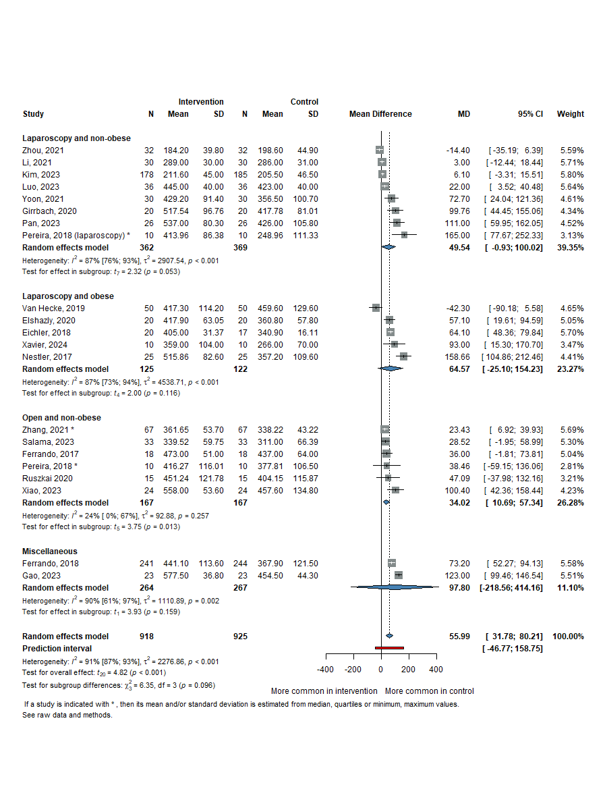
Figure 4 - Forest plot of the mean difference in PaO₂/FiO₂ ratio at the end of surgery, with subgroups.

8.1.4.2. Titrated PEEP Values in the SGs
We analyzed and compared the PEEP levels in each group. Based on data from 20 studies (1,471 patients) [1,6,13–15,17,45–48,50,54,56,58,60–64,67], the PEEP level was approximately 6 cm H₂O higher in the individually titrated PEEP group compared to the group receiving a predefined PEEP setting (MD = 6.27 cm H₂O, CI: 4.30–8.23, I² = 98.0%, p ≤ 0.001), as shown in Figure 5.
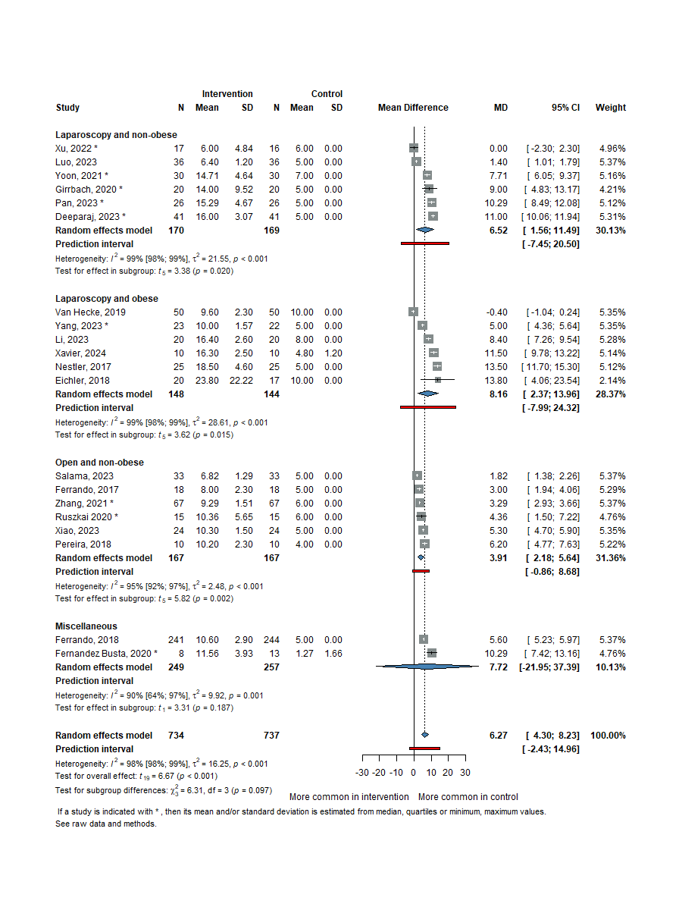
Figure 5 - Forest plot presenting the mean PEEP values, and mean differences of the studies.

8.1.4.3. Vasopressor Requirement
Data from 14 studies (1,261 patients) [1,13–15,17,45,46,51,53,56,61,64–66] indicated a higher prevalence of vasopressor use when individually titrated PEEP was applied compared to the CG receiving any vasopressor agent (58.9% vs. 54.7%). This was further supported by analysis, which showed a tendency toward a higher risk of requiring vasopressors with individually titrated PEEP (Figure 6). However, this finding did not reach statistical significance (RR = 1.07, 95% CI: 1.00–1.14, I² = 0%, p = 0.062).
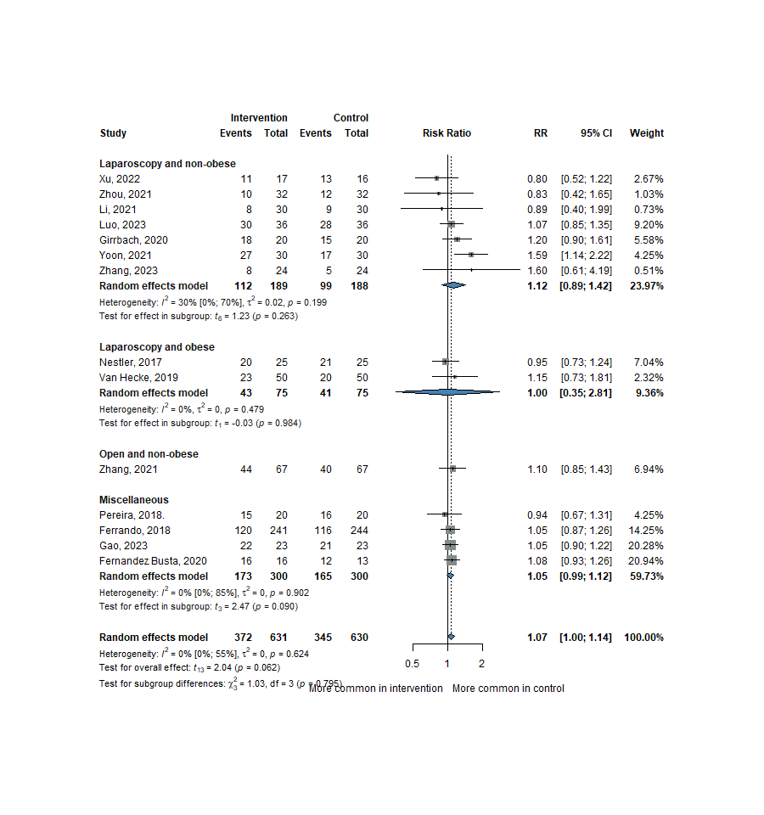
Figure 6 - Forest plot showing the risk ratio for vasopressor requirement.

Our analysis found no significant differences between groups regarding the maximum norepinephrine doses, or the amount of vasopressors (ephedrine, phenylephrine) used (MD = −0.19 mcg/min/kg 95% CI: −2.40–2.01; MD = 0.22 mg 95% CI: −1.23–1.68; MD = 0.00 mcg 95% CI: −0.00–0.00).

8.1.4.4. Respiratory Mechanics
Data on dynamic and static compliance (Cdyn, Cstat) from 20 studies (1,573 patients) [1,6,14,15,47,49–54,56–61,64,64,67] at the end of surgery suggested an increase in dynamic compliance, though it did not reach statistical significance (Cdyn: MD = 3.26 mL/cm H₂O, 95% CI: −0.08 to 6.61, I² = 96%, p = 0.055). However, the increase in static compliance was statistically significant (Cstat: MD = 11.92 mL/cm H₂O, 95% CI: 6.40 to 17.45, I² = 85%, p < 0.001) (Figure 7 and Figure 8).
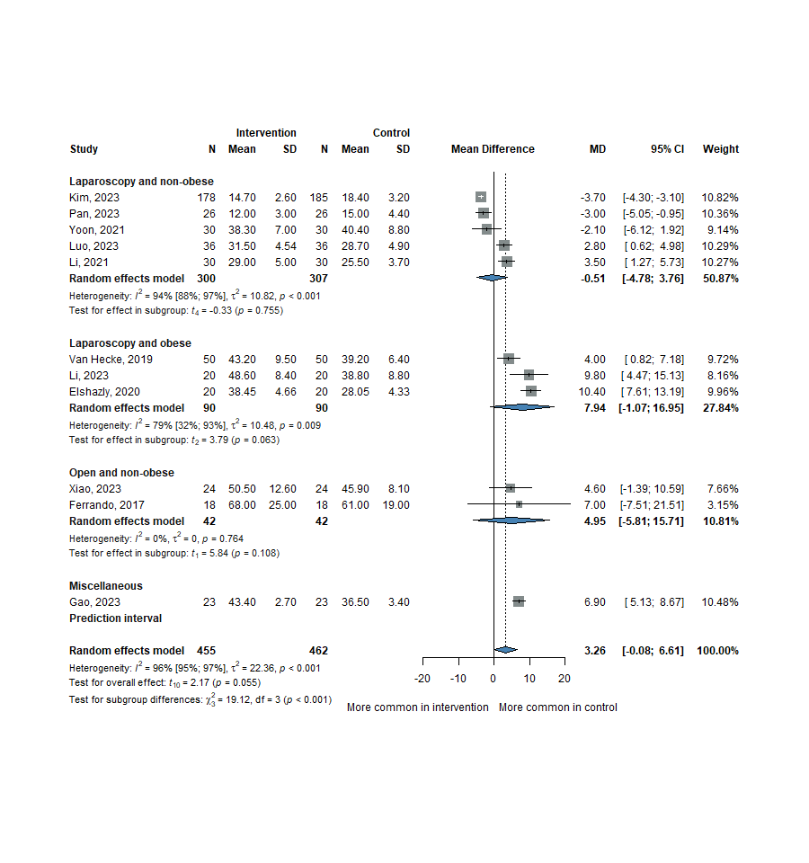
Figure 7 - Forest plot of mean differences in dynamic compliance (Cdyn) between groups.
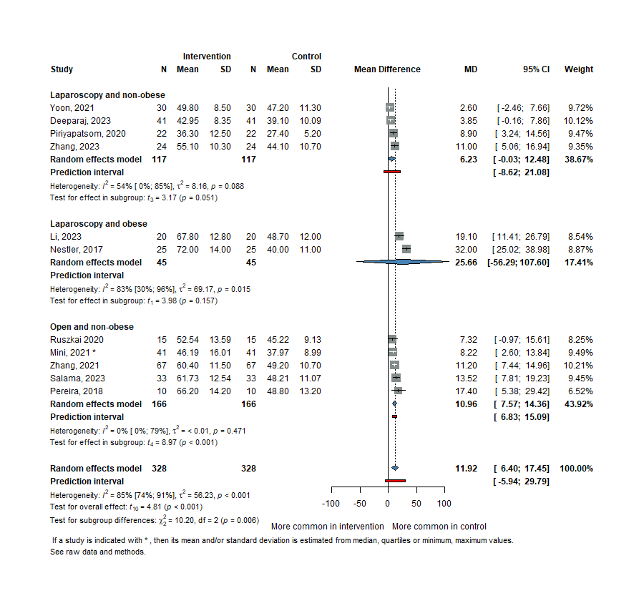
Figure 8 - Forest plot of mean differences in static compliance (Cstat) between groups
Driving pressure (dP) at the end of surgery, based on 15 studies including 1,530 patients [1,6,13–15,17,50,52,57–60,62,64,67], was significantly lower with titrated PEEP settings compared to a fixed PEEP strategy (MD = −2.75 cm H₂O, 95% CI: −3.95 to −1.55, I² = 89%, p < 0.001).
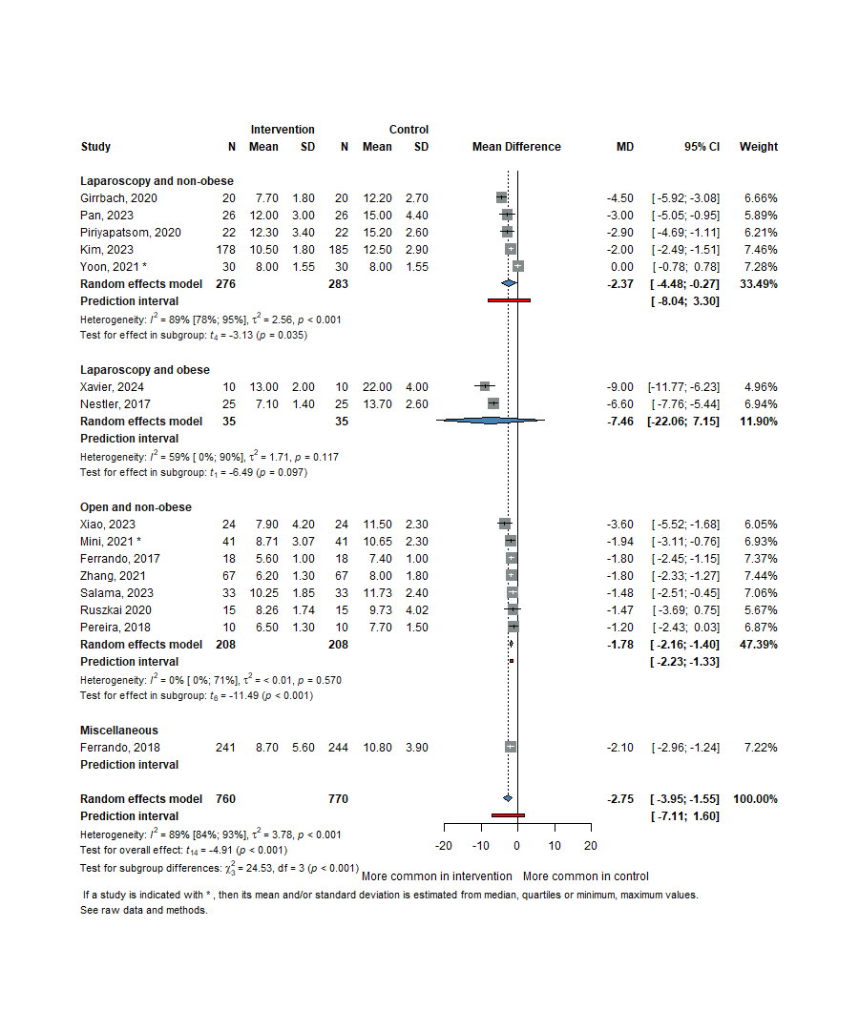
Figure 9 - Forest plot of mean differences of driving pressure (dP) between groups
Plateau pressure (Pplat) (18 studies, 1,762 patients) [1,13–15,17,47,49,52,54,56–60,64,65], was approximately 2.5 cm H₂O higher in patients receiving individually titrated PEEP, a statistically significant difference compared to the CG (MD = 2.49 cm H₂O, 95% CI: 1.08 to 3.90, I² = 92%, p = 0.002), seen on Figure 10.
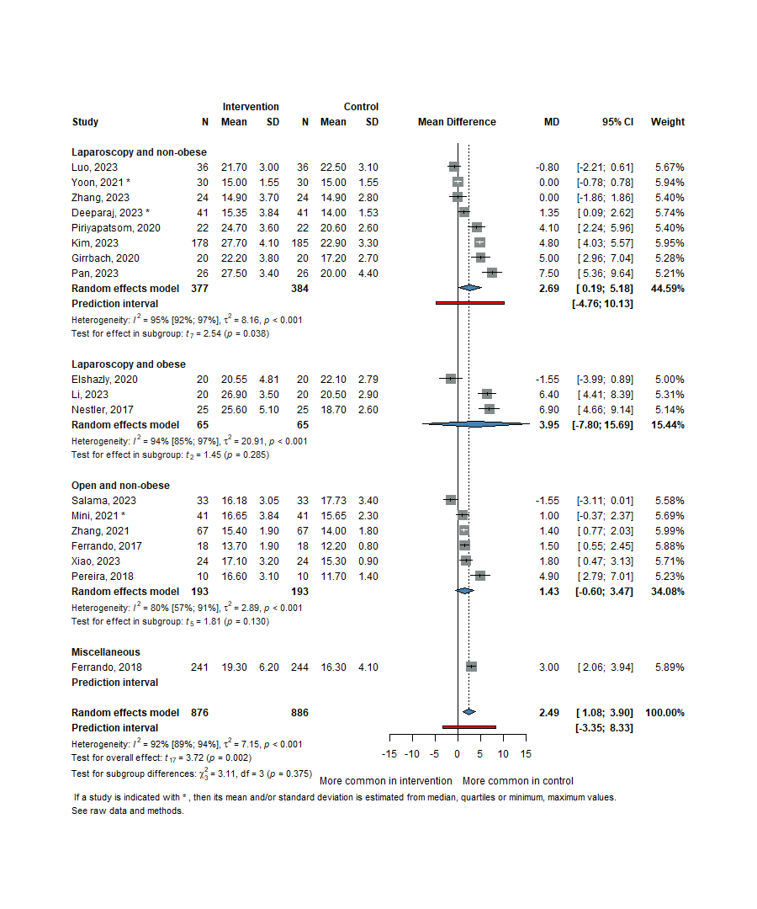
Figure 10 - Forest plot of mean differences of plateau pressure (Pplat) between groups

8.1.4.5. Duration of Anaesthesia and Surgery
According to our analysis, both the duration of anesthesia (19 studies, 1,822 patients) [1,3,6,13,15,45,46,48,52–56,58,59,63–65,67] and the duration of surgery (24 studies, 2,096 patients) [1,3,6,13,15,45,46,48,50–53,55–60,62–67] were longer among patients receiving individualized PEEP. However, statistical significance was observed only for the latter outcome, with neither reaching a mean difference of 5 minutes (MD = +0.49 minutes, 95% CI: −6.08 to 7.06; MD = +4.82 minutes, 95% CI: −2.84 to 6.81, respectively) (Figure 11and Figure 12).
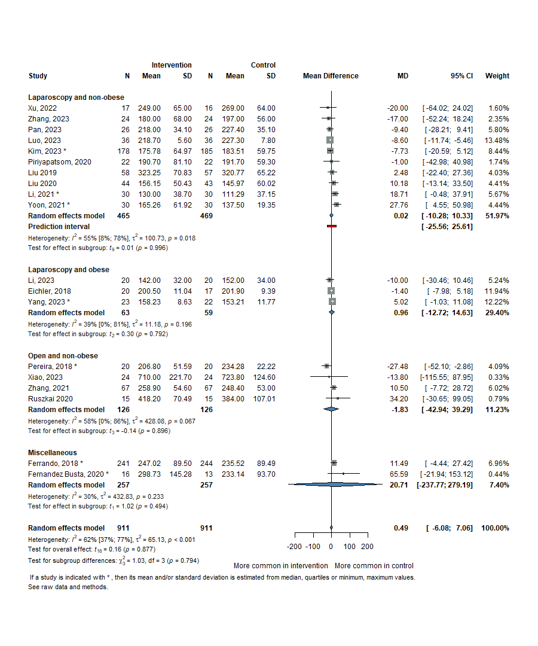
Figure 11 - Forest plot of mean differences of duration of anesthesia (mins) between groups.
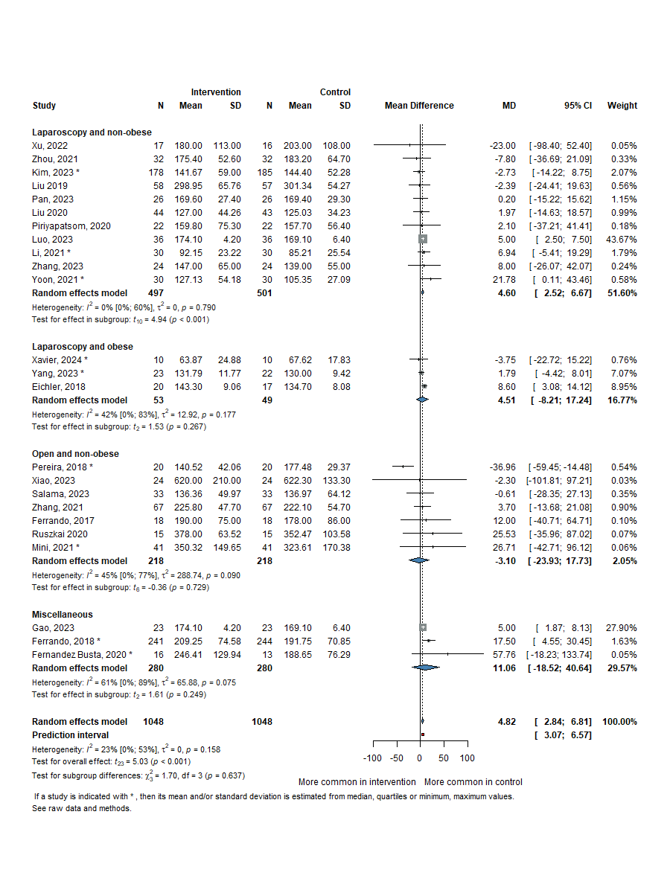
Figure 12 - Forest plot of mean differences of duration of surgery (mins) between groups

8.1.4.6. Length of Hospital Stay, Length of ICU Stay, and Mortality
Our data on the length of hospital stay (14 studies, 1,699 patients) [1,3,6,13,15,46,52,55,57,59–61,64,66] and the length of ICU stay (4 studies, 626 patients) [3,13,14,60,64], showed no significant differences between the study groups (SGs) (MD = −0.06 days, 95% CI: −0.71 to 0.59, I² = 71.0%, p = 0.855, and MD = −0.10 days, 95% CI: −2.70 to 2.51, I² = 77%, p = 0.914, respectively, shown on Figure 13and Figure 14).
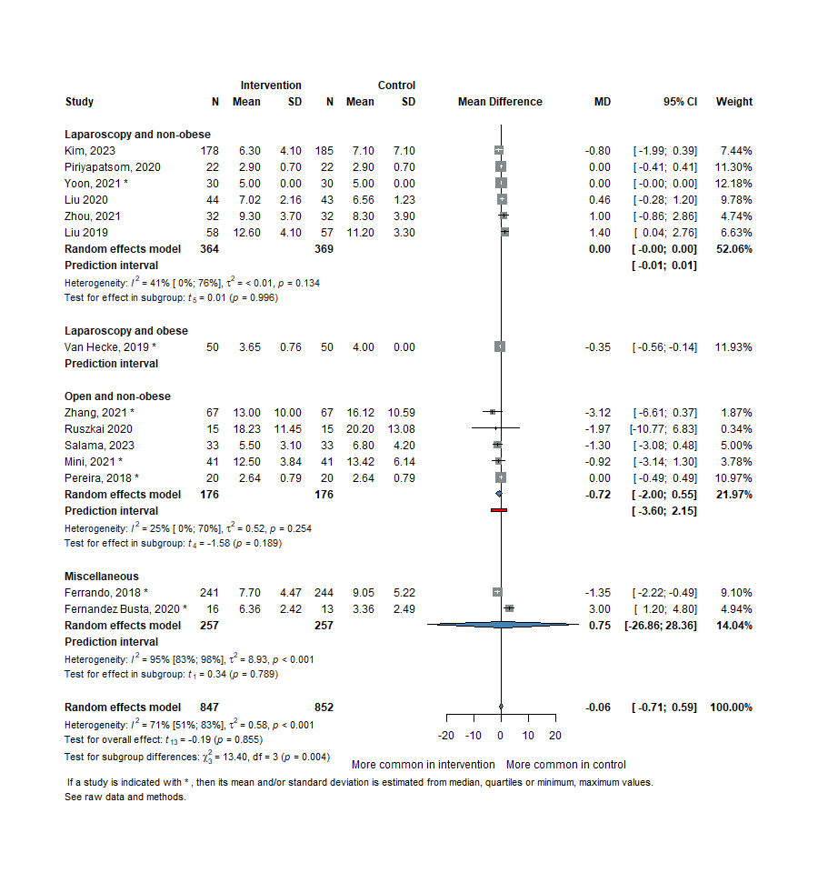
Figure 13 - Forest plot of mean differences of length of hospital stay (days) between groups.
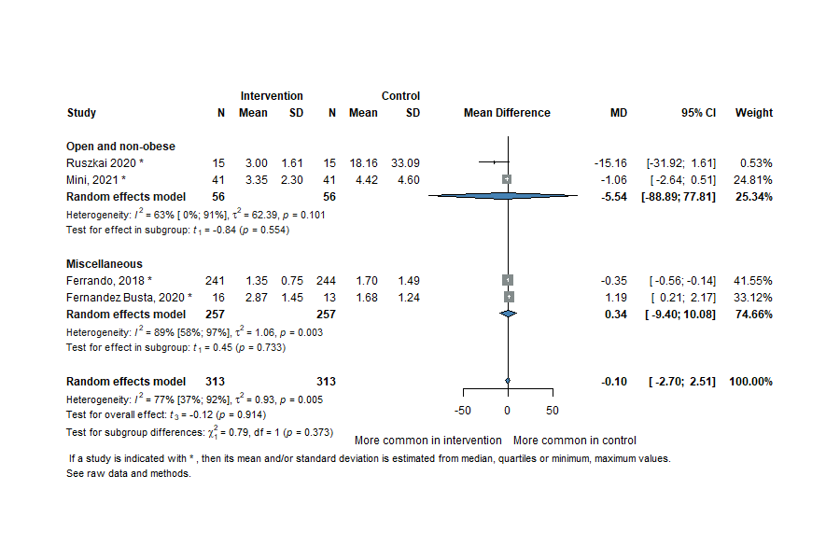
Figure 14 - Forest plot of mean differences of length of intensive care unit stay (days) between groups.
The 28-day mortality rates were reported in 5 studies (850 patients) [3,13,14,60,64], and the overall risk ratio (RR) showed no significant differences between the groups (RR = 1.0, 95% CI: 0.41–2.46, I² = 0%, p = 0.991) shown on Figure 15.
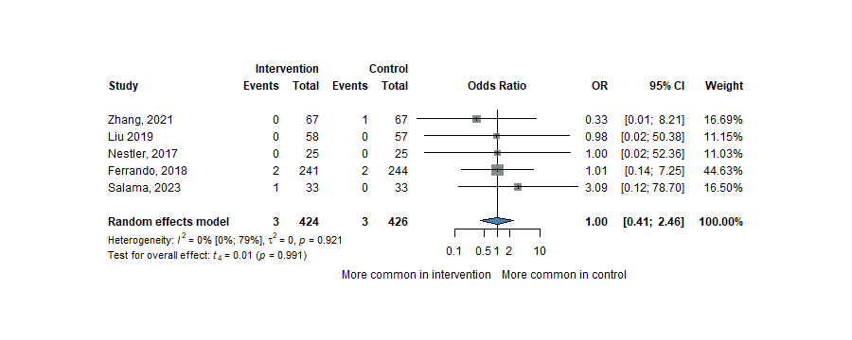
Figure 15 - Forest plot of 28-day mortality in the study groups.
Finally, there were outcomes for which data were insufficient to conduct a meta-analysis, such as oxygen saturation, postoperative IL-6, C-reactive protein (CRP), and procalcitonin (PCT) [6,15,46,53].

8.1.5. Risk of bias and quality of evidence assessment
According to the recommendations, the authors assessed the risk of bias in the included studies using the Cochrane Collaboration Risk of Bias tool. They suggested "some risk" for the majority of the studies and a ’low risk’ of bias for some. (Figure 16). During the GRADE quality assessment, the level of evidence was ’high’ regarding the duration of anesthesia and ’moderate’ for PPCs, the PaO₂/FiO₂ ratio, the need for vasopressors, the duration of surgery, and the doses of ephedrine. It was ’low’ for outcomes such as the PEEP value used, the maximum dose of norepinephrine (NE), Cdyn, Cstat, dP, Pplat, LOH, LO ICU, and phenylephrine used, and ’very low’ level of evidence for 28-day mortality (Figure 16,Table 2). Any disagreements were resolved by a third author during both processes.
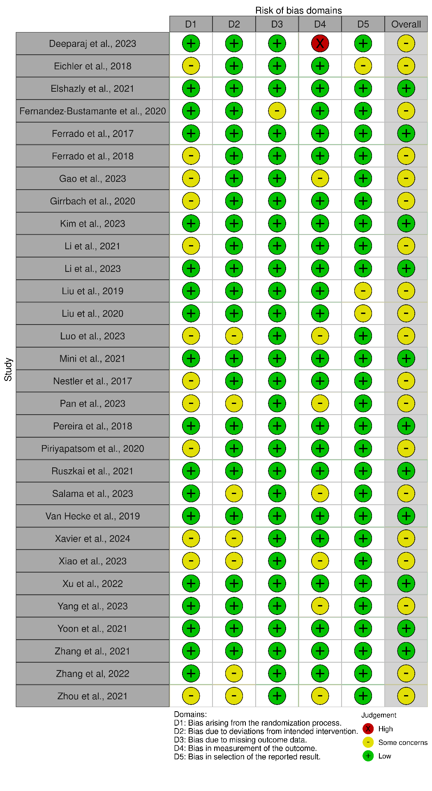
Figure 16 - Risk of bias assessment of the included studies.

Table 2 - GRADE quality assessment of the included studies in Study I.
Individualized PEEP compared to fixed PEEP for patients undergoing abdominal surgery
Patient or population: patients undergoing abdominal surgery
Intervention: individualized PEEP
Comparison: fixed PEEP
Outcomes | Anticipated absolute effects* (95% CI) |  | Relative effect  (95% CI) | № of participants  (studies) | Certainty of the evidence  (GRADE) | Comments
Outcomes | Risk with fixed PEEP | Risk with individualized PEEP
Postoperative pulmonary complications (PPCs)  follow-up: 7 days | 357 per 1000 | 250 per 1000  (207 to 300) | RR 0.70  (0.58 to 0.84) | 1466  (12 RCTs) | ⨁⨁⨁◯  Moderateª
End of surgery PaO₂/FiO₂ (P/F) ratio (P/F ratio) | The mean end of surgery PaO2/FiO2 (P/F) ratio was 0 mmHg | MD 55.99 mmHg higher  (31.78 higher to 80.21 higher) | - | 1843  (20 RCTs) | ⨁⨁⨁◯  Moderate^{b}
PEEP values used (PEEP) | The mean PEEP values used was 0 cmH₂O | MD 6.27 cmH₂O higher  (4.3 higher to 23.54 higher) | - | 1471  (20 RCTs) | ⨁⨁◯◯  Low^{b}
Number of patients need vasopressor | 548 per 1000 | 586 per 1000  (548 to 624) | RR 1.07  (1.00 to 1.14) | 1261  (14 RCTs) | ⨁⨁⨁◯  Moderate
Maximum dose of norepinephrine | The mean maximum dose of norepinephrine was 0 ug/kg/min | MD 0.19 ug/kg/min lower  (2.4 lower to 2.01 higher) | - | 157  (4 RCTs) | ⨁⨁◯◯  Low
Respiratory compliance (dynmic) (Cdyn) | The mean respiratory compliance (dynmic) was 0 cmH2O | MD 3.26 cmH2O higher  (0.08 lower to 6.61 higher) | - | 917  (11 RCTs) | ⨁⨁◯◯  Low^{b}
Respiratory compliance (static) (Cstat) | The mean respiratory compliance (static) was 0 cmH2O | MD 11.92 cmH2O higher  (6.4 higher to 17.45 higher) | - | 656  (11 RCTs) | ⨁⨁◯◯  Low^{b}
Driving pressure (Pdriving) | The mean driving pressure was 0 cmH2O | MD 2.75 cmH2O lower  (3.95 lower to 1.55 lower) | - | 1530  (15 RCTs) | ⨁⨁◯◯  Low^{b}
Plateau pressure (Pplateau) | The mean plateau pressure was 0 cmH2O | MD 2.49 cmH2O higher  (1.08 higher to 3.9 higher) | - | 1762  (18 RCTs) | ⨁⨁◯◯  Low^{b}
Duration of anesthesia (min) | The mean duration of anesthesia (min) was 0 min | MD 0.49 min higher  (6.08 lower to 7.06 higher) | - | 1822  (19 RCTs) | ⨁⨁⨁⨁  High
Duration of surgery (min) | The mean duration of surgery (min) was 0 min | MD 6.24 min higher  (2.16 lower to 14.64 higher) | - | 1299  (13 RCTs) | ⨁⨁⨁◯  Moderate
Length of hospital stay | The mean length of hospital stay was 0 days | MD 0.06 days higher  (0.71 lower to 0.59 higher) | - | 1699  (14 RCTs) | ⨁⨁◯◯  Lowª
Length of ICU stay | The mean length of ICU stay was 0 days | MD 0.1 days lower  (2.7 lower to 2.51 higher) | - | 626  (4 RCTs) | ⨁⨁◯◯  Lowª
28-day mortality | 7 per 1000 | 7 per 1000  (3 to 17) | OR 1.00  (0.41 to 2.46) | 850  (4 RCTs) | ⨁◯◯◯  Very low^{b}
Total amoung of ephedrine used (mg) | The mean total amoung of ephedrine used (mg) was 0 mg | MD 0.22 mg higher  (1.23 lower to 1.68 higher) | - | 323  (6 RCTs) | ⨁⨁⨁◯  Moderate^{b}
Total amount of phenilephrine used (mcg) | The mean total amount of phenilephrine used (mcg) was 0 mcg | MD 0 mcg  (0 to 0 ) | - | 416  (6 RCTs) | ⨁⨁◯◯  Low^{b}
*The risk in the intervention group (and its 95% confidence interval) is based on the assumed risk in the comparison group and the relative effect of the intervention (and its 95% CI).
CI: confidence interval; MD: mean difference; RR: risk ratio
GRADE Working Group grades of evidence
High certainty: we are very confident that the true effect lies close to that of the estimate of the effect.
Moderate certainty: we are moderately confident in the effect estimate: the true effect is likely to be close to the estimate of the effect, but there is a possibility that it is substantially different.
Low certainty: our confidence in the effect estimate is limited: the true effect may be substantially different from the estimate of the effect.
Very low certainty: we have very little confidence in the effect estimate: the true effect is likely to be substantially different from the estimate of effect.

8.2. Study II. – Hemoadsorption as Adjuvant Therapy in ARDS

8.2.1. Systematic search and selection
The initial and un updated systematic literature search identified a total of 1,653 records. Following a two-stage screening process conducted independently by two reviewers—initially based on titles and abstracts, followed by full-text assessment—26 studies met the eligibility criteria and were included in the final analysis (Figure 17) [24,69–93].
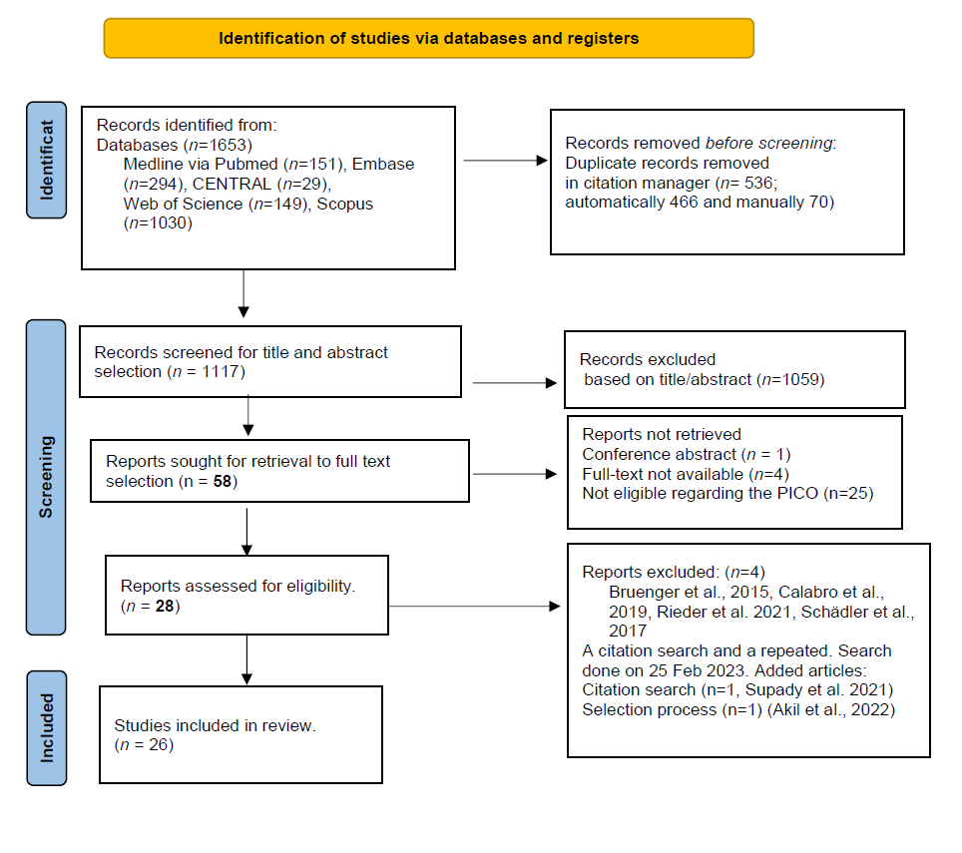
Figure 17 - PRISMA 2020 Flowchart, Steps of the search and selection process of the included articles of Study II.

8.2.2. Baseline characteristics -táblázat, hivatkozás
The included studies primarily comprised case reports, case series, and retrospective analyses, along with two randomized controlled trials. Collectively, these studies encompassed data from 243 patients. A detailed summary of the baseline characteristics of the included studies is presented in Table 3 - Baseline characteristics of the included studies in Study II.
Table 3 - Baseline characteristics of the included studies in Study II.
Study, year | Indication | Patients on HA therapy (n) | Control group (n) | Study design | Cartridge | Average No. of adsorbents | Timeframe for use | Results
Acevedo et al., 2021[69] | ARDS, COVID-19 | 1 | - | case report | CytoSorb | 1 | 9,2 h | improved P/F ratio, reduction of NA need
Akil et al., 2020[70] | ARDS, pneumogenic septic shock | 13 | 7 | prospective obs., + post hoc comparison to retrospective historical controls. | CytoSorb | min. of 2 | each for 24h | mortality 0% SG vs 57% CG, sign. reduction of NA requirement and serum Lactate in SG
Akil et al., 2022[71] | COVID-19 | 16 | 10 | retrospective observational | CytoSorb | mean of 6 treatments (range 2-21) | 24 h each | HA therapy led to hemodynamic stabilization, reduction of inflammation
Alharthy et al., 2020[72] | ARDS, COVID-19 | 50 | - | case series | CytoSorb | 2±1 vs 6±2 (survivors vs non-survivors) | each for 24h | improved P/F ratio among survivors, PLT counts were reduced
Berlot et al., 2020[73] | ARDS, COVID-19 | 1 | - | case report | CytoSorb | 3 | each for 24h | improved P/F ratio, reduced CRP and IL-6,
Berlot et al., 2021[74] | ARDS, COVID-19 | 2 | - | retrospective observational | CytoSorb | 3 | each for 24h | PaO2/FiO2 ratio improved or remained stable, CRP, IL-6 decreased after HA
David et al., 2017[75] | ARDS, influenza pneumonia | 1 | - | case report | CytoSorb | 1 | 24h | Reduction in CRP, PCT, Hgb and NA requirements and improved P/F ratio 24 h after HA
Geraci et al. 2021[76] | ARDS, COVID-19 | 10 | - | case series | CytoSorb | - | 2 in the first 24 hour, then 1 every 24h | HA is a feasible and safe treatment, HA reduced inflammatory markers
Huang et al, 2012[92] | acute lung injury induced by extrapulmonary sepsis | 25 | 21 | RCT | HA-330 | once a day for three consecutive days. | each for 2 h | improving respiratory function, reduction of IL-1 and  TNF-a.
Huang et al., 2021[77] | ARDS, COVID-19 | 1 | - | case report | oXiris | 7 | each for 24 h | reduced vasopressor requirements after HA, reduction in inflammatory markers (IL-6)
Kogelmann et al., 2020[78] | ARDS | 7 | - | case series | CytoSorb | 4 | 12 - 24 hours | improved P/F ratio, decrease in catecholamine  need,
Kovacevic et al., 2020[93] | ARDS, H1N1 influenza | 1 | - | case report | CytoSorb | 2 |  | decreased vasopressor requirements after HA
La Camera et al., 2019[79] | ARDS, postoperative patient, pneumonia | 1 | - | case report | CytoSorb | 2 | - | reduced NA requirement,
Lees et al., 2016[80] | ARDS, PLV+ S.aureus pneumonia | 1 | - | case report | CytoSorb | 1 | 24h | improved oxygenation, decrease vasopressin and NA requirement
Lother et al., 2019[81] | ARDS, septic shock | 3 | - | case series | CytoSorb | mean 1,3 median 1 [1-3] | 38.4, 12 and 13.5 h | reduction in PLT count, no evidence of altered plasmatic coagulation, 67% mortality
Nassiri et al., 2021[82] | ARDS, COVID-19 | 26 | - | case series | CytoSorb | mean 2, median of 2 [1-3] | median 35 IQR [18-48] | significant reduction in inflammatory markers, reduction of NA requirement, improved P/F ratio and SOFA score
Pieri et al., 2022[83] | ARDS, COVID-19 | 15 | - | retrospective observational | CytoSorb | 3 | 17 h (mean) | improved P/F ratio, reduced CRP
Ramírez-Guerro et al., 2020[84] | ARDS, COVID-19 | 1 | - | case report | Jafron HA-380 | 1 | 10 h | improved P/F ratio, and CT picture
Rampino et al., 2020[85] | COVID-19 | 5 | 4 | case series | CytoSorb | 2 | 4h sessions in 2 consecutive days | better clinical course (mortality, PaO₂/FiO₂), lymphocyte no. improved, CRP decreased to grater extent, as well as IL-6, IL-8, and TNF-α decreased, IL-10 remained unchanged
Rieder et al., 2020[86] | ARDS, COVID-19 | 1 | - | case report | CytoSorb | 1 | 72 h | reduction in PLT count, in CRP and IL-6.
Rizvi et al., 2020[87] | ARDS, COVID-19 | 1 | - | case report | CytoSorb | 8 | first 4 for 12h, then 4 for 24h | reduction of PLT, Hgb, WBC
Rodeia et al., 2021[88] | COVID-19 | 5 | - | case series | CytoSorb | 2 | each 24h | safe intervention, positive rational behind the therapy, but with low quality evidence
Supady et al., 2021[24] | COVID-19 pneumonia requiring ECMO | 17 | 17 | RCT | CytoSorb | 3, 24 h each | 72 h | No significant differences for IL-6 were detected between the two groups after 72 h, increased mortality in the Cytosorb group
Träger et al., 2016[89] | ARDS, postoperative patient | 1 | - | case report | CytoSorb | 3 | 85 h in total | reduction of interleukin 6 and 8, reduction of NA requirements
Wiegele and Krenn et al., 2015[90] | ARDS, Legionella Pneumonia associated rhabdomyolysis | 1 | - | case report | CytoSorb | 2 | 1st: 6 h 2nd: 5h | myoglobin levels decreased, reduction of required NA dose, improvement in urinary output,
Wunderlich-Sperl et al., 2021[91] | ARDS, COVID-19 | 13 | - | case series | CytoSorb | Median of 4 HA treatment [range 1-15 days] | max of 24 h, | decreased inflammatory parameters after HA, reduction of NA doses, improvement in PF ratio, reduction in PLT count
HA: hemoadsorption , P/F: PaO₂/FiO₂

8.2.3. Primary outcome
Data from eight studies (162 patients) [71,72,76,78,82,83,91,92], evaluating the primary outcome demonstrated a statistically significant enhancement in the PaO₂/FiO₂ ratio following HA therapy, with a mean difference (MD) of 68.93 mmHg (95% CI: 28.79 to 109.06; I² = 96%; p = 0.005) shown on Figure 18. Additionally, aggregated results from seven individual case reports (n = 7) indicated a trend toward improvement; however, this did not reach statistical significance (p = 0.15).
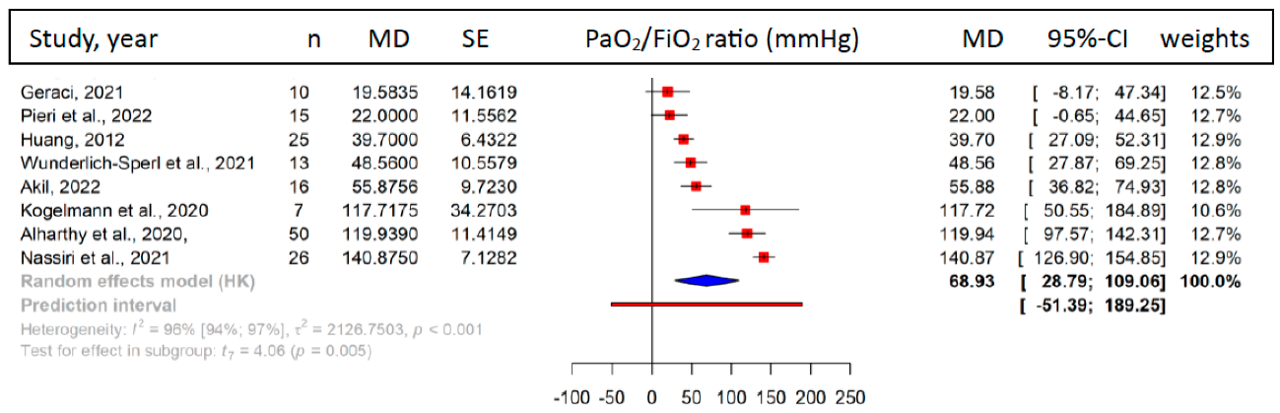
Figure 18 - Forest plot of the mean difference of PaO₂/FiO₂ ratio change after hemoadsorption therapy

8.2.4. Secondary outcomes

8.2.4.1. Inflammarory Biomarkers
Seven studies [70,72,76,82,83,88,91] involving COVID-19 patients (132 patients) demonstrated a significant reduction in serum CRP levels following treatment, with an MD of −45.02 mg/dL (95% CI: −82.64 to −7.39; I² = 95%; p = 0.026) shown on Figure 19. Serum interleukin-6 (IL-6) levels were assessed in seven studies [24,70–72,76,88,91] (124 patients), revealing a non-significant trend toward reduction after HA therapy (MD = −241.17 pg/mL; 95% CI: −570.38 to 88.05; I² = 77%; p = 0.123) presented on Figure 19. These results on CRP and IL-6 levels were further supported by the analysis of pooled individual case data, as illustrated in Figure Figure 20 (p = 0.008 and p = 0.016 respectively).
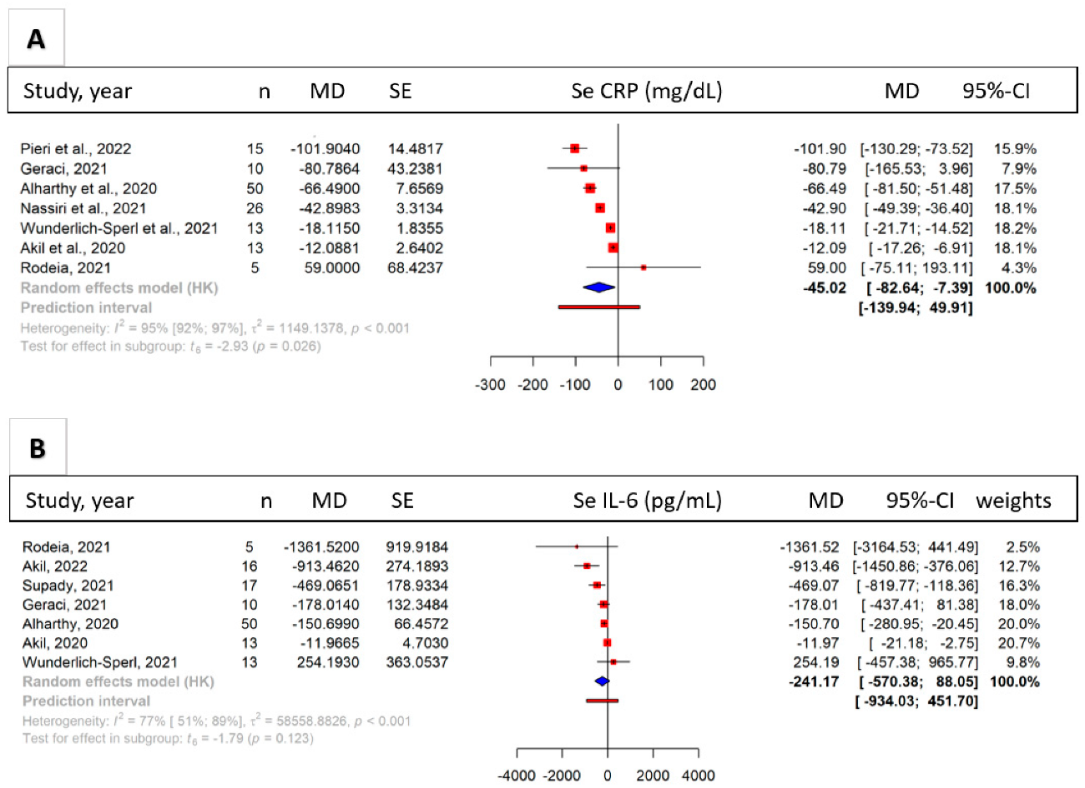
Figure 19 - Forest plots of the difference of mean differences of Se CRP (A) and Se IL-6 (B) after hemoadsorption treatment.
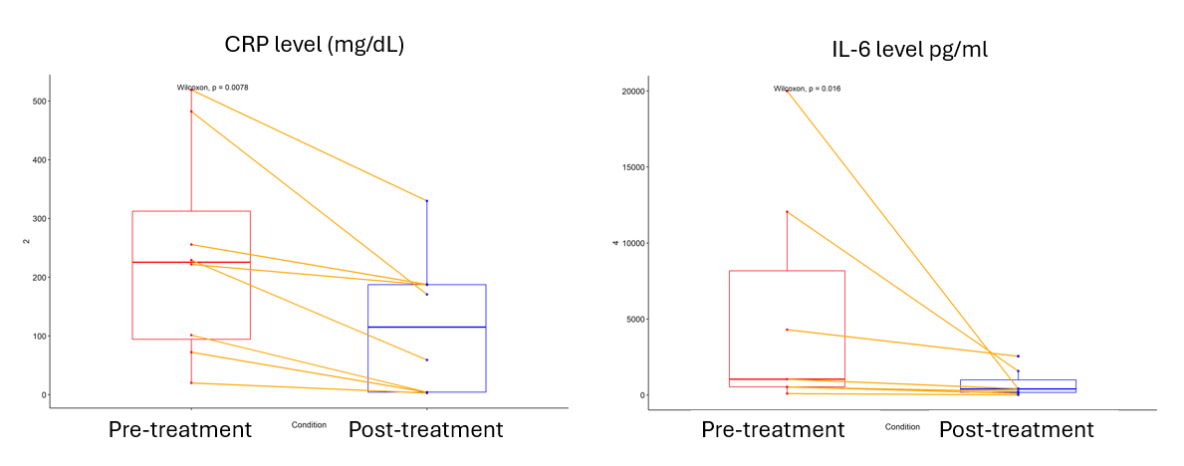
Figure 20 - Pooled data from case reports showing CRP and IL-6 levels (mg/l) before and after the treatment.

8.2.4.2. Effects on vasopressor requirement and lactate
Data from seven studies [24,70–72,82,91,92] (160 patients) assessing norepinephrine (NE) requirements before and after HA therapy demonstrated a significant reduction following treatment, with a MD of −0.23 μg/kg/min (95% CI: −0.43 to −0.04; I² = 99%; p = 0.028) Figure 21A. Additionally, analysis of four studies [24,70,71,92] (126 patients) that included a CG indicated a non-significant trend toward lower vasopressor requirements in patients treated with HA compared to those receiving standard medical care (MD = −0.12 μg/kg/min; 95% CI: −0.29 to 0.05; I² = 74%; p = 0.108). In this comparison, the certainty of evidence was rated as low. Serum lactate levels based on eight studies [70–72,76,78,82,88,91] were also significantly reduced after HA therapy, with a mean difference of −1.63 mg/L (95% CI: −3.05 to −0.21; I² = 96%; p = 0.030) shown on Figure 21B.
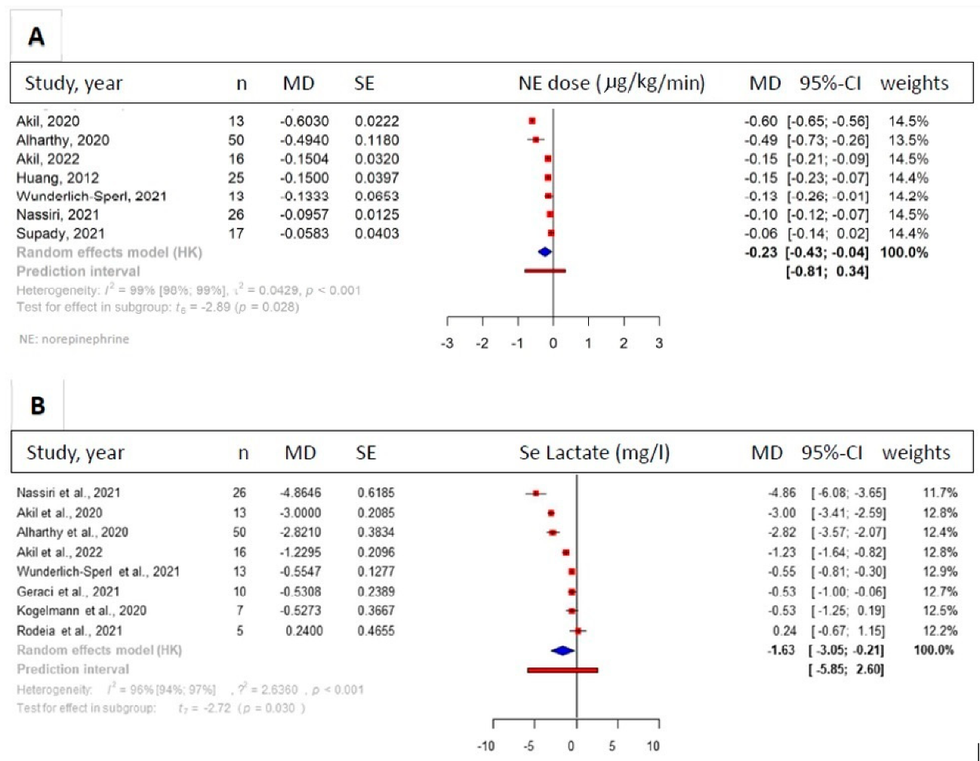
Figure 21 - Forest plots of change in required dose of NE (A) and the level of rerum lactate (B) after hemoadsorption therapy.

8.2.4.3. Length of Stay and Mortality
Based on data from three studies[70,71,92] (92 patients) comparing HA therapy to standard medical treatment, no significant difference was observed in ICU length of stay (MD = 1.17 days; 95% CI: −18.61 to 20.96; I² = 64%; p = 0.82), with the certainty of evidence rated as low. Mortality data were reported in five studies[24,70,71,85,92], though the follow-up periods ranged from 28 to 90 days. A non-significant reduction in mortality was noted in the HA group (RR = 0.64; 95% CI: 0.11 to 3.65; I² = 80%; p = 0.52), with the certainty of evidence rated as very low.

8.2.4.4. Safety Outcomes, and Subgroup Analysis
No device-related adverse events were reported, irrespective of the platform used. We conducted a subgroup analysis on COVID-19 patients, and after excluding non-COVID cases, only the PaO₂/FiO₂ ratio improvement remained significantly better.

8.2.5. Risk of bias and quality of evidence assessment
The risk of bias evaluations (Figure 22) was assessed with the Rob-2 tool (randomized controlled trials), with the Robins I tool (retrospective studies).
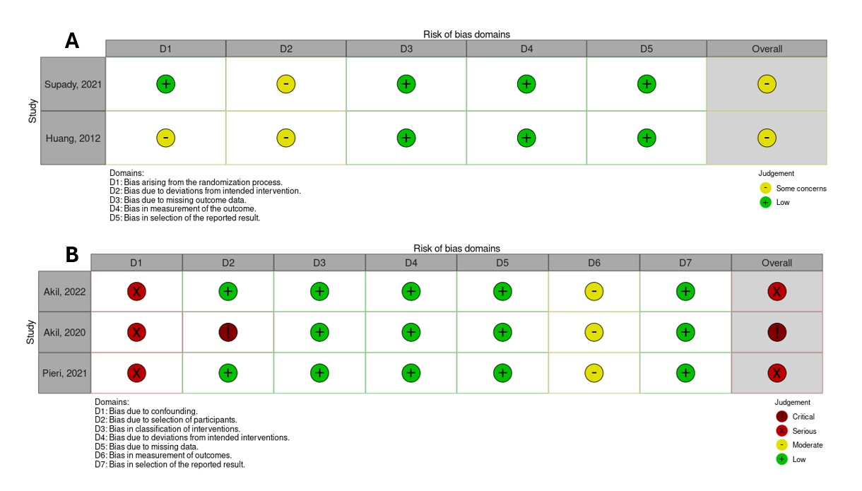
Figure 22 - Risk of bias evaluation of the included RCTs (A) and retrospective studies (B) in Study II.
The JBI critical appraisal tools for case reports and case series (Figure 23). The GRADE summary of findings for the included studies are shown on Table 4.
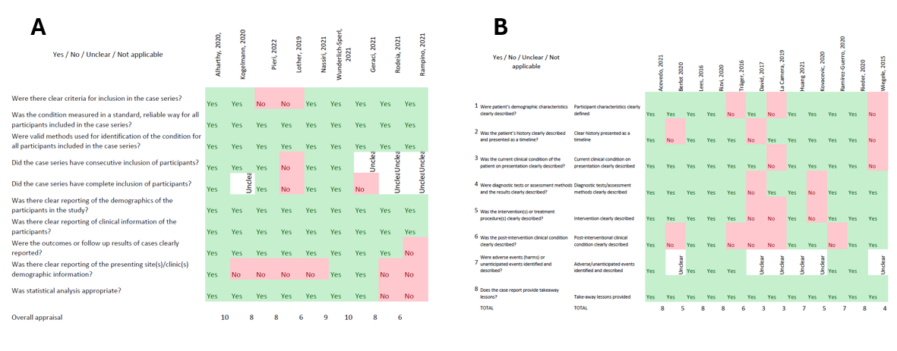
Figure 23 - Risk of bias assessment of the case series (A) and case reports (B) included in Study II.
Table 4 - GRADE quality assessment of the included studies in Study II.
Certainty assessment |  |  |  |  |  |  | № of patients |  | Effect |  | Certainty | Importance
№ of studies | Study design | Risk of bias | Inconsistency | Indirectness | Imprecision | Other considerations | Hemoadsorption (HA) therapy | Standard medical treatment | Relative  (95% CI) | Absolute  (95% CI) | Certainty | Importance
Vasopressor support (norepinephrine)
4 | observational studies | very seriousª | not serious | not serious | not serious | none | 71 | 55 | - | MD 0.12 ug/kg/min lower  (0.29 lower to 0.05 higher) | ⨁⨁◯◯  Low | IMPORTANT
Length of ICU stay
3 | observational studies | very seriousª | not serious | not serious | not serious | none | 54 | 38 | - | MD 1.17 days higher  (18.61 lower to 20.96 higher) | ⨁⨁◯◯  Low | IMPORTANT
Mortality (follow-up: range 28 days to 90 days)
5 | observational studies | very serious^{a,b} | serious^{b} | not serious | not serious | none | 28/76 (36.8%) | 29/59 (49.2%) | RR 0.64  (0.11 to 3.65) | 177 fewer per 1 000  (from 437 fewer to 1 000 more) | ⨁◯◯◯  Very low | IMPORTANT

9. DISCUSSION

9.1. Study I. – Individualized vs. fixed intraoperative PEEP settings
This systematic review and meta-analysis aimed to assess the impact of individualized versus fixed intraoperative PEEP settings on the incidence of postoperative pulmonary complications.

9.1.1. Positive End-Expiratory Pressure settings
On average, the optimal PEEP value in the intervention groups was approximately 6.27 cm H₂O higher than the mean PEEP used in the CGs, aligning with findings from previous studies. This suggests that individual PEEP requirements often exceed the currently recommended levels of 5–6 cm H₂O [16,94].
Subgroup analysis of the obese population revealed an even greater difference, with a mean PEEP increase of 8.16 cm H₂O, indicating that higher PEEP levels were required to prevent atelectasis in this group. The effects of higher PEEP levels (12 vs. 4 cm H₂O) were investigated in a previous large RCT, which did not demonstrate a reduction in postoperative pulmonary complications (PPCs)—a finding consistent with our subgroup analysis of obese patients (RR= 0.79, CI: 0.01–069,84, I2=48%, p=0.84) [14,49,54,95].

9.1.2. Postoperative Pulmonary Complications and Oxygenation
Our primary outcome was the incidence of PPCs(PPCs), defined based on a previous consensus recommendation and included atelectasis, pneumonia, acute respiratory distress syndrome (ARDS), and pulmonary aspiration, either occurring alone or in combination [11]. PPCs are common after major abdominal surgeries and contribute to prolonged hospital stays, increased morbidity, and higher mortality rates [96–98], thus reducing their incidence can improve patient recovery outcomes and decrease healthcare related costs [97,99].
One of the earliest meta-analyses comparing individualized PEEP titration to conventional settings reported a risk ratio (RR) of 0.52 for developing PPCs when titrated PEEP was used [94]. However, this analysis focused on patients receiving one-lung ventilation during thoracic surgery. Our findings align with a more recent meta-analysis, which found a RR of 0.69 in a broader population that also included patients undergoing abdominal surgery, further supporting the consistency of our results with existing evidence [16].
Except for two studies, a higher mean PaO₂/FiO₂ ratio was measured at the end of surgery in the individually set group [61,66]. Our findings reveal not only a significantly greater overall MD in PaO₂/FiO₂ ratios favoring individualized PEEP over fixed settings, but also a larger effect than those reported in earlier meta-analyses involving thoracic (MD = 37.72 mmHg) and abdominal surgeries (MD = 20.8 mmHg) [16,94]. Additionally, a recent meta-analysis comparing EIT-guided PEEP titration to fixed PEEP showed substantially improved intraoperative oxygenation, with individualized PEEP resulting in an oxygenation index over 90 mmHg higher [100].

9.1.3. Hemodynamics
Elevated levels of PEEP can increase right ventricular afterload and potentially reduce preload, which may result in decreased cardiac output. Consequently, PEEP should be administered with caution in patients who are hemodynamically unstable, especially in the presence of hypovolemia [101,102]. We noted a trend toward more frequent vasopressor use in the SG. In a previous study involving obese patients, those treated with individually adjusted PEEP levels required vasoactive support more often during alveolar recruitment maneuvers (ARMs) compared to those managed with a fixed PEEP of 12 cm H₂O (92% vs. 48%) [103]. The most marked difference in vasopressor requirement was observed in a study on robot-assisted radical prostatectomy, where vasopressor use was significantly more common in the SG (90.0% vs. 56.7%; p = 0.004) [15].
Our analysis found a relative risk of 1.07 for not requiring vasopressor support in the CG compared to the SG, though this result did not reach statistical significance. Among the four studies providing data on norepinephrine infusion rates, only one [48] reported lower mean dosing in the SG [6,14,17,48]. Given the limited data available, it remains difficult to draw firm conclusions about the impact of individualized PEEP titration on vasopressor requirements. Supporting this uncertainty, a recent physiological study found no significant difference in maximum norepinephrine infusion rates between individualized and fixed PEEP strategies [104].

9.1.4. Respiratory Mechanics
Our findings demonstrated improved respiratory compliance in the SG, reflected in both dynamic (Cdyn) and static (Cstat) measurements, with a statistically significant increase observed in Cstat. Although elevated pulmonary compliance may be seen in certain pathological conditions, the majority of studies included in our meta-analysis—except one—were conducted on patients without any known pre-existing lung disease [56]. The most commonly used method to determine the optimal PEEP (PEEPopt) involved targeting the level at which pulmonary compliance (either Cstat or Cdyn) was maximized. This introduces the possibility of selection bias, particularly since several of the included studies did not report compliance values. In one study by Boesing et al., both individualized titration methods tested were found to reduce dynamic lung strain and driving pressure more effectively than a fixed level of PEEP of 5 cm H₂O [104].
As for whether it is the PEEP level itself—high or low—or the individualized approach that matters most, evidence from another trial comparing personalized titration strategies suggested superior respiratory mechanics and oxygenation outcomes when PEEP was optimized by targeting an ideal transpulmonary pressure, measured with an esophageal catheter (Peso-guided method) titration over a gas exchange–based approach [105]. A recent RCT further emphasized the importance of re-evaluating PEEP throughout the surgical procedure, following the initial titration [45]. This practice is justified, given that prolonged mechanical ventilation is often associated with a gradual decline in respiratory compliance over time [45].
Excessive dP and high Pplat are well-established contributors to ventilator-induced lung injury [106]. It is therefore unsurprising that six studies in our review chose dP optimization as the preferred method for determining optimal PEEP [45,52,57,63–65]. In one earlier investigation involving obese patients, a secondary analysis compared three PEEP settings: individualized, a fixed 12 cm H₂O, and a fixed 4–5 cm H₂O. The lowest average intraoperative dP was observed in the individualized group (9.8 cm H₂O vs. 14.4 cm H₂O and 18.8 cm H₂O; p < 0.001), suggesting that individualization may be more beneficial than simply increasing PEEP [103].
Although previous studies have supported the use of repeated ARMs as part of lung-protective ventilation during general anesthesia, our analysis did not show improved outcomes in studies that routinely or intermittently used ARMs compared to those that did not [6,107–110].

9.1.5. Other Secondary Outcomes
The duration of anesthesia did not significantly differ between the groups. While the length of surgery was statistically longer in the SG, the difference was under five minutes, raising doubts about its clinical significance. These results imply that the intervention does not add a meaningful time burden.
We found no significant differences in hospital or ICU length of stay, indicating that individualized PEEP appears to have no measurable impact on these outcomes. This may be attributed to the fact that most PPCs in elective surgical populations are recognized early and are generally mild diseases, that can be treated with supportive care. However, frail or comorbid patients may be more vulnerable to even mild complications, experiencing greater physiological stress, prolonged recovery, or functional decline. Also, these complications often require increased monitoring, higher staff workload, and additional pharmacologic interventions, all of which contribute to elevated healthcare resource utilization and cost. Thus, while length of stay and mortality may remain unchanged, the burden on healthcare systems should not be underestimated.
Only a limited number of studies reported mortality data, which is an outcome that is expected to be low in these elective surgical populations. For example, a meta-analysis involving 3.6 million bariatric surgery patients reported just 4,707 perioperative deaths (0,13%) [111]. Similarly, in a study of over 35,000 radical prostatectomy cases, the 30-day mortality was below 0.5% [112]. These figures highlight the challenge of conducting a sufficiently powered mortality study in such low-risk populations.

9.2. Study II. – Hemoadsorption as Adjuvant Therapy in ARDS

9.2.1. Hemoadsorption as an Adjunctive Therapy
Hemoadsorption has gained interest in treating hyperinflammatory critical conditions over the past decade. ARDS may be a potential target, but available scientific data are limited. This systematic review and meta-analysis found few studies, lacking high-quality evidence, yet showed signs of better oxygenation, reduced inflammation, and lower vasopressor needs, with no serious adverse events.

9.2.2. Inflammatory Response Modulation
Innate immune activation triggers pro-inflammatory signals, cytokine and chemokine release, and activates alveolar macrophages, causing endothelial and alveolar damage. [113,114]. Most ARDS cases result from uncontrolled host-response to hyperinflammation causing lung injury. The cytokine absorbing capacity of hemoadsorption cartridges supports their theoretic benefits in hyperinflammatory states. Our findings confirm growing interest in research and use of hemoadsorption in severe respiratory failure.
An effective reduction in circulating inflammatory cytokines has been shown in in vitro studies [115], animal models [116], and clinical trials [117]. In our study, only CRP levels decreased significantly with hemoadsorption, though IL-6 levels also tended to decline, particularly in studies with higher baseline IL-6 levels [24,71,72].
CRP, due to its large molecular weight, is unlikely to be directly adsorbed; its reduction is likely an indirect effect of decreased inflammation. Nonetheless, similar CRP reductions during hemoadsorption have been reported by others, consistent with our findings [118]. The small sample size and high data variability likely limited the ability to draw firm conclusions for the overall population.
Dysregulated host-response often leads to the loss of vasomotor tone, resulting in hemodynamic instability or even vasoplegic shock. Clinical experience and published data suggest that hemoadsorption is often associated with hemodynamic improvement, indicated by reduced vasopressor needs [119] and decreased plasma lactate levels [120]. We were able to pool data on lactate levels and norepinephrine doses from six studies [70,72,76,82,88,91], and the significant reduction in both outcomes after orption treatment was consistent with the results of previous studies [119].

9.2.3. Effects on Oxygenation
A key finding of this study is the marked improvement in oxygenation following hemadsorption treatment, with an average increase of nearly 70 mmHg in the PaO₂/FiO₂ ratio. This improvement is clinically significant, and not only in cases of severe ARDS—where even modest gains in oxygenation can be life-saving—but also in moderate or less severe presentations, where it may alter the whole clinical picture and treatment. Such an increase has the potential to reduce the need for escalation of ventilatory support, it may also impact decisions regarding other forms of adjunctive therapies (e.g., prone positioning or ECMO), and ultimately may improve overall clinical outcomes.
The first RCT on sepsis-induced lung injury using the HA-330 device showed reduced TNF-α and IL-1 levels and improved oxygenation, lung injury scores, and outcomes. Most studies in our review supported these results, with significant PaO₂/FiO₂ improvement after hemoadsorption [92]. In severe ARDS requiring ECMO, recent data suggest that hemoadsorption may reduce inflammation and vasopressor need while improving lung function [121]. Early combined use of ECMO and hemoadsorption could offer a new approach to enhance lung rest, warranting future investigation [71]. Regarding the limitations of this outcome in out meta-analysis, it should be mentioned, that it was conducted on a markedly heterogeneous patient population and relied predominantly on case reports, which are particularly prone to reporting bias. In such a context of heterogeneity and low-level evidence, the observed improvement in oxygenation should be interpreted with caution and cannot be clearly ascribed solely to hemoadsorption. Improvements in oxygenation may result from various pathophysiological mechanisms, such as better ventilation–perfusion matching or reduced diffusion distance, and are strongly influenced by multiple aspects of intensive care, including the underlying disease, the etiology of ARDS, ventilatory mode, patient positioning (supine or prone), the use of other organ support therapies such as CRRT or ECMO, and appropriate antimicrobial treatment.

9.2.4. Hemoadsorption in COVID-19 Patients
The role of hemoadsorption in COVID-19-related ARDS, influenced by varying phenotypes and inflammation levels, remains controversial and is beyond the scope of this review. Still, nearly half of the included studies involved COVID-19 patients, reflecting heightened interest during the pandemic [122]. In our COVID-19 subgroup analysis, only the PaO₂/FiO₂ improvement remained statistically significant, though other outcomes showed similar trends to the overall population. This may be due to the smaller sample size.

9.2.5. Procedure Safety and Mortality
None of the included studies reported major treatment-related adverse events. Bleeding was not observed, and thrombocytopenia—an expected risk—was analyzed in only three studies [72,76,91], showing a non-significant drop in platelet counts without serious, relevant consequences. It is unclear whether this is due to hemoadsorption or extracorporeal circulation. One small RCT in COVID-19 patients reported worse 30-day survival with early hemoadsorption during ECMO [24], but it had several baseline imbalances, unusually low CG mortality, and was underpowered. Our meta-analysis found no significant mortality difference between HA and CGs.

9.3. Strengths (including all studies)
Both of our studies included the most recently published cases and trials on their respective topics, with the literature search and selection process adhering to a predefined protocol. Our review on the effects of PEEP titration analyzed the largest number of patients compared to previous systematic reviews. Another strength of our study is that it exclusively included randomized controlled trials, thereby enhancing the level of evidence for its findings. To the best of our knowledge, our second meta-analysis was first systematic review in the literature that aims to summarize findings on hemoadsorption therapy in ARDS.

9.4. Limitations
Unfortunately, both of our systematic reviews have their own limitations, as well as shared ones.
Firstly, heterogeneity. Both reviews included heterogeneous populations, study designs, even differing definitions of PPC or ARDS. Variations also included measuring outcomes at different time points and using different interventions—e.g., different titration methods in the former review or varying concomitant organ support therapies in the latter. Data interpretation also differed between outcomes (e.g., means vs. medians). When only medians and quartiles were reported, estimating the mean and standard deviation is a commonly accepted method; however, these remain approximations of the true values.
Secondly, quality. Both studies had limited high-quality data for several outcomes. In the systematic review on hemoadsorption, we lacked well-designed trials especially randomized controlled trials and had to rely on a small number of case reports and case series, resulting in inadequate data pools. As a result, the evidence of our findings is inherently low. Additionally, the analyzed data likely suffered from skewed distributions and potential publication bias, especially in case reports. Without CGs, it is impossible to exclude the possibility that improvements were solely due to standard medical treatments rather than the intervention itself.
In the first study, vasopressor requirements were underreported, limiting our ability to draw conclusions about the hemodynamic effects of titrated PEEP. Moreover, the study could not determine whether the benefits observed were due to the individualized approach itself or whether the commonly used PEEP levels (around 5–6 cm H₂O) are suboptimal. Future research should test individualized PEEP titration against higher preset PEEP levels (e.g., 8-12 cm H₂O).
Finally, long-term effects. We could not analyze data on postoperative pulmonary complications potentially associated with higher PEEP, as these outcomes were underreported. Similarly, due to the lack of data, we could not pool data on safety outcomes or mortality after hemoadsorption therapy. Long-term effects, therefore, need further investigation in future studies.

10. CONCLUSIONS

10.1. Study I. – Individualized vs. fixed intraoperative PEEP settings
Our findings indicate that individualized PEEP titration significantly lowers the risk of PPCs and improves oxygenation compared to a conventional fixed PEEP strategy. It may also enhance lung mechanics. Based on these results, further research is needed in a more homogeneous population, with standardized titration methods, consistent definitions, uniform outcome measurement timepoints, and comparisons across various preset PEEP levels.

10.2. Study II. – Hemoadsorption as Adjuvant Therapy in ARDS
Based on our findings, hemoadsorption therapy in patients with ARDS appears to be safe and is associated with improved oxygenation and a reduction in inflammatory mediators. However, these conclusions are supported by a low level of evidence, in an heterogeneous population. Results should be interpreted with caution, and they highlight the necessity for stronger evidence from prospective studies, registries, and RCTs.

11. IMPLEMENTATION FOR PRACTICE
This meta-analysis on PEEP titration highlights the potential clinical value of individualized ventilation during general anesthesia, especially in patients at increased risk of PPCs. The findings suggest that individualized PEEP improves oxygenation and respiratory mechanics without prolonging anesthesia or surgical time or significantly affecting hemodynamics in most patients. Although no corresponding decrease was seen in ICU or hospital length of stay or mortality, even mild complications can lead to increased workload, and costs—particularly in frail or comorbid patients—highlighting the importance of putting effort into individualized patient management.
Despite limited high-quality evidence, hemoadsorption appears to be a promising adjunctive therapy in hyperinflammatory ARDS. Clinicians should be aware of its potential to improve oxygenation, reduce vasopressor needs, and indirectly attenuate systemic inflammation.

12. IMPLEMENTATION FOR RESEARCH
The current data and evidence is limited by heterogeneity, small sample sizes in both topics. Especially lacking randomized controlled trials, in the research of hemoadsorption as adjuvant therapy. The heterogeneity of treatment methods, outcome definitions, and reporting practices currently limits comparability across trials. There is also a lack of robust data on important secondary outcomes such as hemodynamic effects, vasopressor requirements, and patient-centered recovery markers. Future research must aim to address these limitations through well-designed, adequately powered trials.

13. Implementation for Policymakers
The effects of individualized PEEP titration should be studied further and, if future evidence confirms its benefits, its use should be encouraged, as it may lower the risk of postoperative lung complications and improve oxygenation. To achieve this, operating rooms need access to titration methods, clear documentation of ventilation settings, and safety checks for vasopressor use. Policymakers should also support larger trials comparing individualized and fixed PEEP levels.
For hemoadsorption in ARDS, research is more difficult because only a few, very different studies are available, and there are no registries. To move forward, results on oxygenation, hemodynamics, and outcomes should be reported in a uniform way.

14. FUTURE PERSPECTIVES
The key to safe and effective mechanical ventilation in the future is personalization. Novel technologies such as electrical impedance tomography (EIT) and esophageal pressure-guided titration may enhance the precision of PEEP setting, allow real-time optimization during surgery and intensive care unit treatment. With better-designed studies and refined clinical tools, individualized strategies in the OR may a standard care in patients undergoing surgeries. Finally, one cannot exclude the implementation of artificial intelligence and automated strategies in the everyday clinical routine, which enables us to titrate ventilator settings for the patients’ actual needs all around the clock.
Hemoadsorption represents a novel direction in the management of ARDS, shifting the focus toward immune modulation and personalized critical care. The relevant improvements in oxygenation and hemodynamics, combined with the safety of the therapy, suggest that it could become a part of treatment guidelines in severe ARDS.

15. REFERENCES
1. Pereira ST Mauro R; Morais, Caio CA; Simões, Claudia Marquez; Tonelotto, Bruno Francisco Freitas; Pompeo, Michel S; Kay, Fernando Uliana; Pelosi, Paolo; Vieira, Joaquim Edson; Amato, Marcelo BP. Individual Positive End-expiratory Pressure Settings Optimize Intraoperative Mechanical Ventilation and Reduce Postoperative Atelectasis. Anesthesiology. 2018;129(6):1070–81.
2. Hedenstierna G. Optimum PEEP During Anesthesia and in Intensive Care is a Compromise but is Better than Nothing. Turk J Anesth Reanim. 2016 Aug 11;44(4):161–2.
3. Liu JM Zhipeng; Lv, Ran; Zhang, Yaping; Wang, Gaojian; Xie, Junran. Effect of intraoperative lung-protective mechanical ventilation on pulmonary oxygenation function and postoperative pulmonary complications after laparoscopic radical gastrectomy. Braz J Med Biol Res Rev Bras Pesqui Medicas E Biol. 2019;52(6):e8523-NA.
4. Gattinoni LP Paolo; Crotti, S; Valenza, Franco. Effects of positive end-expiratory pressure on regional distribution of tidal volume and recruitment in adult respiratory distress syndrome. Am J Respir Crit Care Med. 1995;151(6):1807–14.
5. Maisch SR Hajo; Fuellekrug, Bernd; Weismann, Dieter; Rutkowski, Thomas; Tusman, Gerardo; Bohm, Stephan H. Compliance and dead space fraction indicate an optimal level of positive end-expiratory pressure after recruitment in anesthetized patients. Anesth Analg. 2008;106(1):175–81.
6. Ruszkai ZK Erika; László, Ildikó; Bokrétás, Gergely Péter; Vizserálek, Dóra; Vámossy, Ildikó; Surány, Erika; Buzogány, István; Bajory, Zoltán; Molnár, Zsolt. Effects of intraoperative positive end-expiratory pressure optimization on respiratory mechanics and the inflammatory response: a randomized controlled trial. J Clin Monit Comput. 2020;35(3):469–82.
7. Hawchar FT Dana; Träger, Karl; Joskowiak, Dominik; Kogelmann, Klaus; Soukup, Jens; Friesecke, Singrun; Jacob, David; Gummert, Jan; Faltlhauser, Andreas; Aucella, Filippo; van Tellingen, Martijn; Malbrain, Manu LN G; Bogdanski, Ralph; Weiss, Günter; Herbrich, Andreas; Utzolino, Stefan; Nierhaus, Axel; Baumann, Andreas; Hartjes, Andreas; Henzler, Dietrich; Grigoryev, Evgeny; Fritz, Harald; Bach, Friedhelm; Schröder, Stefan; Weyland, Andreas; Gottschaldt, Udo; Menzel, Matthias; Zachariae, Olivier; Novak, Radovan; Berden, Jernej; Haake, Hendrik; Quintel, Michael; Kloesel, Stephan; Kortgen, Andreas; Stecher, Stephanie; Torti, Patricia; Nestler, Frieder; Nitsch, Markus; Olboeter, Detlef; Muck, Philip; Findeisen, Michael; Bitzinger, Diane; Kraßler, Jens; Benad, Martin; Schott, Martin; Schumacher, Ulrike; Molnar, Zsolt; Brunkhorst, Frank Martin. Hemoadsorption in the critically ill-Final results of the International CytoSorb Registry. PloS One. 2022;17(10):e0274315–e0274315.
8. Neto ASH Sabrine NT; Barbas, Carmen Silvia Valente; Beiderlinden, Martin; Fernandez Bustamante, Ana; Futier, Emmanuel; Gajic, Ognjen; El Tahan, Mohamed R; Ghamdi, Abdulmohsin A Al; Günay, Ersin; Jaber, Samir; Kokulu, Serdar; Kozian, Alf; Licker, Marc; Lin, Wen Qian; Maslow, Andrew; Memtsoudis, Stavros G; Miranda, Dinis dos Reis; Moine, Pierre; Ng, Thomas; Paparella, Domenico; Ranieri, V Marco; Scavonetto, Federica; Schilling, Thomas F; Selmo, Gabriele; Severgnini, Paolo; Sprung, Juraj; Sundar, Sugantha; Talmor, Daniel; Treschan, Tanja A; Unzueta, Carmen; Weingarten, Toby N; Wolthuis, Esther K; Wrigge, Hermann; Amato, Marcelo BP; Costa, Eduardo LV; de Abreu, Marcelo Gama; Pelosi, Paolo; Schultz, Marcus J. Association between driving pressure and development of postoperative pulmonary complications in patients undergoing mechanical ventilation for general anaesthesia: a meta-analysis of individual patient data. Lancet Respir Med. 2016;4(4):272–80.
9. Ventilation with Lower Tidal Volumes as Compared with Traditional Tidal Volumes for Acute Lung Injury and the Acute Respiratory Distress Syndrome. N Engl J Med. 2000 May 4;342(18):1301–8.
10. Odor PM, Bampoe S, Gilhooly D, Creagh-Brown B, Moonesinghe SR. Perioperative interventions for prevention of postoperative pulmonary complications: systematic review and meta-analysis. BMJ. 2020 Mar 11;m540.
11. Abbott TEF, Fowler AJ, Pelosi P, Gama de Abreu M, Møller AM, Canet J, et al. A systematic review and consensus definitions for standardised end-points in perioperative medicine: pulmonary complications. Br J Anaesth. 2018 May;120(5):1066–79.
12. Young CC, Harris EM, Vacchiano C, Bodnar S, Bukowy B, Elliott RRD, et al. Lung-protective ventilation for the surgical patient: international expert panel-based consensus recommendations. Br J Anaesth. 2019 Dec;123(6):898–913.
13. Ferrando CS Marina; Unzueta, Carmen; Suarez Sipmann, Fernando; Canet, Jaume; Librero, Julián; Pozo, Natividad; Peiró, Salvador; Llombart, Alicia; León, Irene; India, Inmaculada; Aldecoa, Cesar; Diaz Cambronero, Oscar; Pestaña, David; Redondo, Francisco J; Garutti, Ignacio; Balust, Jaume; García, Jose Ignacio; Ibáñez, Maite; Granell, M; Rodríguez, Aurelio; Gallego, Lucía; de la Matta, Manuel; González, Rafael; Brunelli, Andrea; García, Javier Contreras; Rovira, Lucas; Barrios, Francisco; Torres, Vicente; Hernández, Samuel; Gracia, Estefania; Giné, Marta; Garcia, Maria; Garcia, Nuria; Miguel, Lisset; Sánchez, Sergio; Piñeiro, Patricia; Pujol, Roger; García del Valle, Santiago; Valdivia, José; Hernández, María; Padrón, Oto; Colás, Ana; Puig, Jaume; Azparren, Gonzalo; Tusman, Gerardo; Villar, Jesús; Belda, Javier; Acosta, Jesús; Aguilar, Gerardo; Alberola, María José; Alcón, Amalia; Alonso, Jose M; Alonso, María Dolores; Anaya, Rafael; Argente, María Pilar; Agilaga, Marta; Arocas, Blanca; Asensio, Ana; Ayas, Begoña; Ayuso, Mercedes; Balandrón, Victor; Del Barrio, Maria; Bejarano, Natalia; Benítez, Inmaculada; Cabrera, Sergio; Carbonell, José A; Carramiñana, Albert; Carrizo, Juan; Cegarra, Virginia; Chamorro, Estefanía; Charco, Pedro; Cruz, Patricia; Daviu, Francisco; De Fez, Mario; de Miguel, Angeles; Del Río, Elena; Delgado, Carlos; Díaz, Ruben; Díaz, Susana; Díez, Fernando; Dosdá, Rosa; Duca, Alejandro; Etulain, Ma Justina; Fernández, Carmen; Franco, Tania; Fuentes, Isabel; Gallego, Clara; Gallego Casilda, Alberto; Galve, Ana Isabel; Garcés, Cristina; García, Mercedes; Garcia, Pablo; Garrigues, Beatriz; Gilabert, Vicente; González, Domingo; Gutierrez, Andrea; Hernández, Inmaculada; Izquierdo, Ana; Jurado, Ana; Katime, Antonio; Llamazares, Eduardo; Lardies, Rosa; Lisbona, Cristina; López Herrera, Daniel; López, Ramiro; Lozano, Angels; Lozano, Elena; Marcos, José M; Martín, Silvia; Martínez, Nilda; Martínez, Rocío; Martínez Pallí, Graciella; Mazzinari, Guido; Miñana, Amanda; Moral, Victoria; Moreno, Tania; Mugarra, Ana; Muñoz, Lorena; Navarro, José I; Olmedilla, Luis; Olmedo, Jonathan; Ojeda, Nazario; Parera, Ana; Parra, María Asunción; Parrilla, Cristina; Pastor, Ernesto; Peña, Natalia; Pérez, Ana María; Pérez, Jose María; Piqueras, Laura; Rico Feijoo, Jesús; Rodríguez, Rayco; Román, Javier Ignacio; Romero, Antonio; Romero, Carolina; Romero, Esther; Ruiz, Isabel; Sánchez, Ester; Sandín, Francisco; Serralta, Ferran; Socorro, Tania; Soriano, Laura; Tisner, Manuel; Valencia, Lucía; Valls, Paola; Vaquero, Laura; Varón, Viviana; Vila, María; Villazala, Rubén; Villena, Abigail; Zapatero, Sara. Individualised perioperative open-lung approach versus standard protective ventilation in abdominal surgery (iPROVE): a randomised controlled trial. Lancet Respir Med. 2018;6(3):193–203.
14. Nestler C; S P; Petroff, David; Hammermüller, Sören; Kamrath, D; Wolf, Samuel J; Dietrich, Arne; Camilo, Luciana Moisés; Beda, Alessandro; Carvalho, Alysson R; Giannella Neto, Antonio; Reske, Andreas W; Wrigge, Hermann. Individualized positive end-expiratory pressure in obese patients during general anaesthesia: a randomized controlled clinical trial using electrical impedance tomography. Br J Anaesth. 2017;119(6):1194–205.
15. Yoon HKK Bo Rim; Yoon, Susie; Jeong, Young Hyun; Ku, Ja Hyeon; Kim, Won Ho. The Effect of Ventilation with Individualized Positive End-Expiratory Pressure on Postoperative Atelectasis in Patients Undergoing Robot-Assisted Radical Prostatectomy: A Randomized Controlled Trial. J Clin Med. 2021;10(4):850-NA.
16. Zorrilla-Vaca AG Michael C; Urman, Richard D; Frendl, Gyorgy. Individualised positive end-expiratory pressure in abdominal surgery: a systematic review and meta-analysis. Br J Anaesth. 2022;129(5):815–25.
17. Girrbach FP David; Schulz, Susann; Hempel, Gunther; Lange, Mirko; Klotz, Carolin; Scherz, Stephanie; Giannella Neto, Antonio; Beda, Alessandro; Jardim Neto, Alcendino; Stolzenburg, Jens Uwe; Reske, Andreas W; Wrigge, Hermann; Simon, Philipp. Individualised positive end-expiratory pressure guided by electrical impedance tomography for robot-assisted laparoscopic radical prostatectomy: a prospective, randomised controlled clinical trial. Br J Anaesth. 2020;125(3):373–82.
18. Ashbaugh DavidG, Boyd Bigelow D, Petty ThomasL, Levine BernardE. ACUTE RESPIRATORY DISTRESS IN ADULTS. The Lancet. 1967 Aug;290(7511):319–23.
19. Tan R, Ge C, Li Z, Yan Y, Guo H, Song W, et al. Early Prediction of Mortality Risk in Acute Respiratory Distress Syndrome: Systematic Review and Meta-Analysis. J Med Internet Res. 2025 May 20;27:e70537.
20. Griffiths MJD, McAuley DF, Perkins GD, Barrett N, Blackwood B, Boyle A, et al. Guidelines on the management of acute respiratory distress syndrome. BMJ Open Respir Res. 2019 May;6(1):e000420.
21. Guo L, Xie J, Huang Y, Pan C, Yang Y, Qiu H, et al. Higher PEEP improves outcomes in ARDS patients with clinically objective positive oxygenation response to PEEP: a systematic review and meta-analysis. BMC Anesthesiol. 2018 Dec;18(1):172.
22. Koulouras V, Papathanakos G, Papathanasiou A, Nakos G. Efficacy of prone position in acute respiratory distress syndrome patients: A pathophysiology-based review. World J Crit Care Med. 2016;5(2):121.
23. Bos LDJ, Ware LB. Acute respiratory distress syndrome: causes, pathophysiology, and phenotypes. The Lancet. 2022 Oct;400(10358):1145–56.
24. Supady AW Enya; Rieder, Marina; Lother, Achim; Niklaus, Tim; Zahn, Timm; Frech, Franziska; Müller, Sissi; Kuhl, Moritz; Benk, Christoph; Maier, Sven; Trummer, Georg; Flügler, Annabelle; Krüger, Kirsten; Sekandarzad, Asieb; Stachon, Peter; Zotzmann, Viviane; Bode, Christoph; Biever, Paul; Staudacher, Dawid L; Wengenmayer, Tobias; Graf, Erika; Duerschmied, Daniel. Cytokine adsorption in patients with severe COVID-19 pneumonia requiring extracorporeal membrane oxygenation (CYCOV): a single centre, open-label, randomised, controlled trial. Lancet Respir Med. 2021;9(7):755–62.
25. Brouwer WP, Duran S, Kuijper M, Ince C. Hemoadsorption with CytoSorb shows a decreased observed versus expected 28-day all-cause mortality in ICU patients with septic shock: a propensity-score-weighted retrospective study. Crit Care. 2019 Dec;23(1):317.
26. Greil C, Roether F, La Rosée P, Grimbacher B, Duerschmied D, Warnatz K. Rescue of Cytokine Storm Due to HLH by Hemoadsorption in a CTLA4-Deficient Patient. J Clin Immunol. 2017 Apr;37(3):273–6.
27. Hawchar FL Ildikó; Öveges, N; Trásy, Domonkos; Ondrik, Zoltán; Molnár, Zsolt. Extracorporeal cytokine adsorption in septic shock: A proof of concept randomized, controlled pilot study. J Crit Care. 2018;49(NA):172–8.
28. Page MJ; M Joanne E; Bossuyt, Patrick MM; Boutron, Isabelle; Hoffmann, Tammy; Mulrow, Cynthia D; Shamseer, Larissa; Tetzlaff, Jennifer; Akl, Elie A; Brennan, Sue E; Chou, Roger; Glanville, Julie; Grimshaw, Jeremy M; Hróbjartsson, Asbjørn; Lalu, Manoj M; Li, Tianjing; Loder, Elizabeth; Mayo Wilson, Evan; McDonald, Steve; McGuinness, Luke A; Stewart, Lesley A; Thomas, James; Tricco, Andrea C; Welch, Vivian; Whiting, Penny; Moher, David. The PRISMA 2020 statement: an updated guideline for reporting systematic reviews. BMJ. 2021;372(NA):n71-NA.
29. Higgins JPT, Thomas J, Chandler J, Cumpston M, Li T, Page MJ, et al. Cochrane handbook for systematic reviews of interventions [Internet]. 2020 [cited 2022 July 4]. Available from: https://doi.org/10.1002/9781119536604
30. Cooper HM, Hedges LV, Valentine JC, editors. The handbook of research synthesis and meta-analysis. 2. ed. New York: Russell Sage Foundation; 2009. 615 p.
31. J. Sweeting M, J. Sutton A, C. Lambert P. What to add to nothing? Use and avoidance of continuity corrections in meta-analysis of sparse data. Stat Med. 2004 May 15;23(9):1351–75.
32. IntHout JI John PA; Borm, George F. The Hartung-Knapp-Sidik-Jonkman method for random effects meta-analysis is straightforward and considerably outperforms the standard DerSimonian-Laird method. BMC Med Res Methodol. 2014;14(1):25–25.
33. Knapp GH Joachim. Improved tests for a random effects meta-regression with a single covariate. Stat Med. 2003;22(17):2693–710.
34. R Core Team. R: A language and environment for statistical computing. [Internet]. Vienna, Austria: R Foundation for Statistical Computing; 2021. Available from: https://www.R-project.org/
35. Balduzzi SR Gerta; Schwarzer, Guido. How to perform a meta-analysis with R: a practical tutorial. Evid Based Ment Health. 2019;22(4):153–60.
36. Harrer M, Pim Cuijpers, Toshi Furukawa, David Daniel Ebert. dmetar: Companion R Package For The Guide “Doing Meta-Analysis in R”. R package version 0.0.9000 [Internet]. 2019. Available from: http://dmetar.protectlab.org/
37. GRADEpro GDT: GRADEpro Guideline Development Tool [Internet]. 2022. Available from: gradepro.org
38. Harrer M. Doing meta-analysis with R: a hands-on guide. First edition. Boca Raton: CRC Press; 2022. 1 p.
39. Luo DW Xiang; Liu, Jiming; Tong, Tiejun. Optimally estimating the sample mean from the sample size, median, mid-range, and/or mid-quartile range. Stat Methods Med Res. 2016;27(6):1785–805.
40. Wan X, Wang W, Liu J, Tong T. Estimating the sample mean and standard deviation from the sample size, median, range and/or interquartile range. BMC Med Res Methodol. 2014 Dec;14(1):135.
41. Munn Z, Barker TH, Moola S, Tufanaru C, Stern C, McArthur A, et al. Methodological quality of case series studies: an introduction to the JBI critical appraisal tool. JBI Database Syst Rev Implement Rep [Internet]. 2019 Sept 23 [cited 2025 June 7];Publish Ahead of Print. Available from: https://journals.lww.com/10.11124/JBISRIR-D-19-00099
42. Gagnier JJ, Kienle G, Altman DG, Moher D, Sox H, Riley D, et al. The CARE Guidelines: Consensus‐Based Clinical Case Reporting Guideline Development. Headache J Head Face Pain. 2013 Nov;53(10):1541–7.
43. Sterne JA, Hernán MA, Reeves BC, Savović J, Berkman ND, Viswanathan M, et al. ROBINS-I: a tool for assessing risk of bias in non-randomised studies of interventions. BMJ. 2016 Oct 12;i4919.
44. Sterne JA, Hernán MA, Reeves BC, Savović J, Berkman ND, Viswanathan M, et al. ROBINS-I: a tool for assessing risk of bias in non-randomised studies of interventions. BMJ. 2016 Oct 12;i4919.
45. Xu QG Xiao; Liu, Jiang; Li, Si Xun; Ma, Hai Rui; Wang, Fei Xiang; Lin, Jing Yan. Effects of dynamic individualized PEEP guided by driving pressure in laparoscopic surgery on postoperative atelectasis in elderly patients: a prospective randomized controlled trial. BMC Anesthesiol. 2022;22(1):72-NA.
46. Fernandez-Bustamante AS Juraj; Parker, Robert A; Bartels, Karsten; Weingarten, Toby N; Kosour, Carolina; Thompson, B Taylor; Melo, Marcos F Vidal. Individualized PEEP to optimise respiratory mechanics during abdominal surgery: a pilot randomised controlled trial. Br J Anaesth. 2020;125(3):383–92.
47. Deeparaj L, Kumar R, Patel N, Ayub A, Rewari V, Subramaniam R, et al. Effect of Lung Compliance-Based Optimum Pressure Versus Fixed Positive End-Expiratory Pressure on Lung Atelectasis Assessed by Modified Lung Ultrasound Score in Laparoscopic Gynecological Surgery: A Prospective Randomized Controlled Trial. Cureus [Internet]. 2023 June 12 [cited 2025 Apr 28]; Available from: https://www.cureus.com/articles/136396-effect-of-lung-compliance-based-optimum-pressure-versus-fixed-positive-end-expiratory-pressure-on-lung-atelectasis-assessed-by-modified-lung-ultrasound-score-in-laparoscopic-gynecological-surgery-a-prospective-randomized-controlled-trial
48. Eichler LT Katarzyna; Duprée, Anna; Busch, Philipp; Goetz, Alwin E; Zöllner, Christian. Intraoperative Ventilation of Morbidly Obese Patients Guided by Transpulmonary Pressure. Obes Surg. 2017;28(1):122–9.
49. Elshazly MO; K Tamer Mohamed; Bassem, Marina; Mansour, MA. The use of intraoperative bedside lung ultrasound in optimizing positive end expiratory pressure in obese patients undergoing laparoscopic bariatric surgeries. Surg Obes Relat Dis Off J Am Soc Bariatr Surg. 2020;17(2):372–8.
50. Ferrando CSS Fernando; Tusman, Gerardo; León, Irene; Romero, Esther; Gracia, Estefania; Mugarra, Ana; Arocas, Blanca; Pozo, Natividad; Soro, Marina; Belda, Francisco Javier. Open lung approach versus standard protective strategies : Effects on driving pressure and ventilatory efficiency during anesthesia - A pilot, randomized controlled trial. PloS One. 2017;12(5):e0177399-NA.
51. Gao L, Yang L, Pan L, Cui Y, Zhang J. Optimal positive end-expiratory pressure obtained with titration of a fraction of inspiratory oxygen: a randomized controlled clinical trial. Ann Transl Med. 2023;11(5):203.
52. Kim YJ, Kim BR, Kim HW, Jung JY, Cho HY, Seo JH, et al. Effect of driving pressure-guided positive end-expiratory pressure on postoperative pulmonary complications in patients undergoing laparoscopic or robotic surgery: a randomised controlled trial. Br J Anaesth. 2023 Nov;131(5):955–65.
53. Li J, Ma S, Chang X, Ju S, Zhang M, Yu D, et al. Effect of pressure-controlled ventilation-volume guaranteed mode combined with individualized positive end-expiratory pressure on respiratory mechanics, oxygenation and lung injury in patients undergoing laparoscopic surgery in Trendelenburg position. J Clin Monit Comput. 2022 Aug;36(4):1155–64.
54. Li X, Liu H, Wang J, Ni Z, Liu Z, Jiao J, et al. Individualized Positive End-expiratory Pressure on Postoperative Atelectasis in Patients with Obesity: a Randomized Controlled Clinical Trial. Anesthesiology. 2023;139(3):262‐273.
55. Liu J, Huang X, Hu S, Meng Z, He H. Individualized lung protective ventilation vs. Conventional ventilation during general anesthesia in laparoscopic total hysterectomy. Exp Ther Med. 2020;19(4):3051‐3059.
56. Luo L feng, Lin Y mei, Liu Y, Gao X hua, Li C yu, Zhang X qi, et al. Effect of individualized PEEP titration by ultrasonography on perioperative pulmonary protection and postoperative cognitive function in patients with chronic obstructive pulmonary disease. BMC Pulm Med. 2023 June 28;23(1):232.
57. Mini G, Ray BR, Anand RK, Muthiah T, Baidya DK, Rewari V, et al. Effect of driving pressure-guided positive end-expiratory pressure (PEEP) titration on postoperative lung atelectasis in adult patients undergoing elective major abdominal surgery: A randomized controlled trial. Surgery. 2021 July;170(1):277–83.
58. Pan L, Gao L, Yang L, Pan C, Yin Y, Zhu Y, et al. Effect of EIT-guided individualized PEEP setting on the incidence of hypoxemia in elderly patients undergoing robot-assisted radical prostatectomy. Zhonghua Yi Xue Za Zhi. 2022;102(47):3727‐3733.
59. Piriyapatsom AP Sanchai. Effects of intra-operative positive end-expiratory pressure setting guided by oesophageal pressure measurement on oxygenation and respiratory mechanics during laparoscopic gynaecological surgery: A randomised controlled trial. Eur J Anaesthesiol. 2020;37(11):1032–9.
60. Mohammad Salama ME, El-Taher EM, Abdel-Rahman Al-Touny AH, Ismail RA, Abdel-Ghaffar MEE. Effect of individualized intraoperative lung recruitment maneuver on postoperative pulmonary complications in patients undergoing upper abdominal surgeries under general anesthesia. Egypt J Anaesth. 2023 Dec 31;39(1):496–501.
61. Van Hecke D, Bidgoli JS, Van der Linden P. Does Lung Compliance Optimization Through PEEP Manipulations Reduce the Incidence of Postoperative Hypoxemia in Laparoscopic Bariatric Surgery? A Randomized Trial. Obes Surg. 2019 Apr;29(4):1268–75.
62. Xavier TB, Coelho LV, Ferreira DAL, Cota Y Raposeiras JM, Duran MS, Silva LA, et al. Individualized positive end-expiratory pressure reduces driving pressure in obese patients during laparoscopic surgery under pneumoperitoneum: a randomized clinical trial. Front Physiol. 2024 Apr 5;15:1383167.
63. Yang G, Zhang P, Li L, Wang J, Jiao P, Wang J, et al. Driving Pressure-Guided Ventilation in Obese Patients Undergoing Laparoscopic Sleeve Gastrectomy: A Randomized Controlled Trial. Diabetes Metab Syndr Obes. 2023 May;Volume 16:1515–23.
64. Zhang CX Fengying; Li, Weiwei; Tong, Xingyu; Xia, Ran; Wang, Wei; Du, Jianer; Shi, Xueyin. Driving Pressure-Guided Individualized Positive End-Expiratory Pressure in Abdominal Surgery: A Randomized Controlled Trial. Anesth Analg. 2021;133(5):1197–205.
65. Zhang W, Liu F, Zhao Z, Shao C, Xu X, Ma J, et al. Driving pressure-guided ventilation improves homogeneity in lung gas distribution for gynecological laparoscopy: a randomized controlled trial. Sci Rep. 2022 Dec 15;12(1):21687.
66. Zhou J, Wang C, Lv R, Liu N, Huang Y, Wang W, et al. Protective mechanical ventilation with optimal PEEP during RARP improves oxygenation and pulmonary indexes. Trials. 2021 Dec;22(1):351.
67. Xiao L, Yu K, Yang JJ, Liu WT, Liu L, Miao HH, et al. Effect of individualized positive end-expiratory pressure based on electrical impedance tomography guidance on pulmonary ventilation distribution in patients who receive abdominal thermal perfusion chemotherapy. Front Med. 2023 Sept 5;10:1198720.
68. Liu JM Zhipeng; Lv, Ran; Zhang, Yaping; Wang, Gaojian; Xie, Junran. Effect of intraoperative lung-protective mechanical ventilation on pulmonary oxygenation function and postoperative pulmonary complications after laparoscopic radical gastrectomy. Braz J Med Biol Res Rev Bras Pesqui Medicas E Biol. 2019;52(6):e8523-NA.
69. Acevedo ACZ Michael; Scharf, Christina; Liebchen, Uwe; Irlbeck, Michael; Schroeder, Ines. CytoSorb® Hemoadsorption as a Promising Tool to Handle COVID-19-Induced Cytokine Storm. Case Rep Crit Care. 2021;2021(NA):9937499–5.
70. Akil AZ S; Reichelt, J; Rehers, Stephanie; Abdalla, Omer; Semik, Michael; Fischer, Stefan. Combined Use of CytoSorb and ECMO in Patients with Severe Pneumogenic Sepsis. Thorac Cardiovasc Surg. 2020;69(03):246–51.
71. Akil AZ Stephan; Rehers, Stephanie; Ernst, Erik Christian; Fischer, Stefan. Blood purification therapy in patients with severe COVID-19 requiring veno-venous ECMO therapy: A retrospective study. Int J Artif Organs. 2022;45(7):615–22.
72. Alharthy AF Fahad; Memish, Ziad A; Balhamar, Abdullah; Nasim, Nasir; Shahzad, Ahmad; Tamim, Hani; Alqahtani, Saleh A; Brindley, Peter G; Karakitsos, Dimitrios. Continuous renal replacement therapy with the addition of CytoSorb ® cartridge in critically ill patients with COVID-19 plus acute kidney injury: a case-series. Artif Organs. 2020;45(5):E101–12.
73. Berlot GT Ariella; Pognuz, Erik Roman; Randino, Anna; Chiella, Fabrizio; La Fata, Cristina; Piva, Marco; Amato, Paola; Di Maso, Vittorio; Bianco, Francesco; Gerini, Ugo; Tomietto, Paola; Trenti, Tommaso. The Combined Use of Tocilizumab and Hemoadsorption in a Patient with SARS-COV-2-19-Associated Pneumonia: A Case Report. Nephron. 2020;144(9):459–62.
74. Berlot G, Pintacuda S, Moro E, Paluzzano G, Scamperle A, Chillemi A, et al. Effects of tocilizumab versus hemoadsorption combined with tocilizumab in patients with SARS-CoV-2 pneumonia: Preliminary results. Int J Artif Organs. 2022 Jan;45(1):75–80.
75. David S, Thamm K, Schmidt BMW, Falk CS, Kielstein JT. Effect of extracorporeal cytokine removal on vascular barrier function in a septic shock patient. J Intensive Care. 2017 Dec;5(1):12.
76. Geraci TC, Kon ZN, Moazami N, Chang SH, Carillo J, Chen S, et al. Hemoadsorption for management of patients on veno-venous ECMO support for severe COVID-19 acute respiratory distress syndrome. J Card Surg. 2021 Nov;36(11):4256–64.
77. Huang TTM, Chien YC, Wang CH, Chang SY, Wang JT, Hsieh SC, et al. Successful Treatment of a Critically Ill COVID-19 Patient Using Continuous Renal Replacement Therapy With Enhanced Cytokine Removal and Tocilizumab: A Case Report. Front Med. 2021 June 7;8:649583.
78. Kogelmann K, Scheller M, Drüner M, Jarczak D. Use of hemoadsorption in sepsis-associated ECMO-dependent severe ARDS: A case series. J Intensive Care Soc. 2020 May;21(2):183–90.
79. LA CAMERA G. USE OF CYTOSORB IN A CARDIOPATHIC PATIENT SUFFERING FROM SEPTIC SHOCK, MULTIPLE ORGAN FAILURE AND ACUTE RESPIRATORY DISTRESS SYNDROME. THE CASE OF A CENTER IN CATANIA (ITALY). Acta Medica Mediterr. 2019 0 29;(5):2533–5.
80. Lees N, Rosenberg A, Hurtado-Doce A, Jones J, Marczin N, Zeriouh M, et al. Combination of ECMO and cytokine adsorption therapy for severe sepsis with cardiogenic shock and ARDS due to Panton–Valentine leukocidin—positive Staphylococcus aureus pneumonia and H1N1. J Artif Organs. 2016 Dec;19(4):399–402.
81. Lother A, Benk C, Staudacher DL, Supady A, Bode C, Wengenmayer T, et al. Cytokine Adsorption in Critically Ill Patients Requiring ECMO Support. Front Cardiovasc Med. 2019 June 4;6:71.
82. Nassiri AA, Hakemi MS, Miri MM, Shahrami R, Koomleh AA, Sabaghian T. Blood purification with CytoSorb in critically ill COVID‐19 patients: A case series of 26 patients. Artif Organs. 2021 Nov;45(11):1338–47.
83. Pieri M, Fominskiy E, Nardelli P, Bonizzoni MA, Scandroglio AM. CytoSorb purification in critically ill SARS-CoV-2 patients. Int J Artif Organs. 2022 Feb;45(2):216–20.
84. Ramírez-Guerrero G, Torres Cifuentes V, Baghetti Hernández R, Villagrán Cortés F, Rojas Doll S, Oliva Alarcón R, et al. Early Cytokine Removal in Critical COVID-19 Patients with Extracorporeal Therapies (HA-380 plus High Volume Hemofiltration) May Prevent Progression of Acute Respiratory Distress Syndrome: Case Report. Blood Purif. 2021;50(4–5):575–7.
85. Rampino T, Gregorini M, Perotti L, Ferrari F, Pattonieri EF, Grignano MA, et al. Hemoperfusion with CytoSorb as Adjuvant Therapy in Critically Ill Patients with SARS-CoV2 Pneumonia. Blood Purif. 2021;50(4–5):566–71.
86. Rieder M, Zahn T, Benk C, Lother A, Bode C, Staudacher D, et al. Cytokine adsorption in a patient with severe coronavirus disease 2019 related acute respiratory distress syndrome requiring extracorporeal membrane oxygenation therapy: A case report. Artif Organs. 2021 Feb;45(2):191–4.
87. Rizvi S, Danic M, Silver M, LaBond V. Cytosorb filter: An adjunct for survival in the COVID-19 patient in cytokine storm? a case report. Heart Lung J Crit Care. 2021 Feb;50(1):44–50.
88. Rodeia SCM Francisca Lopes; Fortuna, Philip; Bento, Luís. Cytokine Adsorption Therapy during Extracorporeal Membrane Oxygenation in Adult Patients with COVID-19. Blood Purif. 2021;51(9):1–7.
89. Träger K, Schütz C, Fischer G, Schröder J, Skrabal C, Liebold A, et al. Cytokine Reduction in the Setting of an ARDS-Associated Inflammatory Response with Multiple Organ Failure. Case Rep Crit Care. 2016;2016:1–4.
90. Wiegele M, Krenn CG. CytosorbTM in a Patient with Legionella Pneumonia–Associated Rhabdomyolysis: A Case Report. ASAIO J. 2015 May;61(3):e14–6.
91. Wunderlich-Sperl F, Kautzky S, Pickem C, Hörmann C. Adjuvant hemoadsorption therapy in patients with severe COVID-19 and related organ failure requiring CRRT or ECMO therapy: A case series. Int J Artif Organs. 2021 Oct;44(10):694–702.
92. Huang Z, Wang S rong, Yang Z li, Liu J yun. Effect on Extrapulmonary Sepsis-Induced Acute Lung Injury by Hemoperfusion With Neutral Microporous Resin Column: Effect of Hemoperfusion on Sepsis. Ther Apher Dial. 2013 Aug;17(4):454–61.
93. Kovacevic P, Tomic B, Kovacevic T, Dragic S. Use of CytoSorb® as a therapeutic option in a critically ill patient with acute respiratory distress syndrome caused by influenza A (H1N1) pneumonia: A case report. Int J Crit Illn Inj Sci. 2020;10(4):216–9.
94. Li P, Kang X, Miao M, Zhang J. Individualized positive end-expiratory pressure (PEEP) during one-lung ventilation for prevention of postoperative pulmonary complications in patients undergoing thoracic surgery: A meta-analysis. Medicine (Baltimore). 2021 July 16;100(28):e26638.
95. Writing Committee for the PROBESE Collaborative Group of the PROtective VEntilation Network (PROVEnet) for the Clinical Trial Network of the European Society of Anaesthesiology, Bluth T, Serpa Neto A, Schultz MJ, Pelosi P, Gama De Abreu M. Effect of Intraoperative High Positive End-Expiratory Pressure (PEEP) With Recruitment Maneuvers vs Low PEEP on Postoperative Pulmonary Complications in Obese Patients: A Randomized Clinical Trial. JAMA. 2019 June 18;321(23):2292.
96. Lawrence VA; H Susan G; Mulrow, Cynthia D; Dhanda, Rahul; Sapp, Joan; Page, Carey P. Incidence and hospital stay for cardiac and pulmonary complications after abdominal surgery. J Gen Intern Med. 1995;10(12):671–8.
97. Yang CKT Annabelle; Lee, David Y; Rose, Keith. Pulmonary complications after major abdominal surgery: National Surgical Quality Improvement Program analysis. J Surg Res. 2015;198(2):441–9.
98. Patel KH Fatemeh; Ali, Aysha; Broadley, Graham; Evans, Kate; Horder, Claire; Johnstone, Marianne; Langlands, Fiona; Matthews, Jake; Narayan, Prithish; Rallon, Priya; Roberts, Charlotte; Shah, Sonali; Vohra, Ravinder S. Postoperative pulmonary complications following major elective abdominal surgery: a cohort study. Perioper Med Lond Engl. 2016;5(1):10–10.
99. Shander AF Lee A; Barie, Philip S; Bigatello, Luca M; Sladen, Robert N; Watson, Charles B. Clinical and economic burden of postoperative pulmonary complications: patient safety summit on definition, risk-reducing interventions, and preventive strategies. Crit Care Med. 2011;39(9):2163–72.
100. Jiang L, Deng Y, Xu F, Qiao S, Wang C. Individualized PEEP guided by EIT in patients undergoing general anesthesia: A systematic review and meta-analysis. J Clin Anesth. 2024 June;94:111397.
101. Monnet X, Shi R, Teboul JL. Prediction of fluid responsiveness. What’s new? Ann Intensive Care. 2022 Dec;12(1):46.
102. La Via L, Vasile F, Perna F, Zawadka M. Prediction of fluid responsiveness in critical care: Current evidence and future perspective. Trends Anaesth Crit Care. 2024 Feb;54:101316.
103. Simon P, Girrbach F, Petroff D, Schliewe N, Hempel G, Lange M, et al. Individualized versus Fixed Positive End-expiratory Pressure for Intraoperative Mechanical Ventilation in Obese Patients: a Secondary Analysis. Anesthesiology. 2021;134(6):887‐900.
104. Boesing C, Schaefer L, Schoettler J, Quentin A, Beck G, Thiel M, et al. Effects of individualised positive end-expiratory pressure titration on respiratory and haemodynamic parameters during the Trendelenburg position with pneumoperitoneum: a randomised crossover physiologic trial. Eur J Anaesthesiol. 2023;40(11):817‐825.
105. Cammarota G, Lauro G, Sguazzotti I, Mariano I, Perucca R, Messina A, et al. Esophageal Pressure Versus Gas Exchange to Set PEEP During Intraoperative Ventilation. Respir Care. 2020;65(5):625‐635.
106. Amato MBP, Barbas CSV, Medeiros DM, Magaldi RB, Schettino GP, Lorenzi-Filho G, et al. Effect of a Protective-Ventilation Strategy on Mortality in the Acute Respiratory Distress Syndrome. N Engl J Med. 1998 Feb 5;338(6):347–54.
107. Futier E, Constantin JM, Paugam-Burtz C, Pascal J, Eurin M, Neuschwander A, et al. A Trial of Intraoperative Low-Tidal-Volume Ventilation in Abdominal Surgery. N Engl J Med. 2013 Aug;369(5):428–37.
108. Whalen FX, Gajic O, Thompson GB, Kendrick ML, Que FL, Williams BA, et al. The Effects of the Alveolar Recruitment Maneuver and Positive End-Expiratory Pressure on Arterial Oxygenation During Laparoscopic Bariatric Surgery. Anesth Analg. 2006 Jan;102(1):298–305.
109. Talley HC. Anesthesia Providers’ Knowledge and Use of Alveolar Recruitment Maneuvers. J Anesth Clin Res [Internet]. 2012 [cited 2022 July 20];03(08). Available from: https://www.omicsonline.org/anesthesia-providers-knowledge-and-use-of-alveolar-recruitment-maneuvers-2155-6148.1000235.php?aid=8332
110. Hess DR. Recruitment Maneuvers and PEEP Titration. Respir Care. 2015 Nov 1;60(11):1688–704.
111. Robertson AGN, Wiggins T, Robertson FP, Huppler L, Doleman B, Harrison EM, et al. Perioperative mortality in bariatric surgery: meta-analysis. Br J Surg. 2021 Aug 19;108(8):892–7.
112. Pereira JF, Golijanin D, Pareek G, Guo R, Zhang Z, Renzulli J, et al. The association of age with perioperative morbidity and mortality among men undergoing radical prostatectomy. Urol Oncol Semin Orig Investig. 2018 Apr;36(4):157.e7-157.e13.
113. Zhang H, He F, Li P, Hardwidge PR, Li N, Peng Y. The Role of Innate Immunity in Pulmonary Infections. Ashwood P, editor. BioMed Res Int. 2021 Jan 22;2021:1–14.
114. Mantovani A, Cassatella MA, Costantini C, Jaillon S. Neutrophils in the activation and regulation of innate and adaptive immunity. Nat Rev Immunol. 2011 Aug;11(8):519–31.
115. Song M, Winchester J, Albright RL, Capponi VJ, Choquette MD, Kellum JA. Cytokine Removal with a Novel Adsorbent Polymer. Blood Purif. 2004;22(5):428–34.
116. Kellum JA, Song M, Venkataraman R. Hemoadsorption removes tumor necrosis factor, interleukin-6, and interleukin-10, reduces nuclear factor-κB DNA binding, and improves short-term survival in lethal endotoxemia*: Crit Care Med. 2004 Mar;32(3):801–5.
117. Schädler D, Pausch C, Heise D, Meier-Hellmann A, Brederlau J, Weiler N, et al. The effect of a novel extracorporeal cytokine hemoadsorption device on IL-6 elimination in septic patients: A randomized controlled trial. Eller K, editor. PLOS ONE. 2017 Oct 30;12(10):e0187015.
118. Wei S, Zhang Y, Zhai K, Li J, Li M, Yang J, et al. CytoSorb in patients with coronavirus disease 2019: A rapid evidence review and meta-analysis. Front Immunol. 2023 Jan 31;14:1067214.
119. Hawchar FR Cristina; Akil, Ali; Mehta, Yatin; Rugg, Christopher; Scheier, Joerg; Adamson, Harriet; Deliargyris, Efthymios N; Molnár, Zsolt. The Potential Role of Extracorporeal Cytokine Removal in Hemodynamic Stabilization in Hyperinflammatory Shock. Biomedicines. 2021;9(7):768-NA.
120. Rugg C, Klose R, Hornung R, Innerhofer N, Bachler M, Schmid S, et al. Hemoadsorption with CytoSorb in Septic Shock Reduces Catecholamine Requirements and In-Hospital Mortality: A Single-Center Retrospective ‘Genetic’ Matched Analysis. Biomedicines. 2020 Nov 26;8(12):539.
121. Akil A, Napp LC, Rao C, Klaus T, Scheier J, Pappalardo F. Use of CytoSorb© Hemoadsorption in Patients on Veno-Venous ECMO Support for Severe Acute Respiratory Distress Syndrome: A Systematic Review. J Clin Med. 2022 Oct 11;11(20):5990.
122. Ruiz-Rodríguez JC, Molnar Z, Deliargyris EN, Ferrer R. The Use of CytoSorb Therapy in Critically Ill COVID-19 Patients: Review of the Rationale and Current Clinical Experiences. Tisherman SA, editor. Crit Care Res Pract. 2021 July 17;2021:1–10.

16. BIBLIOGRAPHY

16.1. Publications related to the thesis
Hemoadsorption as Adjuvant Therapy in Acute Respiratory Distress Syndrome (ARDS) : A Systematic Review and Meta-Analysis
Szigetváry, Csenge Erzsébet ; Turan, Caner ; Kovács, Emőke Henrietta ; Kói, Tamás ; Engh, Marie Anne ; Hegyi, Péter ; Csukly, Gábor ; Ruszkai, Zoltán ; Molnár, Zsolt BIOMEDICINES 11: 11 Paper: 3068, 18 p. (2023)
IF: 3.9 (2024)

Individualised Positive End-Expiratory Pressure Settings Reduce the Incidence of Postoperative Pulmonary Complications: A Systematic Review and Meta-Analysis
Szigetváry Csenge, Szabó Gergő V., Dembrovszky Fanni, Ocskay Klementina, Engh Marie A., Turan Caner, Szabó László, Walter Anna, Kobeissi Fadl, Terebessy Tamás, Hegyi Péter, Ruszkai Zoltán, Molnár Zsolt
JOURNAL OF CLINICAL MEDICINE 13 : 22 Paper: 6776 , 16 p. (2024)
IF: 2.9 (2024)

16.2. Publications not related to the thesis
Hemoadsorption Therapy for Critically Ill Patients with Acute Liver Dysfunction: A MetaAnalysis and Systematic Review
Turan, Caner ; Szigetváry, Csenge E. ; Kói, Tamás ; Engh, Marie A. ; Atakan, Işıl ; Zubek, László ; Terebessy, Tamás ; Hegyi, Péter ; Molnár, Zsolt:
BIOMEDICINES 12: 1 Paper: 67, 16 p. (2024)
IF: 3.9 (2024)

Point-of-care ultrasound improves clinical outcomes in patients with acute onset dyspnea: a systematic review and meta-analysis
Szabó, Gergő Vilmos, Szigetváry, Csenge, Szabó László, Dembrovszky Fanni, Rottler Máté, Ocskay Klemetina, Madzsar Stefanie, Hegyi Péter, Molnár Zsolt
INTERNAL AND EMERGENCY MEDICINE 18 : 2 pp. 639-653. , 15 p. (2023)
IF: 3.8 (2024)

Fluid resuscitation with balanced electrolyte solutions results in faster resolution of diabetic ketoacidosis than with 0.9% saline in adults – A systematic review and meta-analysis
Szabó, Gergő Vilmos ; Szigetváry, Csenge ; Turan, Caner ; Engh, Marie Anne ; Farkas, Nelli ; Fazekas, Alíz ; Terebessy, Tamás ; Hegyi, Péter ; Molnár, Zsolt DIABETES/METABOLISM RESEARCH AND REVIEWS, 2024 Jul;40(5):e3831
IF: 6.0 (2024)

17. ACKNOWLEDGEMENTS
I would like to express my heartfelt thanks to my fellow PhD candidates, who became true friends during this journey. Their support and our shared experiences helped me through both the challenges and the successes. I am sincerely grateful to my mentor, Zoltán Ruszkai, for generously giving his time, for his clear explanations, and for always listening with patience. He also made this field truly interesting for me, inspiring my continued curiosity. My deepest appreciation goes to my mentor and principal supervisor, Prof. Zsolt Molnár M.D., Ph.D., who consistently encouraged and supported us in creating high-quality scientific work. His professional expertise and personal guidance have been invaluable throughout my studies. Finally, I wish to thank my beloved family, and my husband, for their love, patience, and never-stopping support. This thesis would not have been possible without them.

