FORM A – ENROLLMENT

1. Personal data

Date:..................................................

Social security number:…………………………..

Name:…………………………………………

Date of birth:…………………………………….

Sex: Male/ Female

Race: White / Black / Indian / Asian / other: ................................

Postal Code:.............

Patient telephone:.............

Patient carers telephone:………………

Patient Email:………………………………………………

Doctor providing information on the study:
Name:
Signature:
Doctor performing randomization:
Name:
Signature:
Person providing standard information:
Name:
Signature:
Date if informed consent:
Date of standard information:

2. Personal and medical history

Smoking:
Used tobacco product: conventional cigarette/ heated tobacco product (e.g. IQOS)/ e-cigarette/ other (pipe, chewing tobacco, dip, cigar):…………
amount ( cigarette / day): …………………
How long (years)? …………………………
Alcohol consumption:
frequency: occasionally/monthly/weekly/daily
amount (g/day):…………………………………
since when? (years):………………………….
cumulative alcohol consumption in the last 2 weeks: …………………..
Guide for estimation of the amount:
1 dl beer (4.5 vol. %) = ~3.5 g alcohol
1 dl wine (12.5 vol. %) = ~10 g alcohol
1 dl hard drink (50 vol. %) = ~40 g alcohol
Coffee consumption:
frequency: occasionally/monthly/weekly/daily
amount (espresso(s)/day):…………………………………
since when? (years):………………………….
cumulative coffee consumption in the last 2 weeks (espressos): …………………..
Drug abuse: yes / no (Prescribed medication should not be included here.)
if yes: type of drug:…………………………………….
amount:………………………………………….
for how many years:……………………………

Pancreas disorders in family history: yes / no / no data (multiple choice)
acute pancreatitis: yes / no if yes: relationship to patient: .........................................................
chronic pancreatitis yes / no if yes: relationship to patient: .......................................................
autoimmune pancreatitis: yes / no if yes: relationship to patient: .............................................. pancreas tumor: yes / no if yes: relationship to patient: ............................................................
other (please describe):……………………………….relationship to patient: .............................

2.2 Co-morbidities
Diabetes mellitus: yes / no / no data
if yes: Type? Type I / Type II / Type III. / MODY / no data
Date of diagnosis (years)?.....................................
Hypertension: yes / no / no data
if yes: Date of diagnosis (years)?...................
(choose yes, if the patient has medication for it - even if blood pressure is in the physiological range)
COPD: yes / no / no data
if yes: Date of diagnosis (years)? ..................
Asthma: yes / no / no data
if yes: Date of diagnosis (years)?..................
Other chronic respiratory disease: yes / no / no data
if yes: ............................ Date of diagnosis (years)?..... …… ...
(emphysema, silicosis, chronic bronchitis, pulmonary fibrosis, sarcoidosis, in case of any doubt ask the physician)

Autoimmune disease: yes / no / no data
if yes: ............................ . Date of diagnosis (years)?................
(inflammatory bowel disease, SLE, rheumatoid arthritis, Sjögren's syndrome, Basedow's disease, Hashimoto's thyroiditis, scleroderma, Reiter's syndrome, multiple sclerosis, anemia perniciosa, celiac disease, autoimmune hepatitis, PBC, PSC, ITP, in case of any doubt ask the physician)

Cardiovascular diseases: yes / no / no data
if yes: type: IHD / STEMI / NSTEMI / infarction/ angina / heart failure /cardiomyopathy / peripheral vascular disease / other: ...................... .........
Since when (date: year)? ..........
if heart failure: NYHA class: I / II / III / IV.
(IHD: ischemic heart disease, STEMI and NSTEMI AMI, ie subtypes of acute myocardial infarction; infarction: if data about ST-elevation is not available cardiomyopathy: DCM, ie dilatative, HCM i.e. hypertrophic, RCM i.e. restrictive peripheral vascular disease: generalized atherosclerosis, bypass, stent if heart failure develops as a consequence of any of these disease, please indicate it here separately)

Cirrhosis of the liver: yes / no / no data
if yes: Date of diagnosis (years)? ......
Child class: A / B / C
Other chronic liver disease: yes / no / no data
if yes, please specify ..................... ................................. .....
Date of diagnosis (years)? ......... …………………….....
(autoimmune hepatitis, PBC, PSC, adenoma, NAFLD, fatty liver, peilosis hepatis, intrahepatic cholestasis, chronic viral hepatitis, in case of any doubt the issue should be decided with medical help)
Dialysis-dependent: yes / no / no data
if yes: Since when (date: year)? ... ...

Other chronic kidney disease: yes / no / no data
if yes, please specify:............................... ............................. Date of diagnosis (years)? .............…
(decrease of eGFR may help; nephrosclerosis, cirrhosis of the kidney, renal artery stenosis, if the patient has only one kidney but it is working well then it should not be marked. In case of any doubt the issue should be resolved with medical help)
2.4 Medications

name of medication:………..……..
active substance:………………
dose: …………. (number only!)
unit: g / mg / IU
if fluid, concentration (e.g. 10%, 1g/2ml, etc.)……………………
how many times per day (e.g. 3): ………….
method of administration: intravenous / oral /rectal/ subcutan /transdermal /inhalative
other notes: ………………………………………

3. Laboratory tests
Date of laboratory tests:

Full blood count:
Red blood cell count (RBC)
Hemoglobin (HGB)
Hematocrit (HCT)
Mean corpuscular volume (MCV)
Mean corpuscular hemoglobin (MCH)
Mean corpuscular hemoglobin concentration (MCHC)
Platelet count (PLT)
Red cell distribution width (RDW)
White blood cell count (WBC)
Reticulocyte ratio (relative to RBCs)

Differential blood count:
Neutrophil, segmented
Neutrophil, band form
Neutrophil, metamyelocyte (juvenile form)
Eosinophil count
Basophil count
Monocyte count
Lymphocyte count

Hemostatic parameters:
international normalized ratio (INR)
prothrombin time

Ions:
Sodium
Potassium
Calcium

Metabolites:
Total bilirubin (TBIL)
Direct reacting bilirubin (DBIL)
Glucose
Blood urea nitrogen (BUN)
Creatinine
Total cholesterol
HDL-cholesterol
LDL cholesterol
Triglycerides

Proteins:
Albumin
Total protein
C-reactive protein (CRP)

Enzymes:
alpha-amylase
lipase
alanin-aminotransferase (ALAT/GPT)
aspartate-aminotranspherase (ASAT/GOT)
phosphatase (ALP)
gamma-glutamyl-transpeptidase (GGT)
lactate dehydrogenase (LDH)

4. Pancreas (mandatory fields)
Previous acute pancreatitis (in history): Yes/ No
If yes:
How many acute episodes are in the patient’s medical history (not counting the episode at enrollment)?: …………………
Date of the first documented episode (year): ……………………………………………..……..
How many times was the participant hospitalized due to acute pancreatitis in the last two years (except the episode at enrollment)? ……………………………………………………..
Documented complications (of previous episodes)? Yes / No
If yes: calcifications/ pseudocyst/ fibrotic changes/ walled-off necrosis/ abscess/ acute peripancreatic fluid collection/ acute necrotic fluid collection/ pancreatic necrosis/ peripancreatic fat necrosis
Characteristics of the current (at enrollment) episode:
Length of stay: …………(days) (mandatory field) (calendar days)
Severity: mild/ moderate/ severe (mandatory field)
Local complications: yes/ no (mandatory field)
If yes: peripancreatic fluid collection/, pancreatic necrosis/ abscess/ peripancreatic fat necrosis/ pseudocyst / walled-off necrosis calcifications, seudocyst, fibrotic changes, walled-off necrosis, abscess, acute peripancreatic fluid collection, acute necrotic fluid collection, pancreatic necrosis, peripancreatic fat necrosis
Systemic complications: yes/ no (mandatory field)
If yes: transient (less than 48 hours)/ persistent ( at least 48 hours) (mandatory field)
Pancreatitis induced pleural fluid collection: (any day during hospitalization, mandatory field)
On-admission Marshall score (mandatory field)
Highest Marshall score during (current) hospitalization (mandatory field)

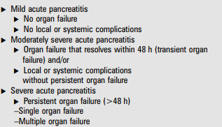
Local complications are peripancreatic fluid collections, pancreatic and peripancreatic necrosis (sterile or infected), pseudocyst and walled-off necrosis (sterile or infected)

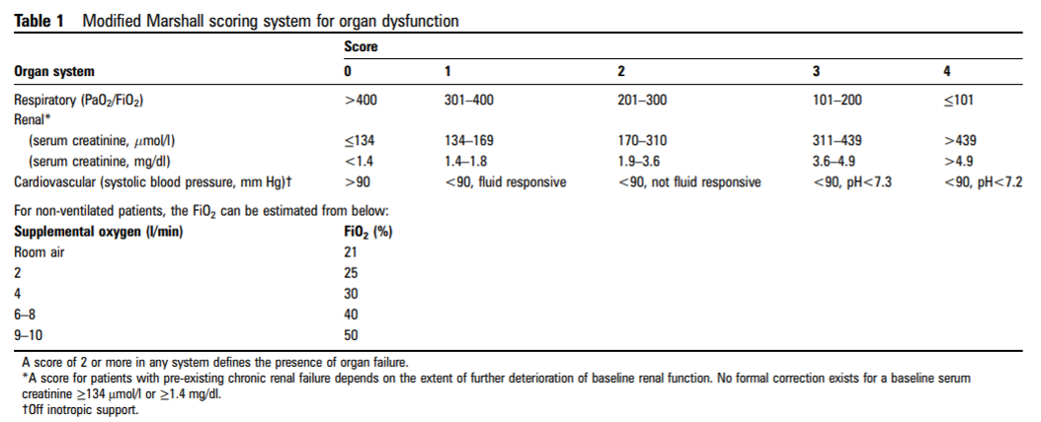
doi:10.1136/gutjnl-2012-302779
“Closing” imaging: hypoechoic
Hypoechoic/ hyperechoic / peripancreatic fluid / irregular and blurred contours / Wirsung dilatation (above 1mm) / calcification / pseudocyst / inhomogeneous structure / fatty tissue infiltration / edematous pancreas / enlarged pancreas / hypodense / hyperdense / pancreatic necrosis / peripancreatic tissue necrosis / walled-off necrosis

Free abdominal fluid: yes / no
Pleural fluid: yes / no
Findings:
Hospital discharge report: file upload (anonym version only)
5. Biobank samples:
Type: serum/ plasma/ urine / hair
Date of sample collection:
Code:
Comments:

